**EMERALD ROYAL INTERNATIONAL SCHOOL**

**MPAPE, ABUJA.**

**LESSON PLAN AND NOTE FOR WEEK 4 ENDING 02/02/2024**

**TERM: 2nd**

**WEEK: 4th**

**DATE: 29/01/2024**

**CLASS: Nursery 2**

**SUBJECT: Nature studies**

**TOPIC: Domestic Animals: Dog**

**SUB—TOPIC: Dog food, uses and first aid treatment for dog.**

**PERIOD: 4th**

**TIME: 10:40—11:20am**

**DURATION: 40 minutes**

**NUMBER IN CLASS: 13**

**AVERAGE AGE: 5 years**

**SEX: Mixed**

**LEARNING OBJECTIVES: By the end of the lesson, the pupils should be able to:**

**1. Mention the uses of dogs.**

**2. States the first aid treatment for dog bites.**

**RATIONALE: For pupils to know more about dogs.**

**PREVIOUS KNOWLEDGE: Pupils have learn the features of dog and the name of a baby dog.**

**INSTRUCTIONAL MATERIALS: Pictures in Pupils textbooks.**

**REFERENCE MATERIALS: Basic science and Technology Nursery schools book 3 by OPEMIPO DADA.**

**LESSON DEVELOPMENT**

|  |  |  |  |
| --- | --- | --- | --- |
| **Steps** | **Teacher's activities** | **Pupils' activities** | **Learning point** |
| **Introduction** | **Teacher asks pupils questions based on the previous Lesson.** | **Pupils answer the questions ask by the teacher.** | **To prepare pupils minds for the lesson ahead.** |
| **Presentation step 1** | **Teacher presents the lesson by explaining to pupils,the food dogs eat and uses of dogs and then ask Pupils to repeat after him or her.** | **Pupils listen to the teacher and repeat after him or her.** | **For proper understanding.** |
| **Step 2** | **Teacher States the first aid treatment for dog bites and also ask Pupils to repeat after him or her.** | **Pupils pay attention to the teacher and repeat after her.** | **For better understanding.** |
| **Board summary** | **Teacher writes the whole note of lesson on the board for pupils to copy . As in;**  **What dogs eat;**  **Dogs like to eat meat and bones but they can also eat the same types of food that human beings eat.**  **Uses of dogs;**  **1. Dogs can be used as pets.**  **2. Dogs can be used to guard a home .**  **3. Dogs can be used for hunting.**  **First aid treatment for dogs bites;**  **1. Wash the wound with soap and warm water.**  **2. Stop the bleeding with a clean cloth.**  **3. Clean the wound with an antiseptic wash.**  **4. Cover the wound with a bandage.**  **5. Go to the hospital to get anti–rabies injection.** | **Pupils copy the note into their books.** | **For onward study.** |
| **Evaluation** | **Teacher evaluates the lesson by asking pupils the following questions;**  **1. What are the food that dogs eat.**  **2. Mention the first aid treatment for dogs.** | **Pupils answer the questions ask by the teacher.** | **To assess pupils level of understanding.** |
| **Conclusion** | **Teacher marks pupils books.** | **Pupils submit their books for marking.** | **For endorsement.** |
| **Assignment** | **Answer all questions in page 41 Activity 11 in science text book.** | **Pupils do their assignment at home .** | **To encourage learning at home.** |

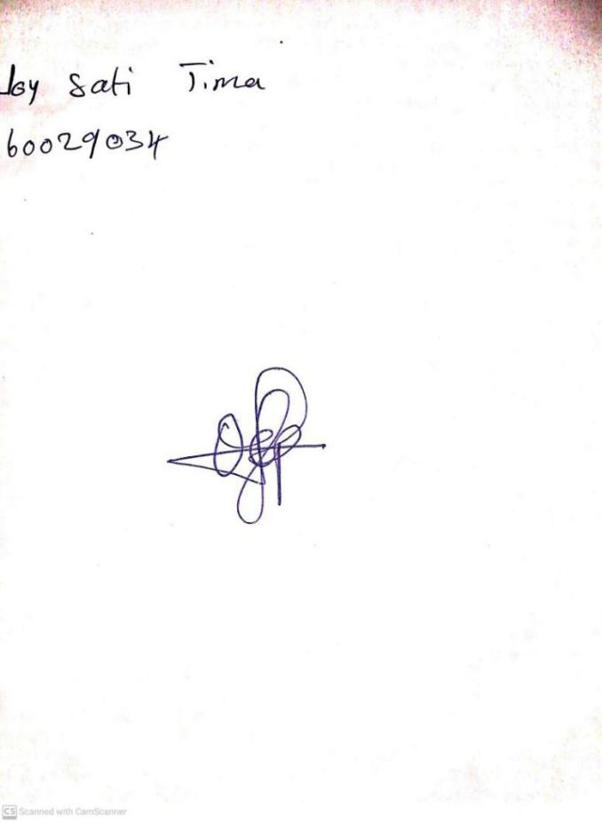

**26th January, 2024**

**Stream Head Nursery**

**Perpetual Ojoma Ocheja**