**EMERALD ROYAL INTERNATIONAL SCHOOL**

**MPAPE, ABUJA.**

**LESSON PLAN AND NOTE 1 FOR WEEK 8 ENDING 14TH JUNE, 2024.**

TERM: 3RD TERM

WEEK: 8TH WEEK

SUBJECT: Number Work

TOPIC: Counting numbers 1 - 45.

SUB-TOPIC: Identification of numbers 1 - 15.

DATE: 10/06/2024.

DURATION: 40 minutes.

TIME: 08 : 50 - 09: 30.

PERIOD: 2ND

CLASS: Pre-nursery

NUMBER OF PUPILS: 19

AVERAGE AGE: 2 years

SEX: Mixed.

SPECIFIC OBJECTIVES: By the end of the lesson, the pupils should be able to:-

1. Count numbers 1- 45
2. Identify numbers 1 - 15

RATIONALE: For pupils to be able to count numbers.

PREVIOUS KNOWLEDGE: Pupils have been counting numbers.

INSTRUCTIONAL MATERIALS: Number chart, flash cards, building blocks etc

REFERENCE MATERIALS: Mastering mathematics for nursery schools book 1 by Henry Idogun.

**LESSON DEVELOPMENT**

|  |  |  |  |
| --- | --- | --- | --- |
| STAGES/STEPS | TEACHER’S ACTIVITIES | PUPILS’ ACTIVITIES | LEARNING POINTS |
| INTRODUCTION | Teacher introduces the lesson by singing a number rhyme for the pupils. | Pupils sing the rhyme after the teacher. | To arouse pupils interest in the lesson. |
| PRESENTATION  STEP 1 | Teacher counts numbers 1 - 45 for the pupils to repeat after her. | Pupils count numbers 1 - 45 after the teacher. | For better understanding of the lesson . |
| STEP2 | Teacher guides each pupils to identify numbers 1 - 15 on flash cards. | Pupils point at the numbers I.e  1 2 3 4 5 6 7 8 9 10 11 12 13 14 15. | For proper understanding of the lesson. |
| SUMMARY | Teacher identifies each number 1 - 15 for the pupils. | Pupils point at the numbers and say the numbers. | For more understanding of the lesson. |
| EVALUATION | Teacher asks Pupils to count numbers 1 - 45 | Pupils count numbers 1 - 45. | To assess pupils understanding of the lesson. |
| CONCLUSION | Teacher sings a number rhyme for the pupils. | Pupils sing the rhyme along with the teacher. | To improve pupils speaking ability. |
| ASSIGNMENT (HOME WORK) | Count numbers 1 - 45 and circle numbers 1 - 15  1 2 3 4 5 6 7 8 9 10 1112 13 14 15 16 17 18 19 20 21 22 23 24 25 26 27 28 29 30 31 32 33 34 35 36 37 38 39 40 41 42 43 44 45. | Pupils do their assignment at home. | To encourage pupils to learn at home. |

**LESSON PLAN AND NOTE 2 FOR WEEK 8 ENDING 14TH JUNE, 2024.**

TERM: 3RD TERM

WEEK: 8TH WEEK

SUBJECT: Number Work

TOPIC: Counting numbers 1 - 45.

SUB-TOPIC: Identification of numbers 16 - 30

DATE: 12/06/2024.

DURATION: 40 minutes.

TIME: 10 : 40 - 11: 20.

PERIOD: 5TH

CLASS: Pre-nursery

NUMBER OF PUPILS: 19

AVERAGE AGE: 2 years

SEX: Mixed.

SPECIFIC OBJECTIVES: By the end of the lesson, the pupils should be able to:-

1 Count numbers 1- 45

2 Identify numbers 16 - 30

RATIONALE: For pupils to be able to count numbers.

PREVIOUS KNOWLEDGE: Pupils have been counting numbers.

INSTRUCTIONAL MATERIALS: Number chart, flash cards, building blocks etc

REFERENCE MATERIALS: Mastering mathematics for nursery schools book 1 by Henry Idogun.

**LESSON DEVELOPMENT**

|  |  |  |  |
| --- | --- | --- | --- |
| STAGES/STEPS | TEACHER’S ACTIVITIES | PUPILS’ ACTIVITIES | LEARNING POINTS |
| INTRODUCTION | Teacher introduces the lesson by singing a number rhyme for the pupils. | Pupils sing the rhyme after the teacher. | To arouse pupils interest in the lesson. |
| PRESENTATION  STEP 1 | Teacher counts numbers 1 - 45 for the pupils to repeat after her. | Pupils count numbers 1 - 45 after the teacher. | For better understanding of the lesson . |
| STEP2 | Teacher guides each pupils to identify numbers 16 - 30 on flash cards. | Pupils point at the numbers I.e  16 17 18 19 20 21 22 23 24 25 26 27 28 29 30. | For proper understanding of the lesson. |
| SUMMARY | Teacher identifies each number 16 - 30 for the pupils. | Pupils point at the numbers and say the numbers. | For more understanding of the lesson. |
| EVALUATION | Teacher asks Pupils to count numbers 1 - 45 | Pupils count numbers 1 - 45. | To assess pupils understanding of the lesson. |
| CONCLUSION | Teacher sings a number rhyme for the pupils. | Pupils sing the rhyme along with the teacher. | To improve pupils speaking ability. |
| ASSIGNMENT (HOME WORK) | Count numbers1 - 45 and circle numbers 16- 30  1 2 3 4 5 6 7 8 9 10 1112 13 14 15 16 17 18 19 20 21 22 23 24 25 26 27 28 29 30 31 32 33 34 35 36 37 38 39 40 41 42 43 44 45. | Pupils do their assignment at home. | To encourage pupils to learn at home. |

**LESSON PLAN AND NOTE 3 FOR WEEK 8 ENDING 14TH JUNE, 2024.**

TERM: 3RD TERM

WEEK: 8TH WEEK

SUBJECT: Number Work

TOPIC: Counting numbers 1 - 45.

SUB-TOPIC: Identification of numbers 31 - 45.

DATE: 13/06/2024.

DURATION: 40 minutes.

TIME: 08 : 50 - 09: 30.

PERIOD: 2ND

CLASS: Pre-nursery

NUMBER OF PUPILS: 19

AVERAGE AGE: 2 years

SEX: Mixed.

SPECIFIC OBJECTIVES: By the end of the lesson, the pupils should be able to:-

1. Count numbers 1- 45
2. Identify numbers 31 - 45

RATIONALE: For pupils to be able to count numbers.

PREVIOUS KNOWLEDGE: Pupils have been counting numbers.

INSTRUCTIONAL MATERIALS: Number chart, flash cards, building blocks etc

REFERENCE MATERIALS: Mastering mathematics for nursery schools book 1 by Henry Idogun.

**LESSON DEVELOPMENT**

|  |  |  |  |
| --- | --- | --- | --- |
| STAGES/STEPS | TEACHER’S ACTIVITIES | PUPILS’ ACTIVITIES | LEARNING POINTS |
| INTRODUCTION | Teacher introduces the lesson by singing a number rhyme for the pupils. | Pupils sing the rhyme after the teacher. | To arouse pupils interest in the lesson. |
| PRESENTATION  STEP 1 | Teacher counts numbers 1 - 45 for the pupils to repeat after her. | Pupils count numbers 1 - 45 after the teacher. | For better understanding of the lesson . |
| STEP2 | Teacher guides each pupils to identify numbers 31 - 45 on flash cards. | Pupils point at the numbers I.e  31 32 33 34 35 36 37 38 39 40 41 42 43 44 45. | For proper understanding of the lesson. |
| SUMMARY | Teacher identifies each number 31 - 45 for the pupils. | Pupils point at the numbers and say the numbers. | For more understanding of the lesson. |
| EVALUATION | Teacher asks Pupils to count numbers 31 - 45 | Pupils count numbers 31 - 45. | To assess pupils understanding of the lesson. |
| CONCLUSION | Teacher sings a number rhyme for the pupils. | Pupils sing the rhyme along with the teacher. | To improve pupils speaking ability. |
| ASSIGNMENT (HOME WORK) | Count numbers1 - 45 and circle numbers 31 - 45  1 2 3 4 5 6 7 8 9 10 1112 13 14 15 16 17 18 19 20 21 22 23 24 25 26 27 28 29 30 31 32 33 34 35 36 37 38 39 40 41 42 43 44 45. | Pupils do their assignment at home. | To encourage pupils to learn at home. |

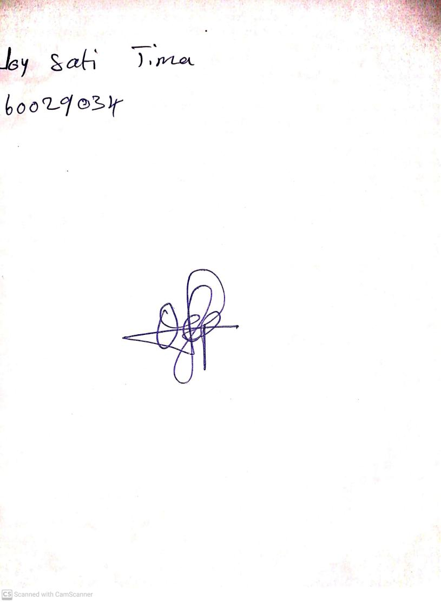

**7th June, 2024**

**Perpetual Ojoma Ocheja**

**Stream Head Nursery**