**EMERALD ROYAL INTERNATIONAL SCHOOL**

**MPAPE, ABUJA.**

**LESSON PLAN AND NOTE FOR WEEK 9 PERIOD 1 ENDING 30/06/2023**

TERM: THIRD

WEEK: 9TH

DATE: 26/06/2023

CLASS: NURSERY 2

SUBJECT: LETTER WORK

TOPIC: PEOPLE I KNOW

SUB-TOPIC: NAMES OF PEOPLE I KNOW AT HOME

PERIOD: 1ST PERIOD

TIME: 09: 30 - 10:10am

DURATION: 40 MINUTES.

NUMBER IN CLASS: 17

AVERAGE AGE: 5 YEARS.

SEX: MIXED.

SPECIFIC OBJECTIVES: BY THE END OF THE LESSON,THE PUPILS SHOULD BE

ABLE TO:

1. MENTION NAMES OF PEOPLE WE KNOW AT HOME

2. SPELL AND PRONOUNCE NAMES OF PEOPLE WE

KNOW AT HOME

RATIONALE: FOR PUPILS TO KNOW HOW TO SPELL AND

PRONOUNCE NAMES OF PEOPLE THEY KNOW AT

HOME.

PREVIOU KNOWLEDGE: PUPILS HAVE BEEN MAKING FRIENDS AT HOME.

INSTRUCTIONAL MATERIALS: PICTURES OF PEOPLE IN THEIR HOME

REFERENCE MATERIALS: THE NEW MASTERING ENGLISH FOR NURSERY

SCHOOLS BOOK 3 BY J .M OMOGBAI

**LESSON DEVELOPMENT**

|  |  |  |  |
| --- | --- | --- | --- |
| STAGES/STEPS | TEACHER’S ACTIVITIES | PUPILS’ ACTIVITIES | LEARNING POINTS |
| INTRODUCTION | Teacher reviews the previous lesson on common things in the classroom and school environment to pupils. | Pupil listen attentively to the teacher. | To prepare pupils minds for the lesson ahead. |
| PRESENTATION  STEP 1 | Teacher guides pupils to mention the names of people they know at home. | Pupils listen attentively to the teacher and mention. | For proper understanding . |
| STEP 2 | Teacher writes the names of people mentioned by the Pupils on the board, spell and pronounce and asks pupils to repeat after her. | Pupils pay attention to the teacher and repeat after her. | For better understanding of the lesson. |
| BOARD SUMMARY | Teacher writes the whole not of lesson on the board for pupils to copy.ie,  PEOPLE I KNOW  Names of people I know at home are:  1. Janet  2. Daniel  3. Tamilore  4. Ono  5. Okiki  6. David  7. Adebo  8. Emmanuel  9. Mary  10. Richard  11. Peace  12. Chisom  13. Monica  14. Solomon  15. James  16. John  17. Alisha  18. Aisha etc. | Pupils copy the note into their exercise books. | For onward study. |
| EVALUATION | Teacher evaluates the lesson by asking asking the following questions:  1. Mention the names of pupils you know at home.  2. Spell and pronounce the names of people you at home on the board one after another | Pupils listen to the teacher and answer the questions asked by her.. | To assess pupils reading skills. |
| CONCLUTION | Teacher concludes the lesson by marking pupils books. | Pupils submit their books for marking. | For endorsement. |
| ASSIGNMENT | Answer the following questions:  1. The number of people you know in school are ____.  2. Spell and write the names of people you know in school. | Pupils do their assignment at home. | To encourage learning at home. |

**LESSON PLAN AND NOTE FOR WEEK 9 PERIOD 2 ENDING 30/06/2023**

TERM: THIRD

WEEK: 9TH

DATE: 29/06/2023

CLASS: NURSERY 2

SUBJECT: LETTER WORK

TOPIC: PEOPLE I KNOW

SUB-TOPIC: NAMES OF PEOPLE I KNOW IN SCHOOL

PERIOD: 2ND PERIOD

TIME: 08: 50 - 09:30am

DURATION: 40 MINUTES.

NUMBER IN CLASS: 17

AVERAGE AGE: 5 YEARS.

SEX: MIXED.

SPECIFIC OBJECTIVES: BY THE END OF THE LESSON,THE PUPILS SHOULD BE

ABLE TO:

1. MENTION NAMES OF PEOPLE YOU KNOW IN SCHOOL

2. SPELL AND PRONOUNCE NAMES OF PEOPLE YOU

KNOW IN SCHOOL.

RATIONALE: FOR PUPILS TO KNOW HOW TO SPELL AND

AND PRONOUNCE THE NAMES OF PEOPLE THEY

KNOW IN SCHOOL.

PREVIOU KNOWLEDGE: PUPILS HAVE LEARNT NAMES OF PEOPLE AT HOME

INSTRUCTIONAL MATERIALS: A CHART OF SCHOLARS NAMES IN CLASS.

REFERENCE MATERIALS: MASTERING ENGLISH FOR NURSERY SCHOOL BOOK 3 BY

J.M OMOGBAI

**LESSON DEVELOPMENT**

|  |  |  |  |
| --- | --- | --- | --- |
| STAGES/STEPS | TEACHER’S ACTIVITIES | PUPILS’ ACTIVITIES | LEARNING POINTS |
| INTRODUCTION | Teacher introduces the lesson by asking pupils to mention the names of people THEY know in school. | Pupil mention the names of people that they know in school. | To prepare pupils minds for the lesson ahead. |
| PRESENTATION  STEP 1 | Teacher mention the names of people in the school for pupils and asks them to repeat after her. | Pupils listen attentively to the teacher and repeat after her. | For proper understanding . |
| STEP 2 | Teacher writes the names of people in school on the board, spell and pronounce and also asks pupils to repeat after her. | Pupils pay attention to the teacher and repeat after her. | For better understanding of the lesson. |
| BOARD SUMMARY | Teacher writes the whole not of lesson on the board for pupils to copy.ie,  PEOPLE I KNOW  The names of people I know in school are:  1. Somadina  2. Emmanuel  3. Mansur  4. Al-ameen  5. Hafiz  6. Daniel  7. Jamal  8. Oluwatamilore  9. Daniella  10. Winifred  11. Mirabel  12. Royalty  13. Vince  14. Chikamso  15. Bella  16. Nourdeen  17. Abubakar etc. | Pupils copy the note into their exercise books. | For onward study. |
| EVALUATION | Teacher evaluates the lesson by asking pupils the following questions:  1. Mention the names of people they know in the school.  2. Spell and pronounce the names of people in school on the board one after the other. | Pupils listen to the teacher and answer the questions asked by her. | To assess pupils reading skills. |
| CONCLUTION | Teacher concludes the lesson by marking pupils books. | Pupils submit their books for marking. | For endorsement. |
| ASSIGNMENT | Write 10 names of staff in emerald royal international school. | Pupils do their assignment at home. | To encourage learning at home. |

**LESSON PLAN AND NOTE FOR WEEK 9 PERIOD 3 ENDING 30/06/2023**

TERM: THIRD

WEEK: 9TH

DATE: 30/06/2023

CLASS: NURSERY 2

SUBJECT: LETTER WORK

TOPIC: PEOPLE I KNOW

SUB-TOPIC: NAMES OF STAFF IN MY SCHOOL

PERIOD: 3RD PERIOD

TIME: 09: 30 - 10:10am

DURATION: 40 MINUTES.

NUMBER IN CLASS: 17

AVERAGE AGE: 5 YEARS.

SEX: MIXED.

SPECIFIC OBJECTIVES: BY THE END OF THE LESSON,THE PUPILS SHOULD BE ABLE TO:

1. MENTION NAMES OF STAFFS IN SCHOOL

2. SPELL AND PRONOUNCE NAMES OF STAFFS IN

SCHOOL.

RATIONALE: FOR PUPILS TO KNOW THE NAMES OF THEIR STAFFS

PREVIOU KNOWLEDGE: PUPILS HAVE LEARNT NAMES OF PEOPLE IN THE SCHOOL. ENVIROMENT.

INSTRUCTIONAL MATERIALS: A CHART OF STAFFS NAMES

REFERENCE MATERIALS: NEW MASTERING ENGLISH FOR NURSERY

SCHOOLS BOOK 3 BY J. M OMOGBAI

**LESSON DEVELOPMENT**

|  |  |  |  |
| --- | --- | --- | --- |
| STAGES/STEPS | TEACHER’S ACTIVITIES | PUPILS’ ACTIVITIES | LEARNING POINTS |
| INTRODUCTION | Teacher reviews the previous lesson on to pupils. | Pupil listen attentively to the teacher. | To prepare pupils minds for the lesson ahead. |
| PRESENTATION  STEP 1 | Teacher mentions the names of staffs in our school and then asks pupils to repeat after her. | Pupils listen attentively to the teacher and repeat after her. | For proper understanding |
| STEP 2 | Teacher writes the names of staffs on the board, spell and pronounce, and also asks pupils to repeat after her. | Pupils listen to the teacher and also repeat after her. | For better understanding of the lesson. |
| BOARD SUMMARY | Teacher writes the whole not of lesson on the board for pupils to copy and match. As;  PEOPLE I KNOW  Names of staffs in our school are:  1. Mrs Vivian  2. Mrs mary  3. Mrs Patricia  4. Mrs Gloria  5. Miss Mercy  6. Miss Favour  7. Mrs Joy  8. Miss Juliet  9. Miss perpetual  10. Mr Dickson  11. Mr Samuel etc. | Pupils copy the note into their exercise books. | For onward study. |
| EVALUATION | Teacher evaluates the lesson by asking pupils the following questions:  1. Mention the names of staffs that you know  2. Spell and pronounce the names of staffs on the board one after another. | Pupils read the note on the board one after another. | To assess pupils reading skills. |
| CONCLUTION | Teacher concludes the lesson by marking pupils books. | Pupils submit their books for marking. | For endorsement. |
| ASSIGNMENT | Spell and write 20 names of people you know. | Pupils do their assignment at home. | To encourage learning at home. |

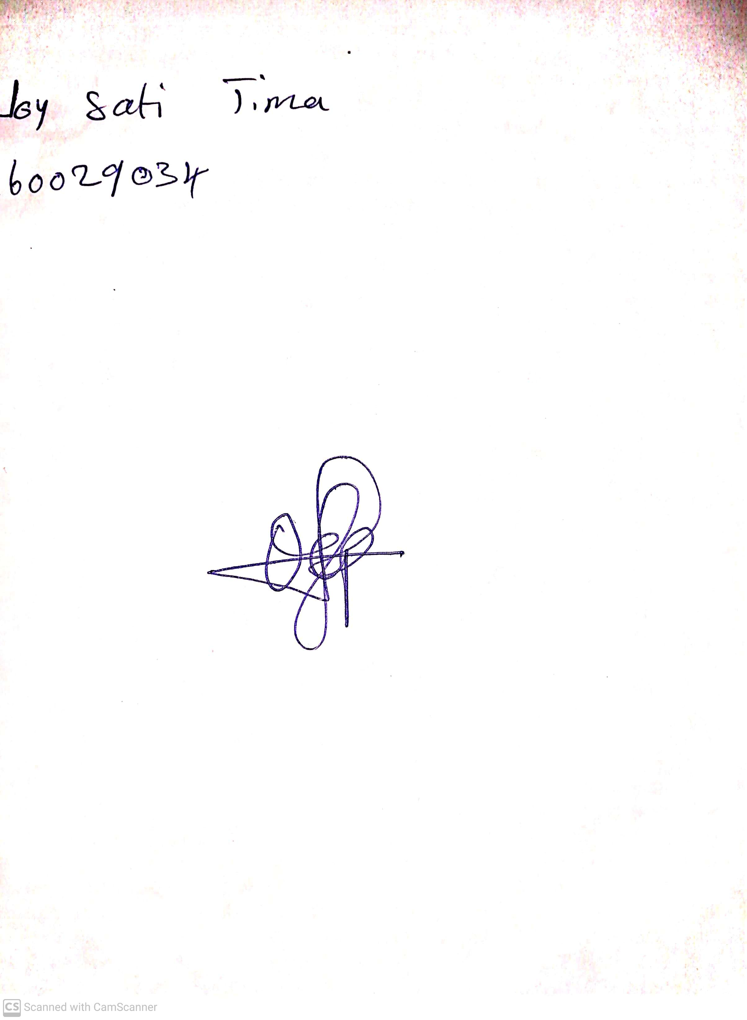

28th May, 2023

Perpetual Ojoma

Stream Head Nursery