LESSON PLAN FOR WEEK 7 ENDING 24TH FEBRUARY, 2023

|  |  |
| --- | --- |
| TERM | 2ND |
| WEEK | 7 |
| DATE | 20TH -24TH February, 2023 |
| CLASS | SS 1 |
| SUBJECT | Government |
| TOPIC | Representative Government |
| SUB-TOPIC | Merits and Demerits of Representative Government |
| PERIOD | 3RD |
| TIME | 9:30-10:10 |
| DURATION | 40 Minutes |
| NO IN CLASS | 2 |
| AVERAGE AGE | 15years |
| SEX | Mixed |
| SPECIFIC OBJECTIVES | By the end of the lesson, scholars should be able to:  i.List the merits of representative government.  ii.Mention the demerits of representative government. |
| RATIONALE | To acquaint the scholars with merits and demerits of representative government. |
| PREVIOUS KNOWLEDGE | The scholars can mention the features of representative government. |
| INSTRUCTIONAL RESOURCES | Charts from textbook explaining the topic. |
| REFERENCE MATERIAL | Essential Government for Senior Secondary Schools.  Debbie C. Chris(2017) |

LESSON DEVELOPMENT

|  |  |  |  |
| --- | --- | --- | --- |
| STEPS | TEACHER’S ACTIVITIES | SCHOLARS’ ACTIVITIES | LEARNING POINTS |
| Introduction | The teacher introduces the lesson by asking the scholars to mention two features of representative government. | The scholars mention them as:   1. Free Press. 2. Rule of Law | To arouse scholar’s interest towards the topic. |
| Step 1 | The teacher lists and explains the merits of representative government. | The scholars listen carefully. | To ensure proper understanding of the topic. |
| Step 2 | The teacher outlines the demerits of representative government. | The scholars ask questions on the topic. | To make room for logical reasoning on the topic. |
| Board Summary | The teacher summarizes the lesson thus:  **Merits of Representative Government**  i.Choice of leaders: The opportunity is created for the people to choose political leaders without any hindrances.  ii.The system is simple to operate: It is easy to identify those responsible for the failure of the government.  iii.It makes for stability: The government in place is legitimate and legally constituted.  iv.Election is the yardstick: The government is set up through the normal electoral process.  v.Rule of law: The administration is based on respect for the rule of law and obedience to the provisions of the constitution by the elected political leaders.  **Demerits of Representative Government**  i.No true independence of the judiciary. This is because judiciary may be under the control of the government in power.  ii.Rigging of Elections: This is a big threat to a truly defined representative government. The electorate could be denied the choice made.  iii.Illiteracy: The inability of some voters to properly identify party names and symbols may lead to wrong choices of candidate.  iv.Corruption: It makes for corrupt practices among the politicians who may want to acquire power at all costs.  v.Costly to run: Too much money, men, etc are needed for a successful conduct of elections of this magnitude. | The scholars copy notes into their notebooks. | For future references. |
| Evaluation | The teacher evaluates the scholars thus:  i.List three merits of representative government.  ii.Explain two demerits of representative government. | The scholars attempt the questions. | To ascertain their level of understanding of the lesson. |
| Conclusion | The teacher check scholars notes and make corrections. | The scholars take corrections made by the teacher. | For consolidation of the lesson. |
| Assignment | The teacher gives the scholars assignment:  Outline five conditions for the establishment of representative government. | The scholars copy their assignment to do it at home. | To encourage scholars to study and learn at home. |

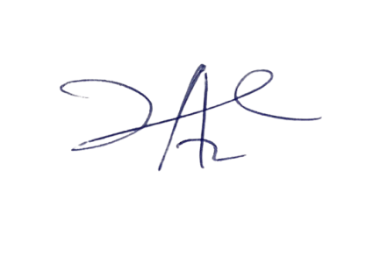

28/3/2023

Principal Head Instructor