**EMERALD ROYAL INTERNATIONAL SCHOOL**

**MPAPE, ABUJA.**

**LESSON PLAN AND NOTE FOR WEEK 1 PERIOD 1 ENDING 15/09/2023**

TERM: First

WEEK: 1

DATE: 11/09/2023

CLASS: NURSERY 2

SUBJECT: NUMBER WORK

TOPIC: NUMBERS 1- 20 .

SUB-TOPIC: IDENTIFY,COUNT AND WRITE NUMBER 1- 10

PERIOD: 1ST

TIME: O8:50-09:30.

DURATION: 40 MINUTES.

NUMBER IN CLASS: 17

AVERAGE AGE: 5 YEARS.

SEX: MIXED.

SPECIFIC OBJECTIVES: BY THE END OF THE LESSON,THE PUPILS SHOULD BE

ABLE TO:

1. COUNT NUMBER 1 - 10

2. WRITE NUMBER 1 - 10

RATIONALE: FOR PUPILS TO BE ABLE TO COUNT NUMBERS 1–10.

PREVIOU KNOWLEDGE: PUPILS HAVE LEARNT COUNTING OF NUMBERS 1- 9 IN PREVIOUS CLASS.

INSTRUCTIONAL MATERIALS: NUMBER CHART 1–10 .

REFERENCE MATERIALS: THE NEW MASTERING MATHEMATICS FOR NURSERY SCHOOLS BOOK 3 BY HENRY.Z.IDOGUN.

**LESSON DEVELOPMENT**

|  |  |  |  |
| --- | --- | --- | --- |
| STAGES/STEPS | TEACHER’S ACTIVITIES | PUPILS’ ACTIVITIES | LEARNING POINTS |
| INTRODUCTION | Teacher introduces the lesson by singing nursery number rhymes like, 1 little 2 little 3 little fingers,4 little 5 little 6 little fingers, 7 little 8 little 9 little fingers, 10 little fingers on my hands. | Pupil listen to the teacher and sing the rhymes along with the teacher. | To arouse pupils interest for the lesson ahead. |
| PRESENTATION  STEP 1 | Teacher presents the lesson by counting numbers from 1- 10 and then asks pupils to repeat after her. | Pupils count the numbers after the teacher. | For proper understanding of the lesson . |
| STEP 2 | Teacher writes numbers on the board for pupils to identify numbers. Ie, 1 2 3 4 5  6 7 8 9 10 . | Pupils identify the numbers 1- 10 on the board. | For better understanding of the lesson. |
| BOARD SUMMARY | Teacher summarizes the lesson by writing the whole note of lesson on the board for pupils to copy into their books.that is,  COUNTING OF NUMBERS 1- 10  1 2 3 4 5  6 7 8 9 10 | Pupils copy the note into their exercise books. | For onward study. |
| EVALUATION | Teacher asks pupils to count numbers 1- 10 on the board one after the other. | Pupils count numbers 1- 10 on the board one after another. | To assess pupils understanding of the lesson. |
| CONCLUSION | Teacher marks pupils books. | Pupils submit their books for marking. | For endorsement. |
| ASSIGNMENT | 1.Identify, count and write numbers 1–10.  2.Rewrite the following numbers  11 12 13 14 15  ___ ___ ___ ___ ___  16 17 18 19 20  ___ ___ ___ ___ ___ | Pupils do their assignment at home. | To encourage learning at home. |

**LESSON PLAN AND NOTE FOR WEEK 1 PERIOD 2 ENDING 15/09/2023**

TERM: First

WEEK: 1

DATE: 12/09/2023

CLASS: NURSERY 2

SUBJECT: NUMBER WORK

TOPIC: NUMBERS 1–20 .

SUB-TOPIC: IDENTIFY,COUNT AND WRITE NUMBER 11- 20

PERIOD: 2nd

TIME: O8:50-09:30.

DURATION: 40 MINUTES.

NUMBER IN CLASS: 17

AVERAGE AGE: 5 YEARS.

SEX: MIXED.

SPECIFIC OBJECTIVES: BY THE END OF THE LESSON,THE PUPILS SHOULD BE

ABLE TO:

1.COUNT NUMBERS 11 - 20

2.IDENTIFY AND WRITE NUMBERS 11 - 20

RATIONALE: FOR PUPILS TO BE ABLE TO COUNT AND WRITE

NUMBER 11–20

PREVIOU KNOWLEDGE: PUPILS HAVE LEARNT COUNTING OF NUMBERS 1- 10 IN PREVIOUS LESS0N.

INSTRUCTIONAL MATERIALS: NUMBER CHART 11–20

REFERENCE MATERIALS: THE NEW MASTERING MATHEMATICS FOR NURSERY SCHOOLS BOOK 3 BY HENRY.Z.IDOGUN.

**LESSON DEVELOPMENT**

|  |  |  |  |
| --- | --- | --- | --- |
| STAGES/STEPS | TEACHER’S ACTIVITIES | PUPILS’ ACTIVITIES | LEARNING POINTS |
| INTRODUCTION | Teacher introduces the lesson by asking pupils to count number 1-10. | Pupil count number 1–10 | To arouse pupils interest for the lesson ahead. |
| PRESENTATION  STEP 1 | Teacher presents the lesson by counting numbers from 11- 20 and then asks pupils to repeat after. | Pupils count the numbers after the teacher. | For proper understanding of the lesson . |
| STEP 2 | Teacher writes numbers 11- 20 on the board, identify and count and then asks pupils to identify and count after her. | Pupils identify the numbers 11- 20 on the board and count after the teacher. | For better understanding of the lesson. |
| BOARD SUMMARY | Teacher summarizes the lesson by writing the whole note of lesson on the board for pupils to copy into their books.that is,  COUNTING OF NUMBERS 11–20.  11 12 13 14 15 16 17 18 19 20 | Pupils copy the note into their exercise books. | For onward study. |
| EVALUATION | Teacher asks Pupils to count numbers 11- 20 on the board one after the other. | Pupils count numbers 11- 20 on the board one after another. | To assess pupils understanding of the lesson. |
| CONCLUSION | Teacher marks pupils books. | Pupils submit their books for marking. | For endorsement. |
| ASSIGNMENT | Identify, count and write numbers 11- 20. | Pupils do their assignment at home. | To encourage learning at home. |

**LESSON PLAN AND NOTE FOR WEEK 1 PERIOD 3 ENDING 15/09/2023**

TERM: First

WEEK: 1

DATE: 15/09/2023

CLASS: NURSERY 2

SUBJECT: NUMBER WORK

TOPIC: NUMBERS 1–20 .

SUB-TOPIC: IDENTIFY,COUNT AND WRITE NUMBER 1- 20

PERIOD: 3RD

TIME: 08:10- 08:50am

DURATION: 40 MINUTES.

NUMBER IN CLASS: 17

AVERAGE AGE: 5 YEARS.

SEX: MIXED.

SPECIFIC OBJECTIVES: BY THE END OF THE LESSON,THE PUPILS SHOULD

BE ABLE TO:

1.COUNT NUMBERS 1- 20

2. WRITE NUMBER 1- 20

RATIONALE: FOR PUPILS TO KNOW COUNTING OF NUMBERS 1-20

PREVIOU KNOWLEDGE: PUPILS HAVE LEARNT COUNTING OF NUMBERS 11–20 IN PREVIOUS LESS0N.

INSTRUCTIONAL MATERIALS: NUMBER CHART 1–20

REFERENCE MATERIALS: THE NEW MASTERING MATHEMATICS FOR NURSERY

SCHOOLS BOOK 3 BY J.M OMOGBAI.

**LESSON DEVELOPMENT**

|  |  |  |  |
| --- | --- | --- | --- |
| STAGES/STEPS | TEACHER’S ACTIVITIES | PUPILS’ ACTIVITIES | LEARNING POINTS |
| INTRODUCTION | Teacher introduces the lesson by jumping and counting numbers 1- 20. | Pupils jump and count the numbers along with the teacher. | To arouse pupils interest for the lesson ahead. |
| PRESENTATION  STEP 1 | Teacher presents the lesson by writing number 1- 20 on the board,count and then asks pupils to repeat after her. | Pupils listen to the teacher and repeat after her. | For proper understanding of the lesson . |
| STEP 2 | Teacher guides pupils to count and identify the numbers on the board often and often. | Pupils count and identify the numbers on the board. | For better understanding of the lesson. |
| BOARD SUMMARY | Teacher summarizes the lesson by preparing pupils books for them to copy the note on the board.ie,  COUNTING AND WRITING OF NUMBERS 1- 20.  1 2 3 4 5  6 7 8 9 10  11 12 13 14 15  16 17 18 19 20 | Pupils copy the note into their exercise books. | For onward study. |
| EVALUATION | Teacher evaluates the lesson by asking pupils to all stand and count the numbers on the board all together. | Pupils all stand and count the numbers on the board. | To create platform for slow learners. |
| CONCLUSION | Teacher concludes the lesson by marking pupils notes . | Pupils submit their books for marking. | For endorsement. |
| ASSIGNMENT | Fill in the missing numbers.  1 2 __ 4 __ 6 __ 8 __ 10 __ 12 __ 14 __ 16 __ 18 __ 20 . | Pupils do their assignment at home. | To encourage learning at home. |

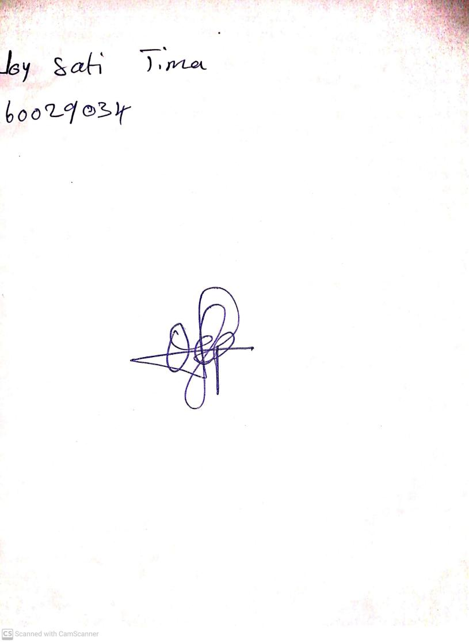

27th August, 2023

Perpetual Ojoma Ocheja

Stream Head Nursery