**LESSON PLAN AND NOTE FOR WEEK 10 ENDING 15/03/2024**

**Term 2nd term**

**Week 10th & 11th week**

**Date 14/03/2024 & 18/03/2024**

**Class Nursery one**

**Subject Social Norms**

**Topic Good Table Manners.**

**Sub-topic Define,Identify & ways of maintaining good table manners**

**Period 2nd period**

**Time 9:05 am**

**Duration 35 minutes**

**No in class 15**

**Average Age 3 years**

**Sex Mixed**

**Specific Objectives: By the end of the lesson the pupils should be able to;**

1. **Define of Good table manners.**
2. **Identify good manner.**
3. **Mention ways of maintaining good table manners.**

**Rationale: To ensure the pupils define,identify & lists ways to keep good table manners**

**Previous knowledge:The pupils can define & mention the types and elements of culture.**

**Instructional Resources:Chart, board, marker.**

**Reference Materials: Online Research,chart,board.**

**LESSON PRESENTATION**

|  |  |  |  |
| --- | --- | --- | --- |
| **Steps** | **Teacher’s Activities** | **Pupils’ Activities** | **Learning points** |
| **Introduction** | **The teacher introduces the topic (Meaning,identification & ways of maintaining good table manners) to the pupils.** | **The pupils listen attentively to the teacher.** | **To arouse the interest of the pupils.** |
| **Step 1** | **The teacher starts by teaching the pupils the meaning of good table manners as “the certain healthy things I must do while eating”.** | **The pupils repeat after the teacher the meaning of good table manners.** | **For proper understanding.** |
| **Step 2** | **The teacher leads the pupils to identify the good behaviour at the dinning table which include:**   1. **Wash yours hands with soap and clean water before and after eating.** 2. **Do not talk when there is food in your mouth** 3. **Take only a small quantity of your food into your mouth.** | **The pupils mention with the teacher the good behaviour at the dinning table.** | **For better understanding.** |
| **Step 3** | **The teacher mention the ways of maintaining good table manners which includes:**   1. **Cover your food when you aren’t eating at the moment to avoid flies.** 2. **Avoid rushing your food ,instead eat slowly.** 3. **Do not cough nor sneeze inside your food when eating.** 4. **Do not pick your nose while eating etc.** | **The pupils mention together with their teacher the ways of maintaining good table manners.** | **For further understanding.** |
| **Summary** | **The teacher summarizes the lesson by defining good table manners for the pupils.** | **The pupils can define good table manners.** | **For onward study.** |
| **Evaluation** | **Question:**   1. **Mention the ways of maintaining good table manners?** 2. **Define good table manners?** 3. **Mention 3 good behaviour at the dining table?** | **The pupils answer the question correctly.** | **To ascertain the pupils’ understanding.** |
| **Conclusion** | **The teacher summarizes, reacts & corrects the pupils.** | **The pupils gives answer to the teacher’s questions.** | **To consolidate the lesson.** |
| **Assignment** | **Question:**   1. **Mention the ways of maintaining good table manners?** 2. **Define good table manners?** 3. **Mention 3 good behaviour at the dining table?** | **The pupils copy and do their homework at home.** | **To encourage learning while at home.** |

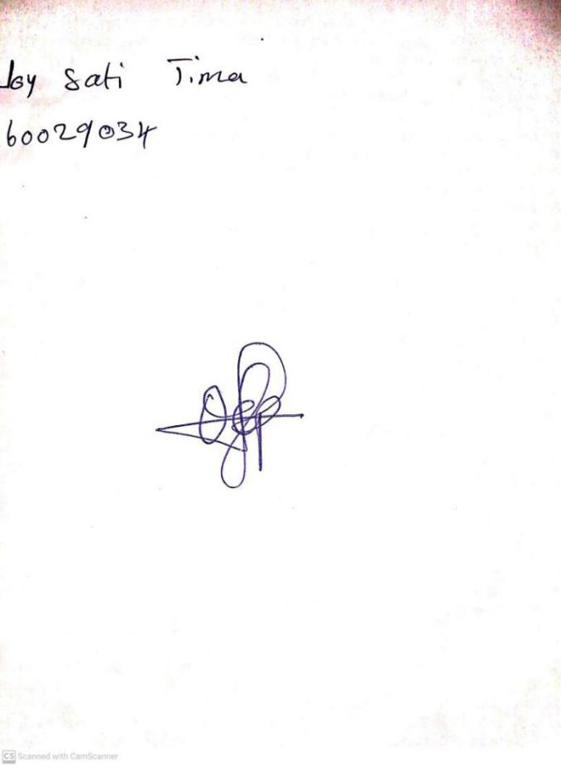

16TH February, 2024

Perpetual Ojoma Ocheja

Stream Head Nursery