EMERALD ROYAL INTERNATIONAL SCHOOL

MPAPE, ABUJA.

LESSON PLAN AND NOTE FOR WEEK 8 ENDING 2ND NOVEMBER,2023

TERM: First term.

WEEK: Eight

SUBJECT: Nature studies.

TOPIC: Common seeds.

SUB-TOPIC: Meaning of seeds.

DATE: 22/10/2023

DURATION: 40 minutes

TIME: 08:50-09:30

PERIOD: 3rd

CLASS: Pre-nursery

NUMBER OF PUPILS: 11

AVERAGE AGE: 2 years

SEX: Mixed

SPECIFIC OBJECTIVES: By the end of the lesson, the pupils should be able to:-

I Define a seed.

2. Mention some common seeds.

RATIONALE: For Pupils to observe the parts of a plant .

PREVIOUS KNOWLEDGE: Pupils have been taught the meaning of plants in their previous lesson.

INSTRUCTIONAL MATERIALS: Chart and text books.

REFERENCE: Showers kiddies books Elementary science book nursery 1 by Showers kiddies books.

LESSON DEVELOPMENT

|  |  |  |  |
| --- | --- | --- | --- |
| Stages/steps | Teacher's activities | Pupils' activities | Learning points |
| Introduction | Teacher introduces the lesson by reviewing the parts of plants taught in the previous lesson for the pupils. | Pupils listen as the teacher review the last lesson. | To arouse the interest of the pupils for the lesson ahead. |
| Presentation  Step 1 | Teacher defines seeds to the pupils as:-  " Seeds are small hard fruits." When seeds are planted in the ground, they grow to become big trees, shrubs, climbers or creepers.  The teacher explains and asks the pupils to repeat after the her. | Pupils listen to the teacher and repeat after the teacher. | For better understanding of the lesson. |
| Step 2 | Teacher mentions some common seeds as:-  Cashew seeds.  Tomato seeds.  Paw-paw seeds  Beans seeds. | Pupils pay attention to the teacher as she list the common seeds. | For better understanding of the lesson. |
| Summary | Teacher summarizes the lesson by going over the lesson again for better understanding of the lesson. | Pupils listen attentively to the teacher as she is going over the lesson again. | To ensure better understanding. |
| Evaluation | Teacher asks the Pupils to :-   1. Define seeds 2. Mention some common seeds. | Pupils answer the teacher's questions correctly. | To ascertain the level of pupils understanding of the lesson. |
| Conclusion | Teacher concludes the lesson by singing nursery rhymes for the pupils. | Pupils sing the rhymes along with the teacher . | For onwards learning. |
| Assignment | Teacher asks the pupils to bring two seeds of beans for planting in the school. | Pupils bring two seeds of beans for planting. the assignment at home. | To encourage Learning at home. |

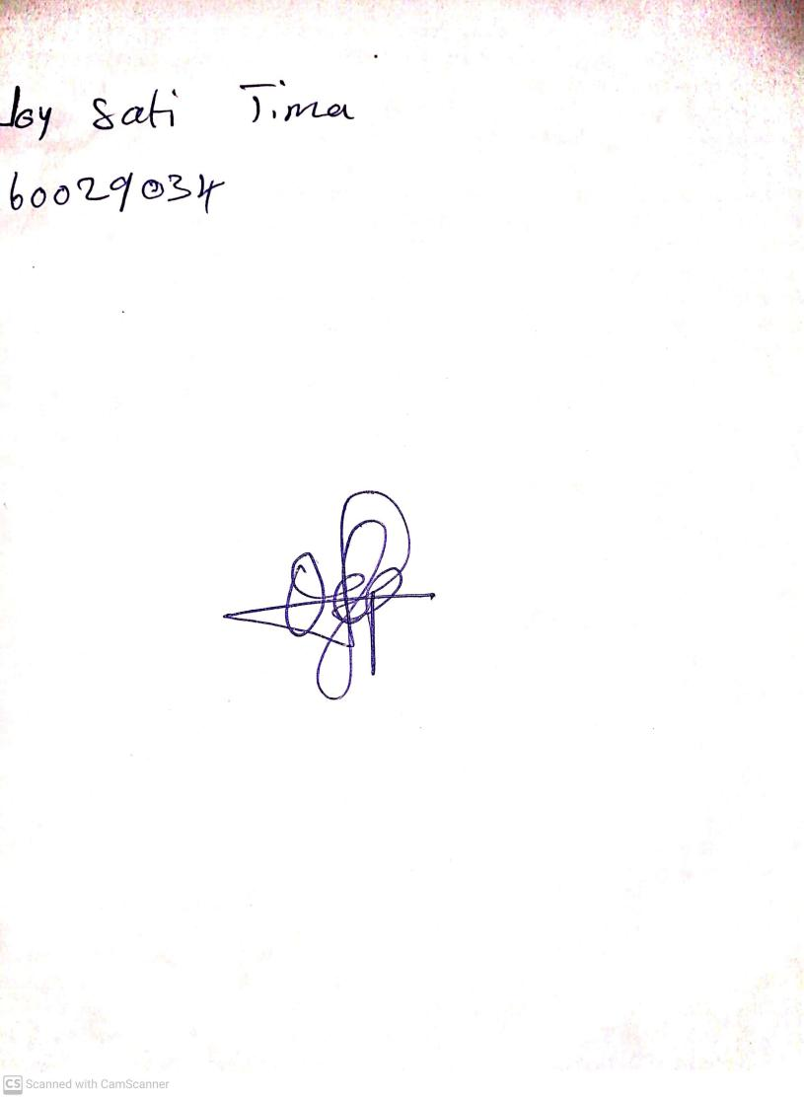

20th August, 2023

Perpetual Ojoma Ocheja

Stream Head Nursery