**Lesson Plan for week 2 Ending 20/1/2023.**

**Term:**2nd

**Week**: 2

**Date:** 16/1/2023.

**Class**: SS 1

**Subject:** Economics

**Topic**: firm and industry

**Sub-Topic:** General and specific problems of Business Enterprises.

**Period:** first

**Time**: 8:10-8:50.

**Duration:** 40 Minutes

**Number in class:** 7 Students

**Average Age**: 14 Years

**Sex:** Mixed

**Specific objectives:** By the end of the lesson, the students should be able to:

(1) Define business enterprises

(11) State the general and specific problems of business enterprises.

(11) Explain the general and specific problems of business enterprises.

**Rationale:** To be able to identify the problems of business enterprises.

**Previous knowledge**: The students have seen people experiencing short of money in their business.

**Instructional Material**: A chart showing dilapidated roads and buildings.

**Reference material:** Ande C E (2020) Essential Economics for senior Secondary schools.

**LESSON DEVELOPMENT**

|  |  |  |  |
| --- | --- | --- | --- |
| **Stages/steps** | **Teacher's Activities** | **Students' Activities** | **Learning points.** |
| **Introduction** | Review the previous lesson. | Participate actively in the class discussion. | To arouse the students’ interest to learn. |
| **Step 1** | Defines Business Enterprise as: business Enterprise refers to a person spotting a business opportunity and setting up a business. | Listen carefully to the teacher. | For better understanding of the lesson. |
| **Step 11** | Asks the students to state the general and specific problems of business enterprises | State the General and specific problems of business enterprises as: (1) inadequate capital (2) inadequate infrastructural facilities. (3) inadequate skilled personnel etc. | To encourage critical thinking. |
| **Step 111** | Guides the students to explain the general and specific problems of business enterprises. | Respond to the class activity. | To enhance their logical reasoning. |
| **Board Summary** | Summarizes the lesson as:  **Business Enterprise**  Business Enterprise refers to a person spotting a business opportunity and setting up a business. This could be set up by the government and private individuals.  **General and specific problems of business enterprises.**  (1) inadequate capital: business enterprises be it private or public enterprises are usually faced with inadequate capital which makes it difficult for them to expand their operation. (2) inadequate infrastructural facilities: infrastructural facilities like good roads, electricity, pipe borne water, telephone services etc, are usually grossly inadequate and this make business operation very tough and difficult. (3) inadequate skilled personnel: most of the skilled personnel required to operate or manage business enterprise are also inadequate. This result to low output and poor quality of products. (4) shortage of raw materials: Most of the raw material needed by business enterprises to operate are in short supply. This has either forced some of them to operate at low capital utilization or even fold up completely. (5) Low patronage: Goods and services provided by some business enterprises do encounter low patronage partly because of low standard of goods and services provided and partly because of consumers preference for foreign goods. | Copy and submit the note book for marking. | For future purpose. |
| **Evaluation** | Evaluates the students as:  (1) Define business enterprise.  (11) state 4 general and specific problems of business enterprises.  (111) Explain any 3 general and specific problems of business enterprises. | Respond to the questions. | Ascertaining the attainment of the stated objectives. |
| **Conclusion** | Rounds up the lesson by marking and correcting students work. | Check and do their correction. | Consolidation of the lesson. |
| **Assignment** | Gives home work as:  (1) Mention and explain 5 advantages of Sole proprietorship.  (2)List and explain 5 disadvantages of partnership. | Respond by doing the home work at home. | To ensure continuity of learning. |

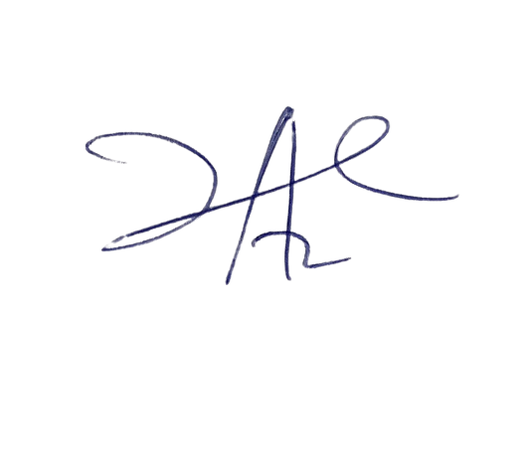

6/3/2023

Principal Head Instructor