**LESSON PLAN AND NOTE 1 FOR WEEK 8 ENDING 3/11/2023**

**Term 1st term**

**Week 8th week**

**Date 30th October,2023**

**Class Nursery One**

**Subject Number Work**

**Topic Counting numbers 1-70.**

**Sub-topic Count numbers 60-65**

**Period 2nd period**

**Time 8:50 am**

**Duration 35 minutes**

**No in class 15**

**Average Age 3 years**

**Sex Mixed**

**Specific Objectives: By the end of the lesson ,the pupils should be able to:**

1. **Count numbers 60-65.**
2. **Identify numbers 60-65.**
3. **Write numbers 60-65**

**Rationale: To make sure the pupils count numbers 1-70.**

**Previous Knowledge: The pupils can match & fill in missing numbers 1-60.**

**Instructional Resources: Chart, board, marker, etc.**

**Reference Material: The new mastering mathematics.**

**LESSON PRESENTATION**

|  |  |  |  |  |
| --- | --- | --- | --- | --- |
| **Steps** | **Teacher’s Activities** | **Pupils’ Activities** | **Learning Points** | |
| **Introduction** | **The teacher introduces the topic (counting numbers 1-70) to the pupils by rhyming it.** | **The pupils with the teacher rhyme the numbers 1-70.** | **To arouse the pupils’ interest.** | |
| **Step 1** | **The teacher assists the pupils to count numbers 60-65**  **60 61 62**  **63 64 65** | **The pupils counts numbers 60-65 with their teacher.** | | **For proper understanding.** |
| **Step 2** | **The teacher leads the pupils to identify numbers 60-65**  **60 61 62**  **63** | **The pupils participate with the teacher in identifying numbers 60-65.**  **60 61 62**  **63** | | **For better understanding.** |
| **Step 3** | **The teacher guides the pupils to write numbers 60-65 inside their notebooks.**   |  |  | | --- | --- | | **60** | **61** | |  |  | | **62** | **63** | |  |  | | **64** | **65** | |  |  | | **The pupils write numbers 60-65 as the teacher guides them.**   |  |  | | --- | --- | | **60** | **61** | |  |  | | **62** | **63** | |  |  | | **64** | **65** | |  |  | | | **For further understanding** |
| **Summary** | **The teacher summarizes the lesson by counting numbers 60-65.** | **The pupils have master and count numbers 60-65**  **.** | | **For onward study.** |
| **Evaluation** | **Write numbers 60-65 inside their notebooks.**   |  |  | | --- | --- | | **60** | **61** | |  |  | | **62** | **63** | |  |  | | **64** | **65** | |  |  |   **Identify numbers 60-65.**  **60 61 62**  **63**  **Count numbers 60-65**  **60 61 62**  **63 64 65** | **The pupils answers the question correctly.** | | **To ascertain the pupils’ understanding.** |
| **Conclusion** | **The teacher summarizes, reacts and corrects the lesson.** | **The pupils gives answers to the teacher’s questions** | | **To consolidate the lesson** |
| **Assignment** | **Identify numbers 60-65.**  **60 61 62**  **63**  **Count numbers 60-65**  **60 61 62**  **63 64 65**  **Write the following numbers below**   |  |  | | --- | --- | | **60** | **61** | |  |  | | **62** | **63** | |  |  | | **64** | **65** | |  |  | | **The pupils copy and do their homework at home.** | | **To encourage learning while at home.** |

**LESSON PLAN AND NOTE 2 FOR WEEK 8 ENDING 3/11/2023**

**Term 1st term**

**Week 8th week**

**Date 2nd November,2023**

**Class Nursery One**

**Subject Number Work**

**Topic Counting numbers 1-70.**

**Sub-topic Count numbers 65-70**

**Period 2nd period**

**Time 8:50 am**

**Duration 35 minutes**

**No in class 15**

**Average Age 3 years**

**Sex Mixed**

**Specific Objectives: By the end of the lesson ,the pupils should be able to:**

1. **Count numbers 65-70.**
2. **Identify numbers 65-70.**
3. **Write numbers 65-70.**

**Rationale: To make sure the pupils count numbers 1-70.**

**Previous Knowledge: The pupils knows how to count numbers 60-65.**

**Instructional Resources: Chart, board, marker, etc.**

**Reference Material: The new mastering mathematics.**

**LESSON PRESENTATION**

|  |  |  |  |
| --- | --- | --- | --- |
| **Steps** | **Teacher’s Activities** | **Pupils’ Activities** | **Learning Points** |
| **Introduction** | **The teacher introduces the topic (counting numbers 1-70) to the pupils by rhyming it.** | **The pupils with the teacher rhyme the numbers 1-70.** | **To arouse the pupils’ interest.** |
| **Step 1** | **The teacher assists the pupils to count numbers 65-70**  **65 66 67**  **68 69 70** | **The pupils counts numbers 65-70 with their teacher.** | **For proper understanding.** |
| **Step 2** | **The teacher leads the pupils to identify numbers 65-70**  **65 66 67**  **68** | **The pupils participate with the teacher in identifying numbers 65-70.**  **65 66 67**  **68** | **For better understanding.** |
| **Step 3** | **The teacher guides the pupils to write numbers 65-70 inside their notebooks.**   |  |  | | --- | --- | | **65** | **66** | |  |  | | **67** | **68** | |  |  | | **69** | **70** | |  |  | | **The pupils write numbers 65-70 as the teacher guides them.** | **For further understanding** |
| **Summary** | **The teacher summarizes the lesson by counting numbers 65-70** | **The pupils have master and count numbers 65-70.** | **For onward study.** |
| **Evaluation** | **Count numbers 65-70**  **65 66 67**  **68 69 70**  **Identify numbers 55-60.**  **65 66 67**  **68**  **Write numbers 65-70 inside their notebooks.**   |  |  | | --- | --- | | **65** | **66** | |  |  | | **67** | **68** | |  |  | | **69** | **70** | |  |  | | **The pupils answers the question correctly.** | **To ascertain the pupils’ understanding.** |
| **Conclusion** | **The teacher summarizes, reacts and corrects the lesson.** | **The pupils gives answers to the teacher’s questions** | **To consolidate the lesson** |
| **Assignment** | **Count numbers 65-70**  **65 66 67**  **68 69 70**  **Identify numbers 55-60.**  **65 66 67**  **68**  **Write the following numbers below**   |  |  | | --- | --- | | **65** | **66** | |  |  | | **67** | **68** | |  |  | | **69** | **70** | |  |  | | **The pupils copy and do their homework at home.** | **To encourage learning while at home.** |

**LESSON PLAN AND NOTE 3 FOR WEEK 8 ENDING 3/11/2023**

**Term 1st term**

**Week 8th week**

**Date 3rd November,2023**

**Class Nursery One**

**Subject Number Work**

**Topic Counting numbers 1-70.**

**Sub-topic Matching numbers 60-70**

**Period 2nd period**

**Time 8:50 am**

**Duration 35 minutes**

**No in class 15**

**Average Age 3 years**

**Sex Mixed**

**Specific Objectives: By the end of the lesson ,the pupils should be able to:**

1. **Match numbers 60-65.**
2. **Fill in the numbers 65-70.**

**Rationale: To make sure the pupils match numbers 1-70.**

**Previous Knowledge: The pupils knows how to count numbers 65-70.**

**Instructional Resources: Chart, board, marker, etc.**

**Reference Material: The new mastering mathematics.**

**LESSON PRESENTATION**

|  |  |  |  |
| --- | --- | --- | --- |
| **Steps** | **Teacher’s Activities** | **Pupils’ Activities** | **Learning Points** |
| **Introduction** | **The teacher introduces the topic (counting numbers 1-70) to the pupils by rhyming it.** | **The pupils with the teacher rhyme the numbers 1-70.** | **To arouse the pupils’ interest.** |
| **Step 1** | **The teacher assists the pupils to match numbers 60-65**  **60 65**  **61 64**    **62 63**  **63 62**  **64 61**  **65 60** | **The pupils match numbers 60-65 with their teacher.**  6**0 65**  6**1 64**    6**2 63**  **63 62**  **64 61**  **65 60** | **For proper understanding.** |
| **Step 2** | **The teacher leads the pupils to fill in the numbers 65-70**  **65____ 67 ______ 69**  **____** | **The pupils participate with the teacher in filling in the missing numbers 65-70.**  **65 66 67**  **68 69 70** | **For better understanding.** |
| **Summary** | **The teacher summarizes the lesson by counting numbers**  **60-70** | **The pupils have master and count numbers 60-70.** | **For onward study.** |
| **Evaluation** | **Match numbers 60-65**  **60 65**  **61 64**    **62 63**  **63 62**  **64 61**  **65 60**  **Fill in the numbers 65-70**  **65____ 67 ______ 69**  **____** | **The pupils answers the question correctly.** | **To ascertain the pupils’ understanding.** |
| **Conclusion** | **The teacher summarizes, reacts and corrects the lesson.** | **The pupils gives answers to the teacher’s questions** | **To consolidate the lesson** |
| **Assignment** | **Question:**  **Fill in the missing numbers below**  **60____62____64____66**  **____ 68____ 70**  **Match the following numbers below**  **60 65**  **61 64**    **62 63**  **63 62**  **64 61**  **65 60**  **66 70**  **67 69**  **68 68**  **69 67**  **70 66** | **The pupils copy and do their homework at home.** | **To encourage learning while at home.** |

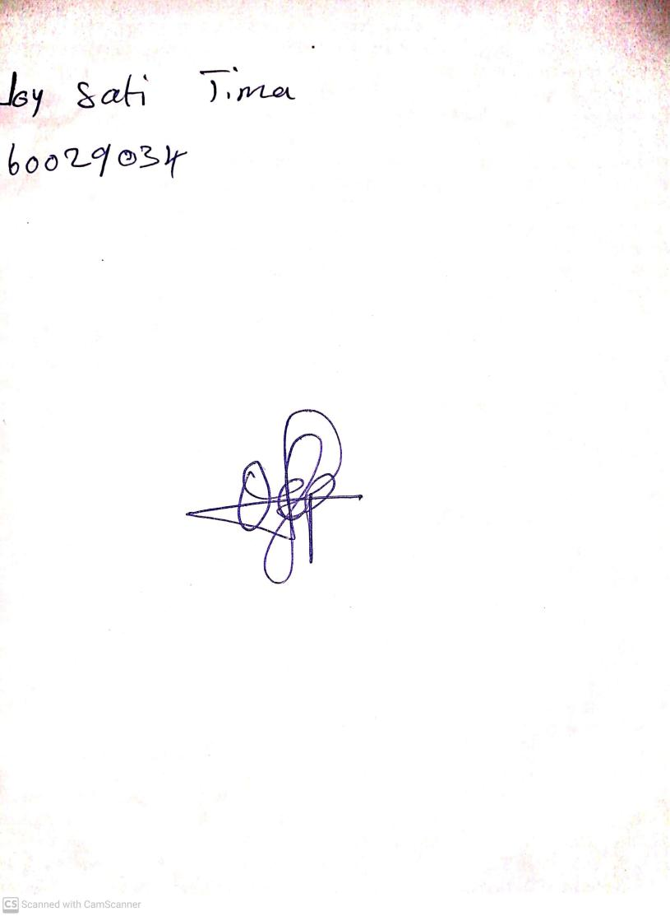

15th August, 2023

Perpetual Ojoma Ocheja

Stream Head Nursery