**LESSON PLAN AND NOTE 1 FOR WEEK 5 ENDING 24/5/2024**

**Term 3rd term**

**Week 5th week**

**Date 20/5/2024.**

**Class Nursery one**

**Subject Letter work**

**Topic Three letter words.**

**Sub-topic Fill in the missing three letter words.**

**Period 4th period**

**Time 10:40 am**

**Duration 35 minutes**

**No in class 14**

**Average Age 3 years**

**Sex Mixed**

**Specific Objectives: By the end of the lesson, the pupils should be able to:**

1. **Fill in the missing three letter words.**
2. **Re-arrange the three letter words.**

**Rationale: To ensure the pupils re-arrange & fill in the missing three letter words.**

**Previous Knowledge: The pupils can write and match three letter words.**

**Instructional Resources: Three letter words chart, Online research.**

**Reference Material: Online research, chart.**

**LESSON PRESENTATION**

|  |  |  |  |
| --- | --- | --- | --- |
| **Steps** | **Teacher’s Activities** | **Pupils’ Activities** | **Learning Points** |
| **Introduction** | **The teacher introduces the lesson by reading three letter words from three letter words chart.** | **The pupils listen to the teacher.** | **To arouse the interest of the pupils.** |
| **Step 1** | **The teacher guides the pupils to fill in the missing three letter words sit, cup, has, toy inside their notebook.**    **si ___ cu ___**  **ha ___ to __** | **The pupils fill in the missing three letter words sit, cup, has, toy inside their notebook**  **si t cu p**  **ha s to y** | **For proper understanding of the pupils.** |
| **Step 2** | **The teacher leads the pupils to re-arrange words and write them e.g**  **tis --------**  **tah --------**  **yot --------**  **tsa ---------** | **The pupils re-arrange the words and write them out**  **tis -------- sit**  **tah -------- hat**  **yot -------- toy**  **tsa --------- sat** | **For better understanding.** |
| **Summary** | **The teacher summarizes the lesson by asking the pupils to spell random three letter words.** | **The pupils respond to the teacher actively.** | **For onward study.** |
| **Evaluation** | **Question:**  **Fill in the missing three letter words**  **i ___k ta ___**  **Re-arrange words and write them e.g**  **tac --------**  **rca --------** | **The pupils answer the question correctly.** | **To ascertain the pupils’ understanding.** |
| **Conclusion** | **The teacher reacts & summarizes the lesson to the pupils.** | **The pupils gives answer to the teacher’s question.** | **To consolidate the lesson.** |
| **Assignment** | **Question:**  **Fill in the missing three letter words**  **i ___k ta ___**  **Re-arrange words and write them e.g**  **egl --------**  **naf --------** | **The pupils copy and do their homework at home.** | **To encourage learning while at home.** |

**LESSON PLAN AND NOTE 2 FOR WEEK 5 ENDING 24/5/2024**

**Term 3rd term**

**Week 5th week**

**Date 22/5/2024**

**Class Nursery one**

**Subject Letter work**

**Topic Three letter words.**

**Sub-topic Find and underline three letter words.**

**Period 4th period**

**Time 10:40 am**

**Duration 35 minutes**

**No in class 14**

**Average Age 3 years**

**Sex Mixed**

**Specific Objectives: By the end of the lesson, the pupils should be able to:**

1. **Find and underline three letter words.**
2. **Pick from a box and identify three letter words.**

**Rationale: To ensure the pupils find and underline & pick and identify three letter words from a box**

**Previous Knowledge: The pupils can re-arrange & fill in the missing three letter words.**

**Instructional Resources: Three letter words chart, Online research.**

**Reference Material: Online research, chart.**

**LESSON PRESENTATION**

|  |  |  |  |
| --- | --- | --- | --- |
| **Steps** | **Teacher’s Activities** | **Pupils’ Activities** | **Learning Points** |
| **Introduction** | **The teacher introduces the lesson by reading three letter words from three letter words chart.** | **The pupils listen to the teacher.** | **To arouse the interest of the pupils.** |
| **Step 1** | **The teacher guides the pupils to find and underline the three letter hidden words and writes them e.g**    **Scsatf -------**  **Bbath --------** | **The pupils find and underline the three letter hidden words and writes them.**  **Scsatf -------- sat**  **Bbath -------- bat** | **For proper understanding of the pupils.** |
| **Step 2** | **The teacher guides the pupils to pick from a box and identify the three letter words they see.** | **The pupils pick from a box and identify the three letter words they see.** | **For better understanding.** |
| **Summary** | **The teacher summarizes the lesson by asking the pupils to identify random three letter words.** | **The pupils respond to the teacher actively.** | **For onward study.** |
| **Evaluation** | **Question:**  **Identify (3) three letter words you know?**  **fan big**  **fat cat**  **Find and underline the three letter hidden words and write them**  **Sujugjm --------** | **The pupils answer the question correctly.** | **To ascertain the pupils’ understanding.** |
| **Conclusion** | **The teacher reacts & summarizes the lesson to the pupils.** | **The pupils gives answer to the teacher’s question.** | **To consolidate the lesson.** |
| **Assignment** | **Question:**  **Identify (3) three letter words you know?**  **mat car**  **can dog**  **Find and underline the three letter hidden words and write them**  **Sumatum --------** | **The pupils copy and do their home-work at home.** | **To encourage learning while at home.** |

**LESSON PLAN AND NOTE 3 FOR WEEK 5 ENDING 24/5/2024**

**Term 3rd term**

**Week 5th week**

**Date 24/5/2024.**

**Class Nursery one**

**Subject Letter work**

**Topic Three letter words.**

**Sub-topic Make sentences with two letter words.**

**Period 4th period**

**Time 10:40 am**

**Duration 35 minutes**

**No in class 14**

**Average Age 3 years**

**Sex Mixed**

**Specific Objectives: By the end of the lesson, the pupils should be able to:**

1. **Make sentences with three letter words.**
2. **Read sentences with three letter words.**

**Rationale: To ensure the pupils make & read sentences with three letter words.**

**Previous Knowledge: The pupils can find,underline & pick from a box three letter words.**

**Instructional Resources: Three letter words chart, Online research.**

**Reference Material: Online research, chart.**

**LESSON PRESENTATION**

|  |  |  |  |
| --- | --- | --- | --- |
| **Steps** | **Teacher’s Activities** | **Pupils’ Activities** | **Learning Points** |
| **Introduction** | **The teacher introduces the lesson by reading three letter words from three letter words chart.** | **The pupils listen to the teacher.** | **To arouse the interest of the pupils.** |
| **Step 1** | **The teacher makes sentences with three letter words for the pupils to understand e.g**  **A bus**  **A big bus**  **A fat boy** | **The pupils pays attention to the pupils.** | **For proper understanding of the pupils.** |
| **Step 2** | **The teacher guides the pupils to read sentences with three letter words.** | **The pupils reads sentences with three letter words.** | **For better understanding.** |
| **Summary** | **The teacher summarizes the lesson by naming random three letter words to the pupils.** | **The pupils understand the lesson actively.** | **For onward study.** |
| **Evaluation** | **Question:**  **Make sentences with three letter words?**  **Read the following sentences with three letter words**  **A fat pig**  **The pig is big**  **A fat hen**  **A fat red hen** | **The pupils answer the question correctly.** | **To ascertain the pupils’ understanding.** |
| **Conclusion** | **The teacher reacts & summarizes the lesson to the pupils.** | **The pupils gives answer to the teacher’s question.** | **To consolidate the lesson.** |
| **Assignment** | **Question:**  **Make sentences with three letter words?**  **Read the following sentences with three letter words**  **A cat**  **A big fat cat** | **The pupils copy and do their home-work at home.** | **To encourage learning while at home.** |

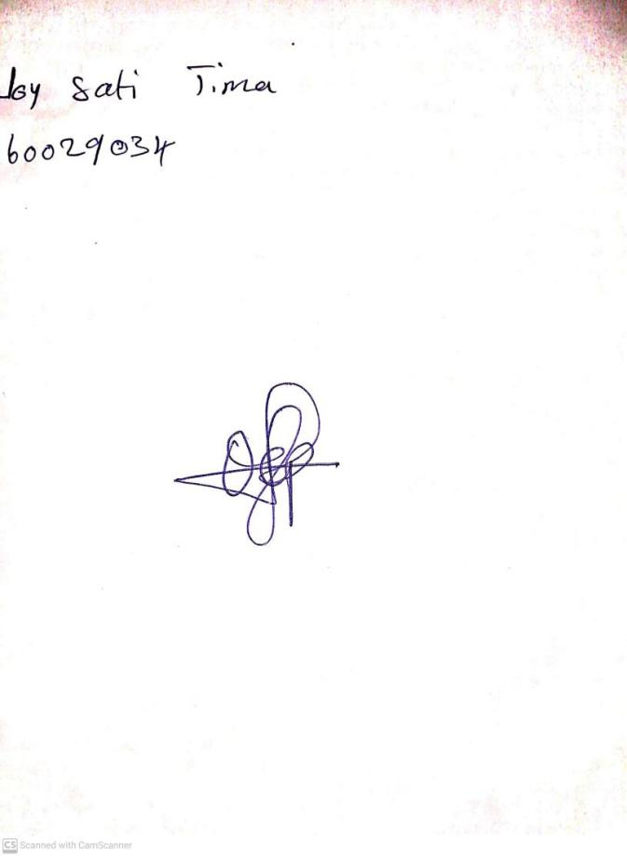

17th May, 2024

Perpetual Ojoma Ocheja

Stream Head Nursery