**EMERALD ROYAL INTERNATIONAL SCHOOL, MPAPE ABUJA**

**LESSON PLAN AND NOTE FOR WEEK 3 ENDING FRIDAY, 29TH SPTEMBER, 2023**

**TERM:** FIRST TERM

**WEEK:** WEEK 3

**SUBJECT:** ENGLISH LANGUAGE (SPEECH)

**TOPIC:** ANIMAL SOUNDS

**SUB-TOPIC:** IDENTIFYING ANIMAL SOUNDS

**DATE:** WEDNESDAY, 27TH SEPTEMBER, 2023

**TIME:** 02:00 – 02:20PM

**DURATION:** 30 MINUTES

**PERIOD:** 9TH

**CLASS:** NURSERY 3

**NUMBER IN CLASS:** ELEVEN

**AVERAGE AGE:** FIVE

**SEX:** MIXED

**LEARNING OBJECTIVES:** By the end of the lesson, the pupils should be able to

1. Identify different animals.
2. Say the sounds of the different animals.

**RATIONALE:** for pupils to learn how to make the sound of differnt animals.

**PREVIOUS KNOWLEGDE:** pupils pupils have learnt how to act out a drama in the classroom using ‘what’ question.

**INSTRUCTIONAL MATERIALS:**

1. Textbook
2. Pictorial charts of animals

**REFERENCE MATERIALS:**

1. Nigeria Primary English book 1 by B. Someye, D Dallas etal 2000

**LESSON DEVELOPMENT**

|  |  |  |  |
| --- | --- | --- | --- |
| **STAGES/STEPS** | **TEACHER’S ACTIVITIES** | **PUPILS’ ACTIVITIES** | **LEARNING POINTS** |
| **INTRODUCTION** | Review previous knowledge and place a chart of different animals for pupils to identify. | Respond to the teacher and identify the animals on the chart. | Arousing pupils’ interest |
| **PRESENTATION**  **STEP 1** | Teaches and guide pupils identify different names of animals.  **Names of animals**   1. Cow 2. Cat 3. Goat 4. Owl 5. Sheep 6. Dog 7. Cock | Learn attentively. | Identifying names of animals. |
| **STEP 2** | Teaches and guide pupils to say the sounds of different animals.  **Animals and their sounds**  Animals sounds   1. Cow mooo 2. Cat meao 3. Goat meee 4. Owl tohooo 5. Sheep baaa 6. Dog bow bow 7. Cock ko ko ro kooo | Mean animals and make their sounds. | Animals and their sounds. |
| **SUMMARY** | Summarises the lesson by emphasising on the main concept and writes note on the board. | Listen and copy their notes | For onward study |
| **EVALUATION** | Asked pupils to:   1. Mention the different animals and make their sounds. | Respond to the teacher’s questions. | Based on the stated objectives. |
| **CONCLUSION** | Summarizes, correct and mark pupils’ notebooks. | Write the note on the board and submit their notebooks for marking | Clarifying the concept. |
| **HOME-WORK** | Nigeria Primary English book 1 page 19, exercise 2. | Return their notebooks for marking. | Extending lesson home. |

**LESSON PLAN AND NOTE FOR WEEK 3 ENDING FRIDAY, 29TH SEPTEMBER, 2023**

**TERM:** FIRST TERM

**WEEK:** WEEK 3

**SUBJECT:** ENGLISH LANGUAGE (GRAMMAR)

**TOPIC:** PUNCTUATION

**SUB-TOPIC:** PUNCTUATION: QUESTION MARK

**DATE:** MONDAY, 25TH SEPTEMBER, 2023

**TIME:** 01:20AM – 02:00PM

**DURATION:** 45 MINUTES

**PERIOD:** 8TH

**CLASS:** NURSERY 3

**NUMBER IN CLASS:** ELEVEN

**AVERAGE AGE:** FIVE

**SEX:** MIXED

**LEARNING OBJECTIVES:** By the end of the lesson, the pupils should be able to:

1. Know the meaning of question mark.
2. Know the use of a question mark.

**RATIONALE:** for pupils to know the meaning and use of question mark.

**PREVIOUS KNOWLEGDE:** pupils have learnt about pronouns.

**INSTRUCTIONAL MATERIALS:**

1. Flash cards
2. Textbooks
3. Charts

**REFERENCE MATERIALS:**

1. Nigeria Primary English book 1 by B. Someye, D Dallas etal 2000

**LESSON DEVELOPMENT**

|  |  |  |  |
| --- | --- | --- | --- |
| **STAGES/STEPS** | **TEACHER’S ACTIVITIES** | **PUPILS’ ACTIVITIES** | **LEARNING POINTS** |
| **INTRODUCTION** | Preview previous knowledge. | Respond to the teacher. | Arousing pupils’ interest. |
| **PRESENTATION**  **STEP 1** | Teaches and explains the meaning of question mark.  **Meaning of question mark**  Question mark is a punctuation mark that indicate a question and it is put at the end of every sentence that ask question such as where? What? Who? Why? When? And how? when writing. | Learns attentively. | Question mark. |
| **STEP 2** | Teaches pupils the use of question.  Question mark is used to ask question and it is put at the end of every sentence that ask question.  Examples   1. How are you? 2. What is your name? 3. Where are you going? 4. Why are you crying? 5. When are you going home? | Listens attentively | Use of question mark. |
| **SUMMARY** | Summarises the lesson by emphasising on the main concept and writes note on the board. | Listen and copy their notes | For onward study |
| **EVALUATION** | Asks pupils to:   1. Give the meaning of question mark. 2. Write down three (3) sentences that ask question and add a question mark at the end. | Respond to teachers’ questions. | Based on the stated objectives. |
| **CONCLUSION** | Summarizes, corrects and marks the pupil’s notebooks. | Cope their notes and submit their notebooks for marking. | Clarifying the concept. |
| **HOME-WORK** | Nigeria Primary English book 1, page 21, exercise 2 and 3. | Return book with task for marking. | Extending lesson home. |

**LESSON PLAN AND NOTE FOR WEEK 3 ENDING FRIDAY, 29TH SEPTEMBER, 2023**

**TERM:** FIRST TERM

**WEEK:** WEEK 3

**SUBJECT:** ENGLISH LANGUAGE (COMPREHENSION)

**TOPIC:** READING

**SUB-TOPIC:** OUR HOUSE

**DATE:** THURSDAY, 19TH JANUARY, 2023

**TIME:** 09:25AM – 09:55AM AND 11:25AM – 12:00PM

**DURATION:** 45 MINUTES

**PERIOD:** 3RD AND 6TH

**CLASS:** NURSERY 3

**NUMBER IN CLASS:** ELEVEN

**AVERAGE AGE:** FIVE

**SEX:** MIXED

**LEARNING OBJECTIVES:** By the end of the lesson, the pupils should be able to

1. Concentrate fully in reading
2. Pronounce difficult words
3. Answer the questions bellow the passage

**RATIONALE:** for pupils to be fluent and improve in their reading skills and pronunciation.

**PREVIOUS KNOWLEGDE:** pupils read the passage ‘our playground’.

**INSTRUCTIONAL MATERIALS:**

1. Nigeria Primary English Book 1 by F Ademola – Adeoye, J omiteru etal 2000

**REFERENCE MATERIALS:**

1. Nigeria Primary English book 1 by B. Someye, D Dallas etal 2000

**LESSON DEVELOPMENT**

|  |  |  |  |
| --- | --- | --- | --- |
| **STAGES/STEPS** | **TEACHER’S ACTIVITIES** | **PUPILS ACTIVITIES** | **LEARNING POINT** |
| **INTRODUCTION** | Preview of previous knowledge | Respond to the teacher. |  |
| **PRSENTATION STEP I** | Leads pupils to read the passage on page 19 of their textbooks titled ‘Our house’.  Our house is built on one plot of land in Ijede, Ikorodu. It is a bungalow. In our house there are four rooms, one kitchen, one bathroom and one store…………………. | Listen and read carefully after the teacher. | Reading skill. |
| **STEP 2** | Teaches pupils to pronounce difficult words in the passage.   1. Bungalow 2. Ikorodu 3. Ijede 4. Window 5. Wardrope 6. Laptop 7. Stool 8. Posters 9. Pillow 10. furniture | Identify all difficult words in the passage. | Difficult words in the passage. |
| **STEP 3** | Leads pupils to answer the question the questions below the passage.   1. Where is our house?   Our house is in Ijede Ikorodu   1. How many rooms are in our house?   There are four rooms in our house.   1. Where is my sister’s bed?   My sister’s bed is in the middle of the room.   1. Which room is the largest?   The living room is the largest. | Answer the questions orally. | Answering the questions from the passage. |
| **SUMMARY** | Summarises the lesson by emphasising on the main concept and writes note on the board. | Listen and copy their notes. | For onward study. |
| **EVALUATION** | Ask pupils to:  1. read the passage.  2. mention the difficult words.  3. answer the question from the passage. | Respond to the teacher’s questions. | Based on stated objectives. |
| **CONCLUSION** | Summaries, corrects and marks pupils’ notebooks. | Copy the note on the board and submit their notebooks for marking. | Clarifying the concept. |
| **HOME WORK** | Nigeria Primary English book 1, page 20, exercise 1. | Return book with task for marking. | Extending lesson home. |

**LESSON PLAN AND NOTE FOR WEEK 3 ENDING FRIDAY, 29TH SEPTEMBER, 2023**

**TERM:** FIRST TERM

**WEEK:** WEEK 3

**SUBJECT:** ENGLISH LANGUAGE (COMPOSITION)

**TOPIC:** COMPOSITION

**SUB-TOPIC:** MY MOTHER

**DATE:** THURSDAY, 28TH SEPTEMBER, 2023

**TIME:** 01:20 – 11:50AM

**DURATION:** 45 MINUTES

**PERIOD:** 5TH

**CLASS:** NURSERY 3

**NUMBER IN CLASS:** ELEVEN

**AVERAGE AGE:** FIVE

**SEX:** MIXED

**LEARNING OBJECTIVES:** By the end of the lesson, the pupils should be able to:

1. Say something about theirs mother.
2. Write about my mother.

**RATIONALE:** for pupils to learn how to write about their mother.

**PREVIOUS KNOWLEGDE:** pupils have learnt how to write about themselves.

**INSTRUCTIONAL MATERIALS:**

1. A book
2. Pencil
3. Text book – Nigeria Primary English book 1 – Fourth Edition

**REFERENCE MATERIALS:**

1. Nigeria Primary English book 1 by B. Someye, D Dallas etal 2000

**LESSON DEVELOPMENT**

|  |  |  |  |
| --- | --- | --- | --- |
| **STAGES /STEPS** | **TEACHER’S ACTIVITIES** | **PUPILS’ ACTIVITIES** | **LEARNING POINT** |
| **INTRODUCTION** | Preview previous knowledge | Respond to the teacher. | Arousing interest. |
| **PRESENTATION**  **STEP 1** | Leads pupils to talk about their mother. | Discuss about first day at school. | Discussing first day at school. |
| **STEP 2** | Leads pupils to write about their mother.  **My mother**   1. My mother’s name is ___________ 2. My mother is very beautiful 3. She is ________ years old. 4. She is a __________ 5. She works at ________ 6. She goes to work every morning by ____ 7. She returns at______ 8. My mother always help me with my _____ | Write about their mother. | Write about their mother |
| **SUMMARY** | Summarises the lesson by emphasising on the main concept and writes note on the board. | Listen and copy their notes | For onward study |
| **EVALUATION** | Ask pupils to:  1. Say something about their mother.  2. write about their mother | Respond to the teacher’s questions. | Based on the stated objectives. |
| **CONCLUSION** | Summarizes, corrects and mark the pupils’ notebook. | Copy the note on the board and submit for marking. | Clarifying the concept. |
| **HOME-WORK** | 1. Nigeria Primary English book 1, page 22. | Return home with task. | Extending lesson home. |

**LESSON PLAN AND NOTE FOR WEEK 3 ENDING FRIDAY, 29TH SEPTEMBER, 2023**

**TERM:** FIRST TERM

**WEEK:** WEEK 3

**SUBJECT:** ENGLISH LANGUAGE (PHONICS)

**TOPIC:** SOUND BANK

**SUB-TOPIC:** SOUND BANK /ɒ/ and /Ɔ:/

**DATE:** TUESDAY26TH SEPTEMBER, 2023

**TIME:** 10:30 – 11:10PM

**DURATION:** 40 MINUTES

**PERIOD:** 4TH

**CLASS:** GRADE 1

**NUMBER IN CLASS:** EIGHTEEN

**AVERAGE AGE:** FIVE

**SEX:** MIXED

**LEARNING OBJECTIVES:** By the end of the lesson, the pupils should be able to:

1. Identify sound /ɒ/ and /Ɔ:/
2. Pronounce the sounds /ɒ/ and /Ɔ:/
3. State and write words with the sounds /ɒ/ and /Ɔ:/

**RATIONALE:** for pupils to learns to transcribe words and letters in their exercises.

**PREVIOUS KNOWLEGDE:** pupils learnt about the sounds /æ/ and /a:/

**INSTRUCTIONAL MATERIALS:**

1. Flash cards
2. pictorial chars

**REFERENCE MATERIALS:**

1. Nigeria Primary English book 1 by B. Someye, D Dallas etal 2000

**LESSON DEVELOPMENT**

|  |  |  |  |
| --- | --- | --- | --- |
| **STAGES/STEPS** | **TEACHER’S ACTIVITIES** | **PUPILS ACTIVITIES** | **LEARNING POINTS** |
| **INTRODUCTION** | Review previous knowledge. | Respond to the teacher. | Arousing interest. |
| **PRESENTATION**  **STEP 1** | Leads pupils to identify the sounds //ɒ/ and /Ɔ:/   |  | | --- | | /ɒ/ |  |  | | --- | | /Ɔ:/ | | Identifies sounds /ɒ/ and /Ɔ:/ | Identifying the sounds /ɒ/ and /Ɔ:/. |
| **STEP 2** | Teaches pupils to pronounce sounds /ɒ/ and /Ɔ:/ | Pronounce sounds /ɒ/ and /Ɔ:/ | Pronouncing sounds /ɒ/ and /Ɔ:/. |
| **STEP 3** | Teaches and highlight words with the sounds /ɒ/ and /Ɔ:/  Words with the sound /ɒ/   1. Hot 2. Cot 3. Long 4. Shop 5. Stop 6. Box     Words with the sound /Ɔ:/ 1. What  2. Watch  3. Was  4. Force  5. Small  6. Draw | Identifies, learn and write words with the sounds /ɒ/ and /Ɔ:/. | Words with sounds /ɒ/ and /Ɔ:/. |
| **SUMMARY** | Summarises the lesson by emphasising on the main concept and writes note on the board. | Listen and copy their notes | For onward study |
| **EVALUATION** | Ask pupils to:   1. Identify /ɒ/ and /Ɔ:/ 2. Pronounce sounds /ɒ/ and /Ɔ:/ 3. Pronounce and underline sounds /ɒ/ and /Ɔ:/ in the following words.   /ɒ/ /Ɔ:/   1. Not talk 2. Pot corn 3. Stop saw | Respond to the teacher’s questions. | Based on the stated objectives. |
| **CONCLUSION** | Summarizes, corrects and mark the pupils’ notebook. | Copy the note on the board and submit for marking. | Clarifying the concept. |
| **HOMEWORK** | Nigeria Primary English book 1, page 17. | Return home with task. | Extending lesson home. |

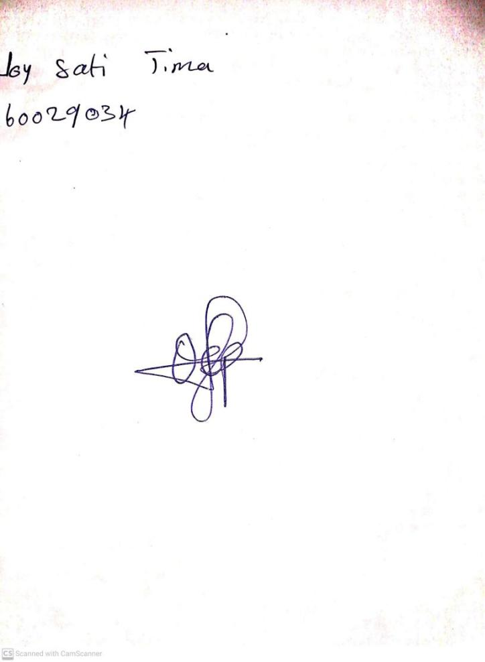

22ND September, 2023

Perpetual Ojoma Ocheja

Stream Head Nursery