EMERALD ROYAL INTERNATIONAL SCHOOL

MPAPE, ABUJA.

LESSON PLAN AND NOTE FOR WEEK 5 ENDING 12TH OCTOBER,2023

TERM: First term.

WEEK: Five

SUBJECT: Nature studies.

TOPIC: Uses of Sense organs.

SUB-TOPIC: Functions of the sense organs. Example .eyes and ear.

DATE: 8/10/2023

DURATION: 40 minutes

TIME: 08:50-09:30

PERIOD: 3rd

CLASS: Pre-nursery

NUMBER OF PUPILS: 11

AVERAGE AGE: 2 years

SEX: Mixed

SPECIFIC OBJECTIVES: By the end of the lesson, the pupils should be able to:-

I Identify the five sense organs.

2. State the uses of eyes and ear.

RATIONALE: For Pupils to mention the Uses of their sense organs.

PREVIOUS KNOWLEDGE: Pupils have been taught the parts of the body.

INSTRUCTIONAL MATERIALS: Charts video clips.

REFERENCE: Showers kiddies books Elementary science book nursery 1 by Showers kiddies books.

LESSON DEVELOPMENT

|  |  |  |  |
| --- | --- | --- | --- |
| Stages/steps | Teacher's activities | Pupils' activities | Learning points |
| Introduction | Teacher introduces the lesson by singing a nursery rhymes:-  Oh be careful little eyes what you see  What you see------------------------------ | Pupils sing the song along with the teacher. | To arouse the interest of the pupils. |
| Presentation  Step 1 | Teacher leads the pupils to identify the five (5) sense organs mentioned in the last lesson on the body parts. | Pupils identify the five (5) Sense organs on their body by touching them and saying:-  This is my eye.  This is my ear.  This is my skin.  This is my tongue.  This is my nose. | For better understanding of the lesson. |
| Step 2 | Teacher leads the pupils to state the functions of the eye and ear as a sense organs. | Pupils state the functions of the eye and ear.  --- The eye is for seeing.  --- The ear is for hearing. | For better understanding of the lesson. |
| Summary | Teacher summarizes the lesson by going over the lesson again for more understanding of the lesson by identifying the sense organs again in the body and the uses of some of them.  Eye is for seeing.  Ear is for hearing.  Tongue  Skin  Nose. | Pupils listen attentively to the teacher as she is going over the lesson again. | To ensure better understanding. |
| Evaluation | Teacher asks the Pupils to identify the followings in their body parts-:  1. Identify the eyes,  2. Identify the ear,  3. Identify the nose, skin and  4. Identify the tongue. | Pupils answer the teacher's questions correctly. | To ascertain the level of pupils understanding of the lesson. |
| Conclusion | Teacher concludes the lesson by correcting pupils who was unable to identify. | Pupils take note of the corrections. | For onwards learning. |
| Assignment | Teacher asks the pupils to answer the these questions at home.  I see with my--------------(eyes,legs)  I hear with my------------(nose,ear) | Pupils do the assignment at home. | To encourage Learning at home. |

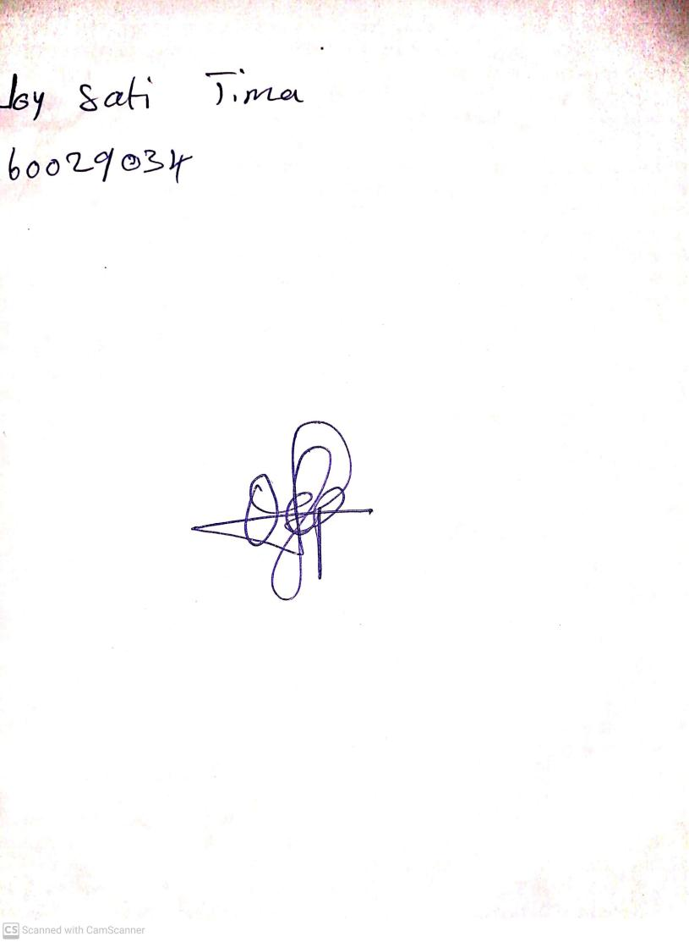

20th August, 2023

Perpetual Ojoma Ocheja

Stream Head Nursery