LESSON PLAN AND NOTE FOR WEEK 5 ENDING 02/06/2023

TERM: 3rd

WEEK: 5th

DATE: 29/05/2023

CLASS: Nursery 2

SUBJECT: Nature studies

TOPIC: Water: Methods of water purification

SUB—TOPIC: Meaning of water and ways of making water clean for drinking.

PERIOD: 4th

TIME: 10:40—11:20am

DURATION: 40 minutes

NUMBER IN CLASS: 14

AVERAGE AGE: 5 years

SEX: Mixed

LEARNING OBJECTIVES: By the end of the lesson, the pupils should be able to:

1. Define water.

2. Mention the ways of making water clean for drinking.

RATIONALE: For pupils to know how to make water clean for drinking.

PREVIOUS KNOWLEDGE:Pupils have been drinking water on daily bases.

INSTRUCTIONAL MATERIALS: Water, alum and filter.

REFERENCE MATERIALS: Basic science and technology for Nursery schools book 3 by OPEMIPO DADA.

LESSON DEVELOPMENT

|  |  |  |  |
| --- | --- | --- | --- |
| Steps | Teacher's activities | Pupils' activities | Learning point |
| Introduction | Teacher introduces the lesson by asking pupils if it is good to drink dirty water? | Pupils answer the question asked by the teacher. | To prepare pupils minds for the lesson ahead. |
| Presentation step 1 | Teacher defines water and asks pupils to repeat after her. | Pupils listen to the teacher and repeat after her. | To improve pupils listening and speaking ability. |
| Step 2 | Teacher mentions the ways of making water clean for drinking and also asks pupils to repeat after her. | Pupils pay attention to the teacher and repeat after the teacher. | To enhance pupils participation in the class. |
| Board summary | Teacher writes the whole note of lesson on the board for pupils to copy into their books.  WATER  Water is a liquid substance that is colourless, odourless and tasteless.  WHY WE SHOULD MAKE WATER CLEAN BEFORE DRINKING  Drinking dirty water can make us sick.  This is why we should make water clean before drinking it.  There are simple ways of making water in the home clean for drinking. These are:  1. Adding alum to water.  2. Boiling water.  3. Filtering water. | Pupils copy the note into their exercise books. | To build pupils writing ability. |
| Evaluation | Teacher evaluates the lesson by asking pupils the following questions;  1. Water is water?  2. Mention 3 ways of making water clean for drinking. | Pupils answer the questions ask by the teacher. | To assess pupils level of understanding. |
| Conclusion | Teacher concludes the lesson by marking pupils books. | Pupils submit their books for marking. | For endorsement. |
| Assignment | Activity 19 page 64. Basic science textbook. | Pupils do their assignment at home. | To encourage learning at home. |

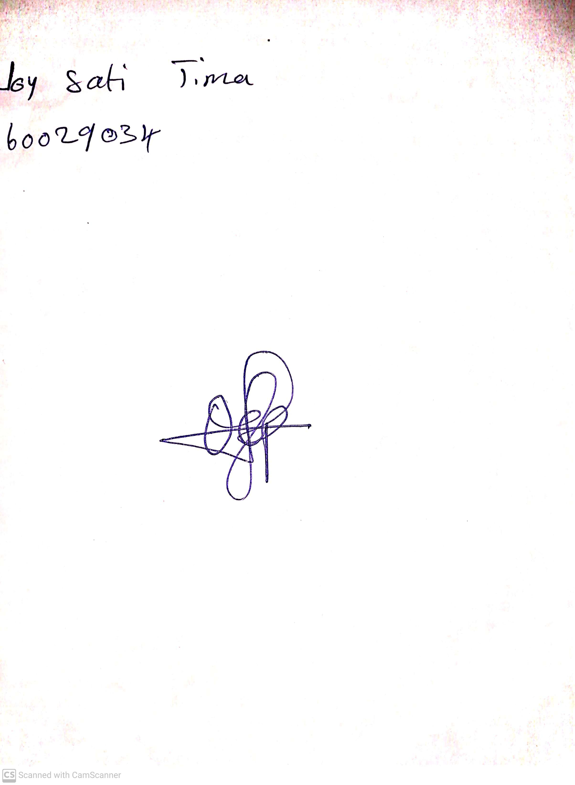

28th April, 2023

Perpetual Ojoma

Stream Head Nursery