**EMERALD ROYAL INTERNATIONAL SCHOOL**

**MPAPE, ABUJA.**

**LESSON PLAN AND NOTE FOR WEEK 8 PERIOD 1 ENDING 01/11/2024**

**TERM: FIRST**

**WEEK: 8TH**

**DATE: 28/10/2024**

**CLASS: NURSERY 2**

**SUBJECT: NUMBER WORK**

**TOPIC: ROMAN NUMERALS i - x .**

**SUB-TOPIC: NUMBERS IN ROMAN NUMERALS 1-5**

**PERIOD: 1ST.**

**TIME: O8:50-09:30.**

**DURATION: 40 MINUTES.**

**NUMBER IN CLASS: 14**

**AVERAGE AGE: 5 YEARS.**

**SEX: MIXED.**

**SPECIFIC OBJECTIVES: BY THE END OF THE LESSON,THE PUPILS SHOULD BE ABLE TO:**

1. **RECITE NUMBERS IN ROMAN NUMERALS i-v.**
2. **IDENTIFY NUMBERS IN ROMAN NUMERALS i - v.**

**RATIONALE: FOR PUPILS TO KNOW NUMBERS IN ROMANCE NUMERALS I - v**

**PREVIOU KNOWLEDGE: PUPILS HAVE LEARNT VARIOUS SHAPES IN PREVIOUS LESSON.**

**INSTRUCTIONAL MATERIALS: A CHART OF NUMBERS IN ROMAN NUMERALS 1-5.**

**REFERENCE MATERIALS: THE NEW MASTERING MATHEMATICS FOR NURSERY SCHOOLS BOOK 3 BY HENRY.Z.IDOGUN.**

**LESSON DEVELOPMENT**

|  |  |  |  |
| --- | --- | --- | --- |
| **STAGES/STEPS** | **TEACHER’S ACTIVITIES** | **PUPILS’ ACTIVITIES** | **LEARNING POINTS** |
| **INTRODUCTION** | **Teacher introduces the lesson by singing a number rhyme for the pupils.** | **Pupils sing the rhyme along with the teacher.** | **To arouse pupils interest in the lesson.** |
| **PRESENTATION**  **STEP 1** | **Teacher recites numbers in Roman numerals 1-5 and then asks pupils to repeat after her.** | **Pupils pay attention to the teacher and repeat after her.** | **To enhance pupils speaking ability .** |
| **STEP 2** | **Teacher writes numbers in Roman numerals 1-5 on the board and then identify and asks pupils to repeat after her. As;**  **i - 1**  **ii -2**  **iii -3**  **iv - 4**  **V -5** | **Pupils identify the numbers in Roman numerals 1-5 on the board after the teacher.** | **For better understanding of the lesson.** |
| **BOARD SUMMARY** | **Teacher summarizes the lesson by preparing pupils books for them to copy the note on the board into their exercise books.** | **Pupils copy the note into their books. As;**  **NUMBERS IN ROMAN NUMERALS i - v.**  **i - 1**  **ii - 2**  **iii - 3**  **iv - 4**  **V - 5** | **To build pupils writing skills.** |
| **EVALUATION** | **Teacher asks Pupils to**   1. **Recite numbers in Roman numerals i–v on the board.** 2. **Read numbers in Roman numerals i–v one after another.** | **Pupils read the numbers in Roman numerals on the board one after another.** | **To assess pupis level of understanding.** |
| **CONCLUSION** | **Teacher ends the lesson by marking pupils books.** | **Pupils submit their books for marking.** | **For endorsement.** |
| **ASSIGNMENT (HOME WORK)** | **Identify and match the letter with numbers in Roman numerals 1-5**  **iii 4**  **i 3**  **V 1**  **ii 5**  **iv 2** | **Pupils do their assignment at home.** | **To encourage learning at home.** |

**LESSON PLAN AND NOTE FOR WEEK 8 PERIOD 2 ENDING 01/11/2024**

**TERM: FIRST**

**WEEK: 8TH**

**DATE: 29/10/2024**

**CLASS: NURSERY 2**

**SUBJECT: NUMBER WORK**

**TOPIC: ROMAN NUMERALS i - x .**

**SUB-TOPIC: ROMAN NUMERALS vi - x**

**PERIOD: 2ND.**

**TIME: O8:50-09:30.**

**DURATION: 40 MINUTES.**

**NUMBER IN CLASS: 14**

**AVERAGE AGE: 5 YEARS.**

**SEX: MIXED.**

**SPECIFIC OBJECTIVES: BY THE END OF THE LESSON,THE PUPILS SHOULD BE ABLE TO:**

**1.RECITE NUMBERS IN ROMAN NUMERALS VI -X**

**2. IDENTIFY NUMBERS IN ROMAN NUMERALS VI -X**

**RATIONALE: FOR PUPILS TO KNOW NUMBERS 6-10 IN ROMAN NUMERALS**

**PREVIOU KNOWLEDGE: PUPILS HAVE LEARNT NUMBERS IN ROMAN NUMERALS 1-5 IN PREVIOUS LESSON**

**INSTRUCTIONAL MATERIALS: CHART OF NUMBERS IN ROMAN NUMERALS 6-10.**

**REFERENCE MATERIALS: THE NEW MASTERING MATHEMATICS FOR NURSERY SCHOOLS BOOK 3 BY HENRY.Z.IDOGUN.**

**LESSON DEVELOPMENT**

|  |  |  |  |
| --- | --- | --- | --- |
| **STAGES/STEPS** | **TEACHER’S ACTIVITIES** | **PUPILS’ ACTIVITIES** | **LEARNING POINTS** |
| **INTRODUCTION** | **Teacher introduces the lesson by reviewing the previous lesson.** | **Pupil listen to the teacher.** | **To arouse pupils interest for the lesson ahead.** |
| **PRESENTATION**  **STEP 1** | **Teacher recites numbers in Roman numerals vi -x and then asks pupils to repeat after her.** | **Pupils recite numbers in Roman numerals vi -x after the teacher.** | **For proper understanding of the lesson .** |
| **STEP 2** | **Teacher then writes numbers in Roman numerals vi -x on the board for pupils to identify after her. as,**  **NUMBERS IN ROMAN NUMERALS VI -X**  **VI - 6**  **Vii - 7**  **Viii - 8**  **Ix - 9**  **X - 10** | **Pupils identify the numbers in Roman numerals vi -x on the board after the teacher.** | **For better understanding of the lesson.** |
| **BOARD SUMMARY** | **Teacher summarizes the lesson by going through the lesson on the board over and over again and then prepares pupils books for them to copy.** | **Pupils pay attention to the teacher as she summarizes the lesson and then copy their note.** | **For onward study** |
| **EVALUATION** | **Teacher asks Pupils to all stand and**   1. **sing numbers in Roman numerals vi -x from the board.** 2. **Recite numbers in Roman numerals vi –x off hand.** | **Pupils stand and sing numbers in Roman numerals vi -x all together.** | **To assess pupils understanding of the lesson.** |
| **CONCLUSION** | **Teacher marks pupils books.** | **Pupils submit their books for marking.** | **For endorsement.** |
| **ASSIGNMENT** | **Recite and write numbers in Roman numerals vi -x.** | **Pupils do their assignment at home.** | **To encourage learning at home.** |

**LESSON PLAN AND NOTE FOR WEEK 8 PERIOD 3 ENDING 01/11/2024**

**TERM: FIRST**

**WEEK: 8TH**

**DATE: 01/11/2024**

**CLASS: NURSERY 2**

**SUBJECT: NUMBER WORK**

**TOPIC: ROMAN NUMERALS I-X .**

**SUB-TOPIC: NUMBERS IN ROMAN NUMERALS I-X**

**PERIOD: 3RD.**

**TIME: O8:1O- 08:50.**

**DURATION: 40 MINUTES.**

**NUMBER IN CLASS: 14**

**AVERAGE AGE: 5 YEARS.**

**SEX: MIXED.**

**SPECIFIC OBJECTIVES: BY THE END OF THE LESSON,THE PUPILS SHOULD BE ABLE TO:**

1. **RECITE NUMBERS IN ROMAN NUMERALS I-X**
2. **WRITE NUMBERS IN ROMAN NUMERALS I-X**

**RATIONALE: FOR PUPILS TO BE ABLE TO RECITEAND WRITE NUMBERS IN ROMAN NUMERALS I-X ON THEIR OWN**

**PREVIOU KNOWLEDGE: PUPILS HAVE LEARNT NUMBERS IN ROMAN NUMERALS VI -X IN PREVIOUS LESSON.**

**INSTRUCTIONAL MATERIALS: A CHART OF NUMBERS IN ROMAN NUMERALS I-X**

**REFERENCE MATERIALS: THE NEW MASTERING MATHEMATICS FOR NURSERY SCHOOLS BOOK 3 BY HENRY.Z.IDOGUN.**

**LESSON DEVELOPMENT**

|  |  |  |  |
| --- | --- | --- | --- |
| **STAGES/STEPS** | **TEACHER’S ACTIVITIES** | **PUPILS’ ACTIVITIES** | **LEARNING POINTS** |
| **INTRODUCTION** | **Teacher introduces the lesson by reviewing the previous lesson.** | **Pupil listen to the teacher.** | **To arouse pupils interest for the lesson ahead.** |
| **PRESENTATION**  **STEP 1** | **Teacher recites numbers in Roman numerals I-x and then asks pupils to repeat after her.** | **Pupils pay attention and recite numbers in Roman numerals I-x after the teacher.** | **For proper understanding of the lesson .** |
| **STEP 2** | **Teacher prepares pupils books for them to recite and write numbers in Roman numerals I-x from their head.** | **Pupils recite and write numbers in Roman numerals I-x on their own.** | **To test pupils ability of the topic treated so far.** |
| **BOARD SUMMARY** | **Teacher summarizes the lesson by writing the whole note of lesson on the board for pupils to copy. As;**  **NUMBERS IN ROMAN NUMERALS I-X**  **i - 1**  **ii - 2**  **iii - 3**  **iv - 4**  **V - 5**  **VI - 6**  **Vii - 7**  **Viii - 8**  **Ix - 9**  **X - 10** | **Pupils copy the note into their exercise books.** | **For onward study.** |
| **EVALUATION** | **Teacher asks pupils to:**   1. **Recite numbers in Roman numerals i–x on the board.** 2. **Back the board and sing numbers in Roman numerals i–x off hand.** | **Pupils recite numbers in Roman numerals I-x .** | **To crate platform for slow learners.** |
| **CONCLUSION** | **Teacher marks pupils books.** | **Pupils submit their books for marking.** | **For endorsement.** |
| **ASSIGNMENT** | **Identify,sing and re-write numbers in Roman numerals I- xx**  **I - 1**  **----------------**  **Ii -2**  **----------------**  **Iii -3**  **-----------------**  **Iv - 4**  **-----------------**  **V -5**  **-----------------**  **Vi -6**  **-----------------**  **Vii -7**  **-----------------**  **Viii -8**  **----------------**  **Ix -9**  **----------------**  **X -10**  **----------------**  **Xi - 11**  **----------------**  **Xii -12**  **----------------**  **Xiii -13**  **----------------**  **Xiv - 14**  **----------------**  **Xv - 15**  **---------------**  **Xvi - 16**  **-----------------**  **X vii - 17**  **-----------------**  **X viii - 18**  **-----------------**  **Xix - 19**  **-----------------**  **Xx - 20**  **-----------------** | **Pupils do their assignment at home.** | **To encourage learning at home.** |

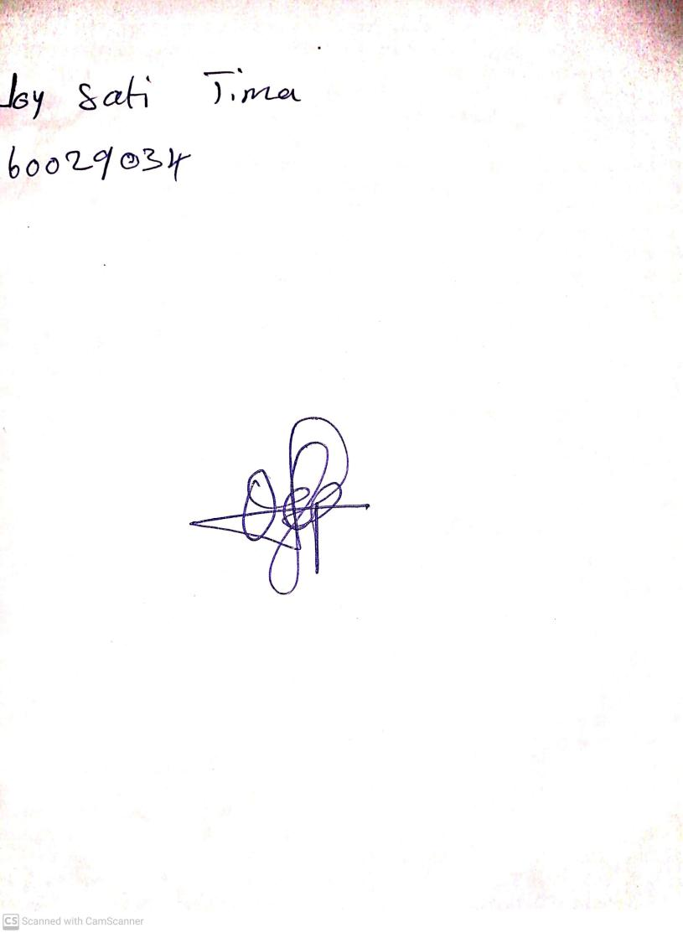

**18th OctoSber, 2024**

**Perpetual Ojoma Ocheja**

**Stream Head Nursery**