EMERALD ROYAL INTERNATIONAL SCHOOL MPAPE, ABUJA

LESSON PLAN AND NOTE FOR WEEK 10 PERIOD 1 ENDING 17/11/2023

TERM: FIRST

WEEK: 10TH

DATE: 03/11/2023

CLASS: NURSERY 2

SUBJECT: NUMBER WORK

TOPIC: MULTIPLICATION TABLE 2

SUB-TOPIC: MULTIPLICATION TABLE 2 FROM 1-4

PERIOD: 2ND

TIME: 08: 50-09: 30 am

DURATION: 40 MINUTES

NUMBER IN CLASS: 16

AVERAGE AGE: 4

SEX: MIXED

SPECIFIC OBJECTIVES: BY THE END OF THE LESSON, THE PUPILS SHOULD BE ABLE

TO:

1. RECITE MULTIPLICATION TABLE 2 FROM 1-4
2. WRITE MULTIPLICATION TABLE 2 FROM 1-4

RATIONALE: FOR PUPILS TO KNOW HOW TO RECITE MULTIPLICATION TABLE 2.

PREVIOUS KNOWLEDGE: PUPILS HAVE LEARNT MOULDING OF NUMBERS 1-30 IN PREVIOUS LESSON.

INSTRUCTIONAL MATERIALS: A CHART OF MULTIPLICATION TABLE 2.

REFERENCE MATERIALS: MY CHOICE OF MATHEMATICS STAGE 3 BY TOP STAR.

LESSON DEVELOPMENT

|  |  |  |  |
| --- | --- | --- | --- |
| STAGES/STEPS | TEACHER’S ACTIVITIES | PUPILS’ ACTIVITIES | LEARNING POINT |
| INTODUCTION | Teacher introduces the lesson by reviewing the previous lesson. | Pupils listen attentively to the teacher. | To arouse pupils interest for the lesson ahead. |
| PRESENTATION STEP 1 | Teacher writes multiplication table 2 from 1-4 on the board, and then recites and then asks pupils to repeat after her. | Pupils pay attention to the teacher and repeat after her. | For proper understanding. |
| STEP 2 | Teacher then wipes the board and then asks pupils to sing and write multiplication table 2 from 1-4 on the board one after another. | Pupils sing and write multiplication table 2 from 1-4 on the board one after another. | To create platform for slow learners. |
| BOARD SUMMARY | Teacher summarizes the lesson by writing the whole note of lesson on the board for pupils to copy into their books. That is;  MULPIPLICATION TABLE 2 FROM 1-4  2 X 1 = 2  2 X 2 = 4  2 X 3 = 6  2 X 4 = 8 | Pupils copy the note on the board into their exercise books. | For onward study. |
| EVALUATION | Teacher evaluates the lesson by asking the following questions:   1. Recite multiplication table 2 from 1-4 all together. 2. Recite multiplication table 2 from 1-4 one after the other. | Pupils answer the questions asked by the teacher. | To asses pupils level of understanding of the lesson. |
| CONCLUSION | Teacher concludes the lesson by marking pupils books. | Pupils submit their books for marking. | For endorsement. |
| ASSIGNMENT | Sing and write multiplication table 2 from 1-8 | Pupils do their assignment at home. | To encourage learning at home. |

LESSON PLAN AND NOTE FOR WEEK 10 PERIOD 2 ENDING 17/11/2023

TERM: FIRST

WEEK: 10TH

DATE: 14/11/2023

CLASS: NURSERY 2

SUBJECT: NUMBER WORK

TOPIC: MULTIPLICATION TABLE 2

SUB-TOPIC: MULTIPLICATION TABLE 2 FROM 5-8

PERIOD: 2ND

TIME: 08: 50-09: 30 am

DURATION: 40 MINUTES

NUMBER IN CLASS: 16

AVERAGE AGE: 4

SEX: MIXED

SPECIFIC OBJECTIVES: BY THE END OF THE LESSON, THE PUPILS SHOULD BE ABLE

TO:

1. RECITE MULTIPLICATION TABLE 2 FROM 5-8
2. WRITE MULTIPLICATION TABLE 2 FROM 5-8

RATIONALE: FOR PUPILS TO KNOW HOW TO RECITE MULTIPLICATION TABLE 2.

PREVIOUS KNOWLEDGE: PUPILS HAVE LEARNT MULTIPLICATION TABLE 2 FROM 1-4 IN PREVIOUS LESSON.

INSTRUCTIONAL MATERIALS: A CHART OF MULTIPLICATION TABLE 2.

REFERENCE MATERIALS: MY CHOICE OF MATHEMATICS STAGE 3 BY TOP STAR.

LESSON DEVELOPMENT

|  |  |  |  |
| --- | --- | --- | --- |
| STAGES/STEPS | TEACHER’S ACTIVITIES | PUPILS’ ACTIVITIES | LEARNING POINT |
| INTODUCTION | Teacher introduces the lesson by reviewing the previous lesson. | Pupils listen attentively to the teacher. | To arouse pupils interest for the lesson ahead. |
| PRESENTATION STEP 1 | Teacher writes multiplication table 2 from 5-8 on the board, and then recites and then asks pupils to repeat after her. | Pupils pay attention to the teacher and repeat after her. | For proper understanding. |
| STEP 2 | Teacher then wipes the board and then asks pupils to sing and write multiplication table 2 from 5-8 on the board one after another. | Pupils sing and write multiplication table 2 from 5-8 on the board one after another. | To create platform for slow learners. |
| BOARD SUMMARY | Teacher summarizes the lesson by writing the whole note of lesson on the board for pupils to copy into their books. That is;  MULPIPLICATION TABLE 2 FROM 5-8  2 X 5 = 10  2 X 6 = 12  2 X 7 = 14  2 X 8 = 16 | Pupils copy the note on the board into their exercise books. | For onward study. |
| EVALUATION | Teacher evaluates the lesson by asking the following questions:   1. Recite multiplication table 2 from 5-8 all together. 2. Recite multiplication table 2 from 5-8 one after the other. | Pupils answer the questions asked by the teacher. | To asses pupils level of understanding of the lesson. |
| CONCLUSION | Teacher concludes the lesson by marking pupils books. | Pupils submit their books for marking. | For endorsement. |
| ASSIGNMENT | Sing and write multiplication table 2 from 9-12 | Pupils do their assignment at home. | To encourage learning at home. |

LESSON PLAN AND NOTE FOR WEEK 10 PERIOD 3 ENDING 17/11/2023

TERM: FIRST

WEEK: 10TH

DATE: 17/11/2023

CLASS: NURSERY 2

SUBJECT: NUMBER WORK

TOPIC: MULTIPLICATION TABLE 2

SUB-TOPIC: MULTIPLICATION TABLE 2 FROM 9-12

PERIOD: 1ST

TIME: 08: 10-08: 50 am

DURATION: 40 MINUTES

NUMBER IN CLASS: 16

AVERAGE AGE: 4

SEX: MIXED

SPECIFIC OBJECTIVES: BY THE END OF THE LESSON, THE PUPILS SHOULD BE ABLE

TO:

1. RECITE MULTIPLICATION TABLE 2 FROM 9-12
2. WRITE MULTIPLICATION TABLE 2 FROM 9-12

RATIONALE: FOR PUPILS TO KNOW HOW TO RECITE MULTIPLICATION TABLE 2.

PREVIOUS KNOWLEDGE: PUPILS HAVE LEARNT MULTIPLICATION TABLE 2 FROM 5-8 IN PREVIOUS LESSON.

INSTRUCTIONAL MATERIALS: A CHART OF MULTIPLICATION TABLE 2.

REFERENCE MATERIALS: MY CHOICE OF MATHEMATICS STAGE 3 BY TOP STAR.

LESSON DEVELOPMENT

|  |  |  |  |
| --- | --- | --- | --- |
| STAGES/STEPS | TEACHER’S ACTIVITIES | PUPILS’ ACTIVITIES | LEARNING POINT |
| INTODUCTION | Teacher introduces the lesson by reviewing the previous lesson. | Pupils listen attentively to the teacher. | To arouse pupils interest for the lesson ahead. |
| PRESENTATION STEP 1 | Teacher writes multiplication table 2 from 9-12 on the board, and then recites and then asks pupils to repeat after her. | Pupils pay attention to the teacher and repeat after her. | For proper understanding. |
| STEP 2 | Teacher then wipes the board and then asks pupils to sing and write multiplication table 2 from 9-12 on the board one after another. | Pupils sing and write multiplication table 2 from 9-12 on the board one after another. | To create platform for slow learners. |
| BOARD SUMMARY | Teacher summarizes the lesson by writing the whole note of lesson on the board for pupils to copy into their books. That is;  MULPIPLICATION TABLE 2 FROM 9-12  2 X 9 = 18  2 X 10 = 20  2 X 11 = 22  2 X 12 = 24 | Pupils copy the note on the board into their exercise books. | For onward study. |
| EVALUATION | Teacher evaluates the lesson by asking the following questions:   1. Recite multiplication table 2 from 9-12 all together. 2. Recite multiplication table 2 from 9-12 one after the other. | Pupils answer the questions asked by the teacher. | To asses pupils level of understanding of the lesson. |
| CONCLUSION | Teacher concludes the lesson by marking pupils books. | Pupils submit their books for marking. | For endorsement. |
| ASSIGNMENT | Sing and write multiplication table 2 from 1-12. | Pupils do their assignment at home. | To encourage learning at home. |

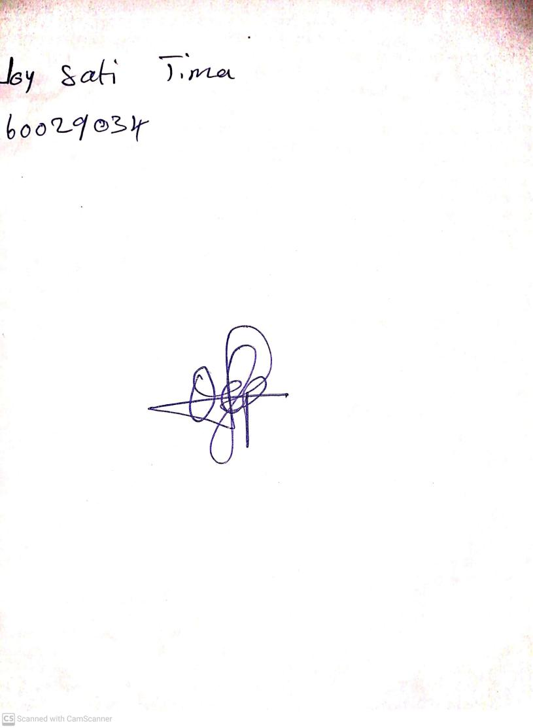

10TH November, 2023

Perpetual Ojoma Ocheja

Stream Head Nursery