**EMERALD ROYAL INTERNATIONAL SCHOOL,**

**MPAPE ABUJA**

**NURSERY 2 SCHEME OF WORK ON SOCIAL NORMS THIRD TERM**

|  |  |
| --- | --- |
| **WEEKS** | **TOPICS** |
| 1 | Revision of 2nd term work |
| 2 | Parental care: effects of Denial |
| 3 | Violence (physical) |
| 4 | Violence (mental) |
| 5 | Care of children with special needs |
| 6 | Love and care for orphaned and vulnerable children |
| 7 | Living with people with HIV/ AIDS |
| 8 | My country 2 |
| 9 | Some basic home appliances. |
| 10–11 | Revision |
| 12–13 | Examination |

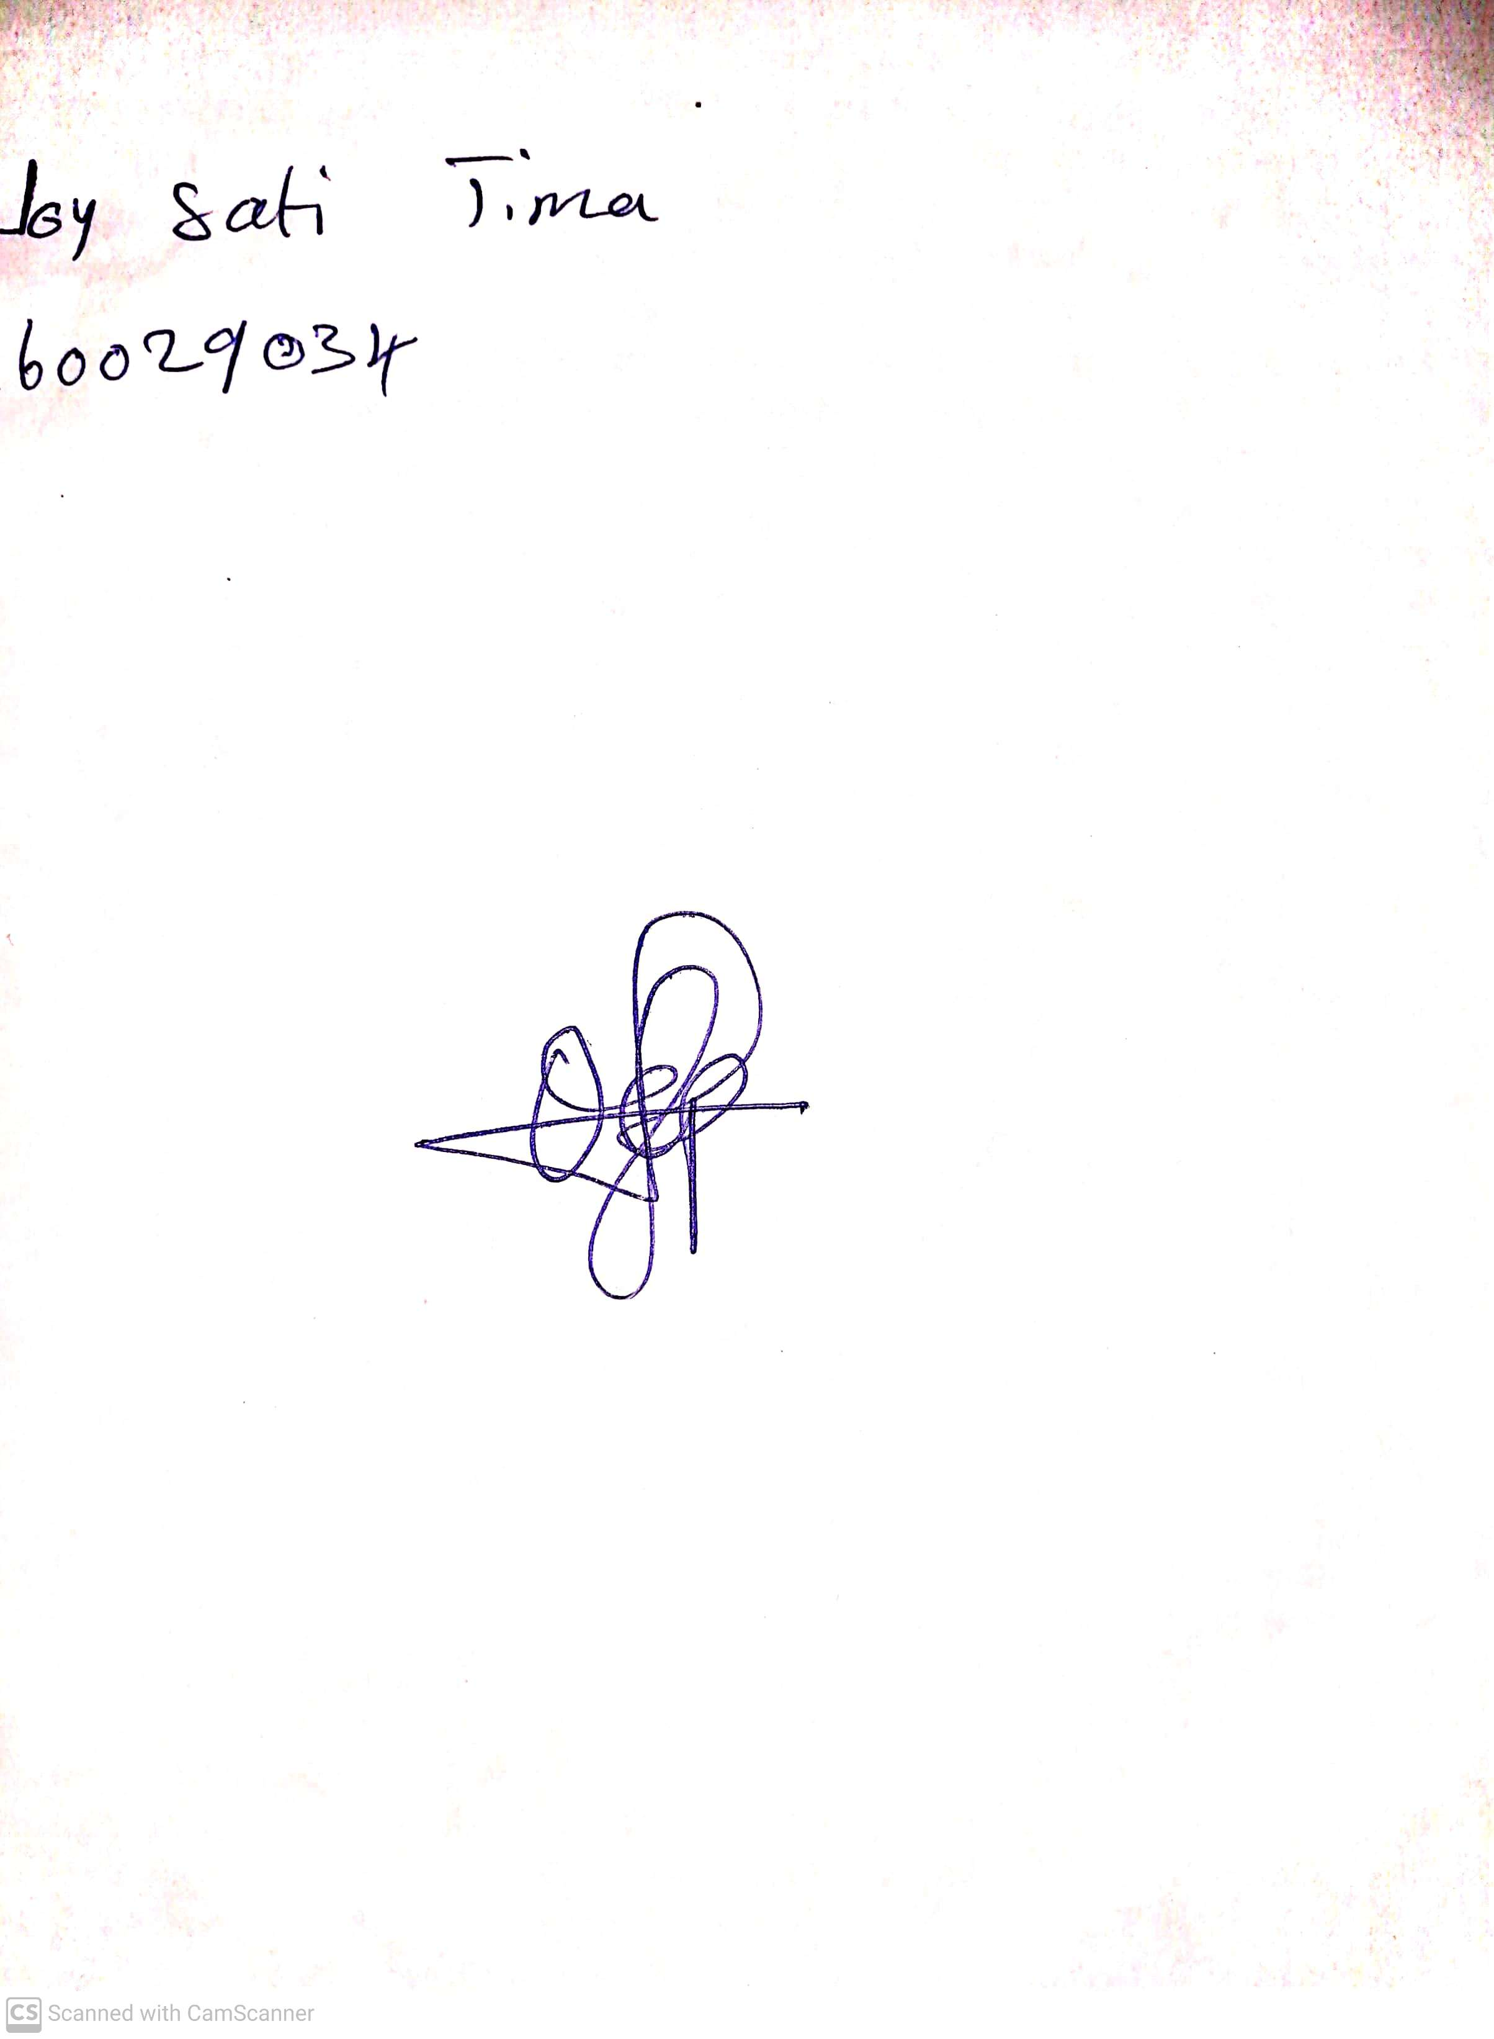

4th May, 2023

Perpetual Ojoma

Stream Head Nursery