**EMERALD ROYAL INTERNATIONAL SCHOOL,**

**MPAPE ABUJA**

**NURSERY 2 SCHEME OF WORK ON LETTER WORK THIRD TERM**

|  |  |
| --- | --- |
| **WEEKS** | **TOPICS** |
| 1 | Revision of 2nd term's work |
| 2 | Vowel Digraphs 1— ee, ea, oo, |
| 3 | Vowel Digraphs 2— ai, ay, or, aw |
| 4 | Vowel Digraphs 3— ea, ie, is, oi |
| 5 | Vowel Digraphs 4— oy, aw, ow, ou |
| 6 | Words study : parts of my body — spelling of parts of the body. |
| 7 | Vowel Digraphs 5— ie, igh, y, ew. |
| 8 | Common things in the classroom. |
| 9 | People I know |
| 10 | Revision |
| 11 | Examination |
| 12 –13 | End of session activities |

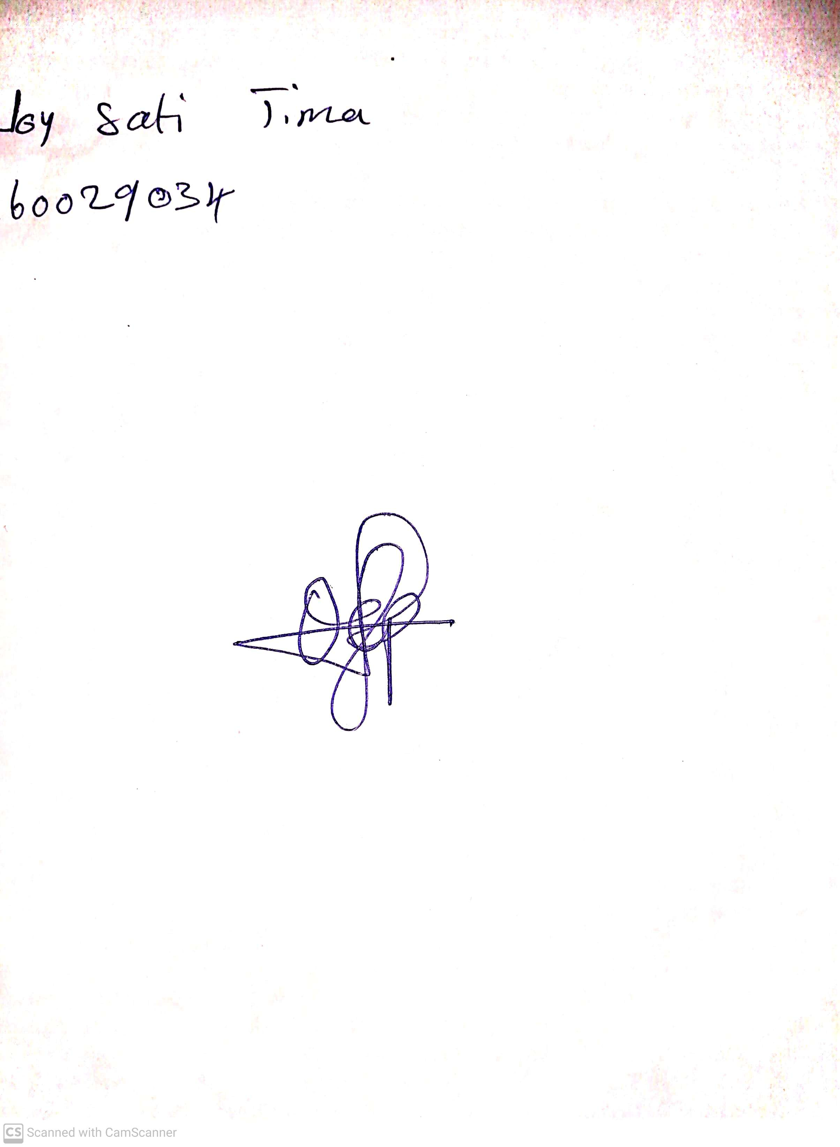

4th May, 2023

Perpetual Ojoma

Stream Head Nursery