**LESSON PLAN FOR WEEK 9 ENDING 8/11/2024**

**Term 1st term**

**Week 9th  week**

**Date 5th November,2024**

**Class Nursery One**

**Subject Nature studies**

**Topic Soil.**

**Sub-topic Meaning of Soil.**

**Period 4th period**

**Time 10:40 am**

**Duration 35 minutes**

**No in class 15**

**Average Age 3 years**

**Sex Mixed**

**Specific Objectives: By the end of the lesson, the pupils should be able to:**

1. **Define Soil.**
2. **Mention the types of Soil.**

**Rationale: To ensure the pupils can define & list the types of Soil.**

**Previous Knowledge: The pupils can define and colour things in the sky.**

**Instructional Resources: Online Research.**

**Reference Material: Elementary science by Showers kiddies nursery 1**

**LESSON PRESENTATION**

|  |  |  |  |
| --- | --- | --- | --- |
| **Steps** | **Teacher’s Activities** | **Pupils’ Activities** | **Learning Points** |
| **Introduction** | **The teacher introduces the lesson (Soil) to the pupils.** | **The pupils listens attentively to the teacher.** | **To arose the pupils’ interest.** |
| **Step 1** | **The teacher defines Soil as “the surface of the earth where plant grows”**  **.** | **The pupils repeats after the teacher to define Soil.** | **For proper understanding.** |
| **Step 2** | **The teacher teaches the pupils the types of soil which includes:**  **SANDY SOIL.**  **LOAMY SOIL.**  **CLAY SOIL.** | **The pupils mention with the teacher the different types of soil.** | **For better understanding.** |
| **Summary** | **The teacher summarizes the lesson by defining Soil.** | **The pupils can define Soil.** | **For onward study.** |
| **Evaluation** | 1. **Define Soil ?.** 2. **Mention the three types of soil?** | **The pupils answer the question correctly.** | **To ascertain the pupils’ understanding.** |
| **Conclusion** | **The teacher summarizes, reacts, and corrects the pupils.** | **The pupils gives answer to the teacher’s questions** | **To consolidate the lesson.** |
| **Assignment** | 1. **Define Soil ?.** 2. **Mention the 3 types of Soil?** | **The pupils copy and do their homework at home.** | **To encourage learning while at home.** |

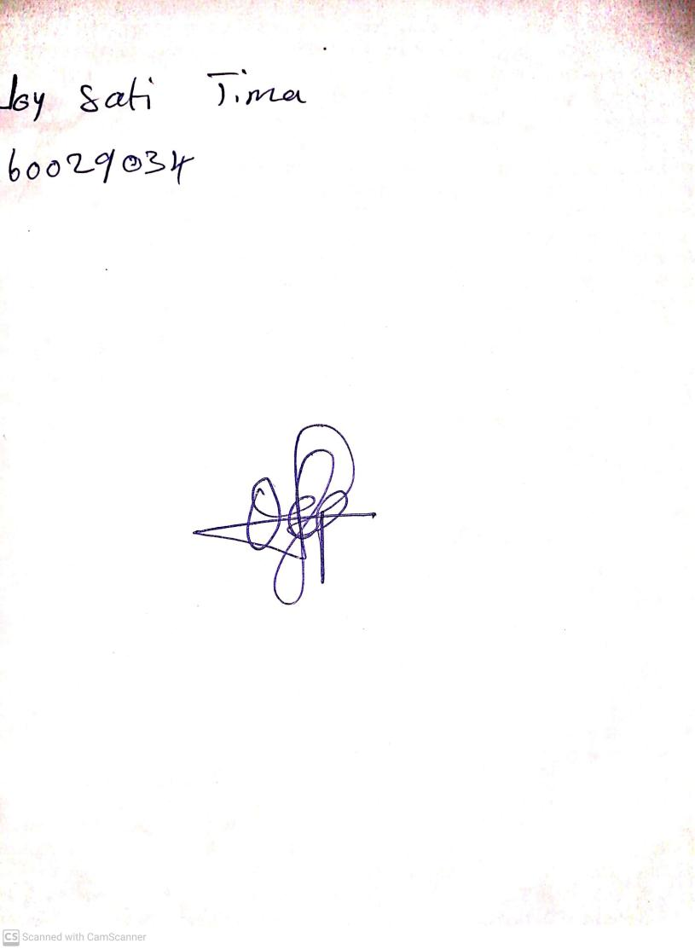

8th November, 2024

Perpetual Ojoma Ocheja

Stream Head Nursery