**EMERALD ROYAL INTERNATIONAL SCHOOL, MPAPE ABUJA**

**LESSON PLAN AND NOTE FOR WEEK 1 ENDING FRIDAY, 12TH JANUARY, 2024**

**TERM:** FIRST TERM

**WEEK:** WEEK 1

**SUBJECT:** ENGLISH LANGUAGE (SPEECH)

**TOPIC:** LISTENING AND SPEAKING

**SUB-TOPIC:** OUR SCHOOL COMPOUND

**DATE:** WEDNESDAY, 10TH JANUARY, 2024

**TIME:** 02:00 – 02:20PM

**DURATION:** 30 MINUTES

**PERIOD:** 9TH

**CLASS:** NURSERY 3

**NUMBER IN CLASS:** TWELVE

**AVERAGE AGE:** FIVE

**SEX:** MIXED

**LEARNING OBJECTIVES:** By the end of the lesson, the pupils should be able to

1. Identify the school compound.
2. Mention places in the school compound.

**RATIONALE:** for pupils to learn about the school compound.

**PREVIOUS KNOWLEGDE:** pupils are familiar with the school compound.

**INSTRUCTIONAL MATERIALS:**

1. Text book – Nigeria Primary English book 1 – Fourth Edition

**REFERENCE MATERIALS:**

1. Nigeria Primary English book 1 by B. Someye, D Dallas etal 2000

|  |  |  |  |
| --- | --- | --- | --- |
| **STAGES /STEPS** | **TEACHER’S ACTIVITIES** | **PUPILS’ ACTIVITIES** | **LEARNING POINT** |
| **INTRODUCTION** | Takes the pupils outside the classroom to view the school compound. | Look around the school compound and mention the things they can see around the school compound. | Arouse their interest |
| **PRESENTATION**  **STEP 1** | Leads pupils to talk about the school compound.  **Our school compound**  This is our school.  This is our garden.  This is our playground.  We play here.  Here is our head instructor.  This is our teachers’ room.  This is our school office.  The clerk works here.  The computer operator also works here.  We must go to school.  In school we learn hoe to read and write.  We must respect our teachers.  We must keep our school clean. | Respond to the teacher. | The school compound |
| **STEP 2** | Leads pupils to identify the things in the school compound.  **Places in the school compound**   1. School garden 2. Playground 3. Teachers’ room 4. School office 5. Computer laboratory 6. Examination hall 7. Refectory or cafeteria 8. Classrooms | List the places in the school compound. | For better understanding. |
| **SUMMARY** | Summarises the lesson by emphasising on the main concept and writes note on the board. | Listen and copy their notes | For onward study |
| **EVALUATION** | Ask pupils to:   1. Mention the places in the school compound. 2. Write out places in the school. | Respond to the teacher’s question. | To test the pupils’ understanding of the lesson |
| **CONCLUSION** | Summarizes, correct and mark the pupils note books. | Submits their notes for marking. | Clarifying the concept. |
| **HOME-WORK** | Nigeria Primary English book 1 page 93. | Return home with task | Extending lesson home. |

**LESSON PLAN AND NOTE FOR WEEK 1 ENDING FRIDAY, 12TH JANUARY, 2024**

**TERM:** FIRST TERM

**WEEK:** WEEK 1

**SUBJECT:** ENGLISH LANGUAGE (GRAMMAR)

**TOPIC:** GRAMMAR

**SUB-TOPIC:** WORDS ENDING IN ‘ING’

**DATE:** MONDAY, 8TH JANUARY, 2024

**TIME:** 01:20 – 02:00PM

**DURATION:** 40 MINUTES

**PERIOD:** 8TH

**CLASS:** NURSERY 3

**NUMBER IN CLASS:** TWELVE

**AVERAGE AGE:** FIVE

**SEX:** MIXED

**LEARNING OBJECTIVES:** at the end of the lesson, pupils should be able to:

1. Identify words that ends in ‘ing’
2. Make sentences with words that ends in ‘ing’.

**RATIONALE:** for pupils to learn to identify words that ends in ‘ing’.

**PREVIOUS KNOWLEGDE:** pupils are familiar with words that ends in ‘ing’. **INSTRUCTIONAL MATERIALS:**

1. Charts
2. Flash cards
3. Text book – Nigeria Primary English book 1 – Fourth Edition

**REFERENCE MATERIALS:**

1. Nigeria Primary English book 1 by B. Someye, D Dallas etal 2000

**LESSON DEVELOPMENT**

|  |  |  |  |
| --- | --- | --- | --- |
| **STAGES /STEPS** | **TEACHER’S ACTIVITIES** | **PUPILS’ ACTIVITIES** | **LEARNING POINT** |
| **INTRODUCTION** | Place flash cards on a flat surface for pupils to identify and pronounced.. | Identify and pronounced words that ends in ‘ing’ in the flash cards. | Arouse their interest |
| **PRESENTATION**  **STEP 1** | Leads pupils to identify words that ends with ‘ing’  **Words that ends in ‘ing’**   1. Sweeping 2. Reading 3. Writing 4. Watching 5. Washing 6. Cooking 7. Working 8. Teaching 9. Playing 10. Swimming | Identify words that ends in ‘ing’. | For better understanding. |
| **STEP 2** | Leads pupils to makes sentences with words that ends in ‘ing’   1. Labara is sweeping the room. 2. My father is watching television. 3. Audu is reading a novel. 4. Sarah is washing her school uniform. 5. My mother is cooking porridge in the kitchen. 6. Mr. Bala is working in his farm. 7. Bayo is writing his note. 8. The teacher is teaching the pupils. 9. Emmanuel is swimming in the pool. 10. Miracle is dancing to the song. | Read the sentences with word ending in ‘ing’. | For proper understanding.. |
| **SUMMARY** | Summarises the lesson by emphasising on the main concept and writes note on the board. | Listen and copy their notes | For onward study |
| **EVALUATION** | Ask pupils to:   1. Mentions words that ends in ‘ing’ 2. Make sentences with the words that ends in ‘ing’. | Respond to the teacher’s question. | To test the pupils’ understanding of the lesson |
| **CONCLUSION** | Summarizes, correct and mark the pupils note books. | Submits their notes for marking. | Clarifying the concept. |
| **HOME-WORK** | Nigeria Primary English workbook 1 pages 22 | Return home with task | Extending lesson home. |

**LESSON PLAN AND NOTE FOR WEEK 1 ENDING FRIDAY, 12TH JANUARY, 2024**

**TERM:** FIRST TERM

**WEEK:** WEEK 1

**SUBJECT:** ENGLISH LANGUAGE (COMPREHENSION)

**TOPIC:** READING

**SUB-TOPIC:** TORTOISE AND THE CALABASH OF WISDOM

**DATE:** THURSDAY, 11TH AND FRIDAY, 12TH JANUARY, 2024

**TIME:** 09:25 – 10:55AM AND 11: 25 – 12PM

**DURATION:** 40 MINUTES

**PERIOD:** 3RD AND 6TH

**CLASS:** NURSERY 3

**NUMBER IN CLASS:** TWELVE

**AVERAGE AGE:** FIVE

**SEX:** MIXED

**LEARNING OBJECTIVES:** by the end of the lesson, pupils should be able to:

1. Read the passage.
2. Write out difficult words from the passage.

**RATIONALE:** for pupils to learn to identify objects in the classroom.

**PREVIOUS KNOWLEGDE:** pupils are familiar with objects in the classroom

**INSTRUCTIONAL MATERIALS:**

1. Charts
2. Flash cards
3. Text book – Nigeria Primary English book 1 – Fourth Edition

**REFERENCE MATERIALS:**

1. Nigeria Primary English book 1 by B. Someye, D Dallas etal 2000

**LESSON DEVELOPMENT**

|  |  |  |  |
| --- | --- | --- | --- |
| **STAGES /STEPS** | **TEACHER’S ACTIVITIES** | **PUPILS’ ACTIVITIES** | **LEARNING POINT** |
| **INTRODUCTION** | Ask the pupils to open their textbook to page 93. | Open their textbook to page 93 | Arouse their interest |
| **PRESENTATION**  **STEP 1** | Leads the pupils to read the passage ‘tortoise and the calabash of wisdom.  **Tortoise and the calabash of wisdom**  A very long time ago, when animals talked and acted like humans, tortoise started boasting that he was the wisest of all living beings……….. | Read the passage after the teacher. | For fluency in reading. |
| **STEP 2** | Guides pupils to identify difficult words in the passage.  **Words from the passage**   1. Animals 2. Humans 3. Tortoise 4. Boasting 5. Calabash 6. Trunk 7. Transfer 8. Climb 9. Ashamed 10. village | Write out words from the passage. | For better understanding. |
| **SUMMARY** | Summarises the lesson by emphasising on the main concept and writes note on the board. | Listen and copy their notes | For onward study |
| **EVALUATION** | Ask pupils to:   1. Read the passage. 2. Identify difficult words from the passage. | Respond to the teacher’s question. | To test the pupils’ understanding of the lesson |
| **CONCLUSION** | Summarizes, correct and mark the pupils note books. | Submits their notes for marking. | Clarifying the concept. |
| **HOME-WORK** | Nigeria Primary English  book 1 pages 94 and 95 exercise 1 and 2. | Return home with task | Extending lesson home. |

**LESSON PLAN AND NOTE FOR WEEK 1 ENDING FRIDAY, 12TH JANUARY, 2024**

**TERM:** FIRST TERM

**WEEK:** WEEK 1

**SUBJECT:** ENGLISH LANGUAGE (COMPOSITION)

**TOPIC:** COMPOSITION

**SUB-TOPIC:** MY NEIGHBOUR

**DATE:** THURSDAY, 11TH JANUARY, 2024

**TIME:** 11:10 – 11:50PM

**DURATION:** 45 MINUTES

**PERIOD:** 5TH

**CLASS:** NURSERY 3

**NUMBER IN CLASS:** TWELVE

**AVERAGE AGE:** FIVE

**SEX:** MIXED

**LEARNING OBJECTIVES:** By the end of the lesson, the pupils should be able to

1. Say something about their neighbour
2. Write about ‘my neighbour’

**RATIONALE:** for pupils to learn about their neighbour.

**PREVIOUS KNOWLEGDE:** pupils have learnt to say something about their selves

**INSTRUCTIONAL MATERIALS:**

1. A book
2. Pencil
3. Text book – Nigeria Primary English book 1 – Fourth Edition

**REFERENCE MATERIALS:**

1. Nigeria Primary English book 1 by B. Someye, D Dallas etal 2000

|  |  |  |  |
| --- | --- | --- | --- |
| **STAGES /STEPS** | **TEACHER’S ACTIVITIES** | **PUPILS’ ACTIVITIES** | **LEARNING POINT** |
| **INTRODUCTION** | Review previous knowledge. | Open their text books | Arouse their interest |
| **PRESENTATION**  **STEP 1** | Leads pupils to say something about their neighbour.  I live in a flat with my parents. We have very lovely and nice neighbours. They came to this house after we had been here for more than one year.  At first, we did not have much to speak about with each other. As time went on, we started to talk more and more. We also share many things together now. We invited them for birthdays and other special occasions. They also do the same when they have something special at their home.  They are also kind people who help others very much. | Respond to the teacher. | For better understanding. |
| **STEP 2** | Leads pupils to write about ‘my neighbour’  My neighbours very lovely and nice.  They are very kind.  They help others very much.  We invite them for our birthdays and other special occasions and they also invite us whenever they have something special. | Write about ‘my neighbour’. | Writing a composition about ‘my neighbour’. |
| **SUMMARY** | Summarises the lesson by emphasising on the main concept and writes note on the board. | Listen and copy their notes | For onward study |
| **EVALUATION** | Ask pupils to:  1. Ask pupils to say something about their neighbour.  2. write a composition titled ‘my neighbour’.  3. answer the question. | Respond to the teacher’s question. | To test the pupils’ understanding of the lesson |
| **CONCLUSION** | Summarizes, correct and mark the pupils note books. | Submits their notes for marking. | Clarifying the concept. |
| **HOME-WORK** | Nigeria Primary English book 1 page 99 | Return home with task | Extending lesson home. |

**LESSON PLAN AND NOTE FOR WEEK 1 ENDING FRIDAY, 12TH JANUARY, 2024**

**TERM:** FIRST TERM

**WEEK:** WEEK 1

**SUBJECT:** ENGLISH LANGUAGE (PHONICS)

**TOPIC:** SOUND BANK

**SUB-TOPIC:** SOUND BANK /ʃ/

**DATE:** TUESDAY9TH JANUARY, 2024

**TIME:** 10:30 – 11:10PM

**DURATION:** 40 MINUTES

**PERIOD:** 4TH

**CLASS:** NURSERY 3

**NUMBER IN CLASS:** TWELVE

**AVERAGE AGE:** FIVE

**SEX:** MIXED

**LEARNING OBJECTIVES:** By the end of the lesson, the pupils should be able to:

1. Identify sound /ʃ/
2. Pronounce the sound /ʃ/
3. State and write words with the sound /ʃ/

**RATIONALE:** for pupils to learns to pronounce the sound /ʃ/

**PREVIOUS KNOWLEGDE:** pupils learnt about sounds

**INSTRUCTIONAL MATERIALS:**

1. Flash cards
2. pictorial charts

**REFERENCE MATERIALS:**

1. Nigeria Primary English book 1 by B. Someye, D Dallas etal 2000

|  |  |  |  |
| --- | --- | --- | --- |
| **STAGES/STEPS** | **TEACHER’S ACTIVITIES** | **PUPILS ACTIVITIES** | **LEARNING POINTS** |
| **INTRODUCTION** | Displays cards on a flat surface. | Identifies the flash cards. | Arousing interest. |
| **PRESENTATION**  **STEP 1** | Leads pupils to identify sound /ʃ/   |  | | --- | | **/ʃ/** | | Identifies sound /ʃ/ | Identifying the sound /ʃ/. |
| **STEP 2** | Teaches pupils to pronounce /ʃ/ | Pronounce sound /ʃ/ | Pronouncing sound /ʃ/ . |
| **STEP 3** | Teaches and highlight words with the sound /ʃ/.  Words with the sound /ʃ/   1. Shop 2. Rush 3. Nation 4. Shout 5. Ash 6. Cash 7. Bush 8. Station 9. Action 10. Sugar 11. Ocean 12. Sure 13. Special | Identifies, learn and write words with the sound /ʃ/. | Words with sounds /ʃ/. |
| **SUMMARY** | Summarises the lesson by emphasising on the main concept and writes note on the board. | Listen and copy their notes | For onward study |
| **EVALUATION** | Ask pupils to:   1. Identify sound /ʃ/ 2. Pronounce sound /ʃ/ | Respond to the teacher’s questions. | To test the pupils’ understanding on the lesson. |
| **CONCLUSION** | Summarizes, corrects and mark the pupils’ notebook. | Copy the note on the board and submit for marking. | Clarifying the concept. |
| **HOMEWORK** | Write 5 words with the sound /ʃ/ | Return home with task. | Extending lesson home. |

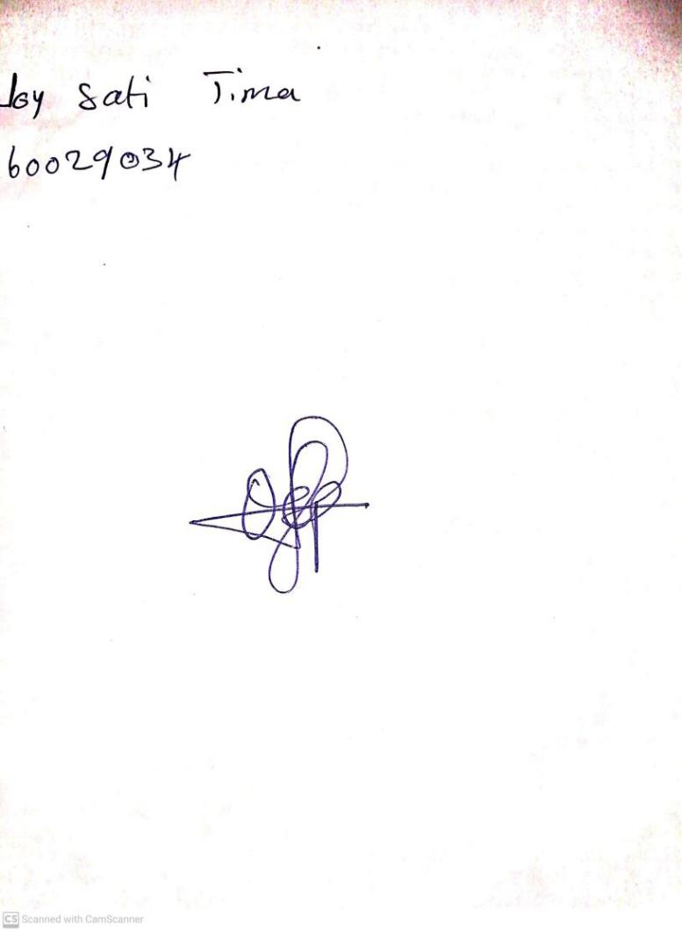

12TH January, 2024

Perpetual Ojoma Ocheja

Stream Head Nursery