LESSON PLAN FOR WEEK 8 ENDING 3RD MARCH 2023

|  |  |
| --- | --- |
| TERM | 2ND |
| WEEK | 9 |
| DATE | 2nd march 2023 |
| CLASS | SS1 |
| SUBJECT | History |
| TOPIC | The Efik Kingdom |
| SUB-TOPIC | Historical Background |
| PERIOD | 4th |
| TIME | 10:30-11:10 |
| DURATION | 40 Minutes |
| NO IN CLASS | 11 |
| AVERAGE AGE | 15 years |
| SEX | Mixed |
| SPECIFIC OBJECTIVES | By the end of the lesson, scholars should be able to:  i.Explain the historical background of the Efik kingdom  ii.Mention the main products that were produced in the Efik kingdom. |
| RATIONALE | To acquaint the scholars with the history and product of the Efik kingdom. |
| PREVIOUS KNOWLEDGE | The scholars can explain the administrative system Kingdom of the Benin kingdom. |
| INSTRUCTIONAL RESOURCES | Charts from textbook explaining the topic. |
| REFERENCE MATERIAL | A History of Nigeria.  GIC Eluwa (2017) |

LESSON DEVELOPMENT

|  |  |  |  |
| --- | --- | --- | --- |
| STEPS | TEACHER’S ACTIVITIES | SCHOLARS’ ACTIVITIES | LEARNING POINTS |
| Introduction | The teacher introduces the topic by asking the scholars the year Britain occupation Benin empire. | The scholars mention the year as 1897. | To arouse scholars’ interest towards the topic. |
| Step 1 | The teacher explains history of the Efik kingdom. | The scholars pay attention. | To enhance proper understanding of the topic. |
| Step 2 | The teacher mentions some important events in the Benin empire. | The scholars listen and ask questions. | To encourage critical thinking on the topic. |
| Board summary | The teacher summarizes the lesson thus:  The *Efik* were good farmers , fishermen, traders and great carvers of wood. They lived in an environment that was almost entirely riverine and therefore they were essentially fishermen.  The main products of these areas were carved materials, fish, crayfish and salt. They exchanged these with foodstuff and iron products with their Igbo, *Idoma* and *Jukun* neighbors. So, Agriculture and trade flourished in the area before the coming of the Europeans into *Efik* land.  When the Europeans came in the 15th century, trade developed between them. In this new trade, the *Efik* played the middlemen role between the Europeans at the coast and the peoples of the inland region of Igbo,Benin and others. The main articles of this trade were slaves. Other articles of the trade included kola-nuts and carved materials, which they exchanged for European goods like textile, gin, gun, gunpowder and others.  In the *Calabar* area of *Efik*, competition for trade led to the development of the “House” system. The House was made up of the household and members of the extended family.  However in the 19th century, there was a change from the slave trade to the Palm-oil trade. The trade brought about new changes in the pattern of trade and led to greater foreign intervention in local politics in *Efik* kingdom. The *Efik* operated a middleman trade in the palm produce trade. *Itu* a town on the Cross River was the main collecting centre for all produce from Igbo and farther inland. *Ikom* was another collecting centre relaying produce between the Cross River and *Bamenda* in the Cameroons. Other products of the new trade include ivory, wild rubber, yams and carved materials. The trade on palm produce continued in this way until the European merchants at the coast decided to penetrate the hinterland with the primary motive of getting at the sources of the commodities. | The scholars copy notes into their notebooks. | For reference purposes. |
| Evaluation | The teacher evaluates the scholars thus:  1.Discuss briefly the structure of the *Efik* kingdom.  ii.Mention three products traded in the *Efik* kingdom. | The scholars attempt the questions. | To ascertain scholars understanding of the lesson. |
| Conclusion | The teacher check scholars notes and make corrections. | The scholars take corrections made by the teacher. | For better understanding of the lesson. |
| Assignment | The teacher gives the scholars assignment:  Explain the socio-political relationship that existed in the *Efik* Kingdom. | The scholars copy their assignment to do it at home. | To encourage continuity of learning. |

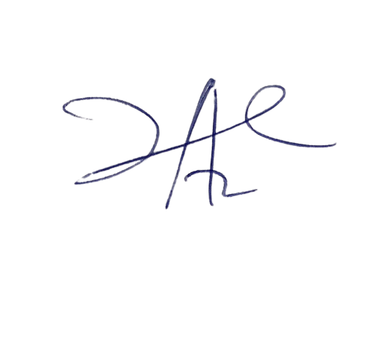

21/3/2023

Principal Head Instructor