**EMERALD ROYAL INTERNATIONAL SCHOOL, MPAPE ABUJA**

**LESSON PLAN AND NOTE FOR WEEK 4 ENDING FRIDAY, 2ND FEBRUARY, 2024**

**TERM:** FIRST TERM

**WEEK:** WEEK 4

**SUBJECT:** SOCIAL STUDIES

**TOPIC:** SOCIAL AND HEALTH ISSUES

**SUB-TOPIC:** PRACTICAL EFFECTS OF TAKING SUBSTANCES INTO THE BODY

**DATE:** TUESDAY, 30TH ANDWEDNESDAY, 31ST JANUARY, 2024

**TIME:** 11:50 – 12:30PM AND 01:20 – 02:00PM

**DURATION:** 40 MINUTES

**PERIOD:** 6TH AND 8TH

**CLASS:** NURSERY 3

**NUMBER IN CLASS:** TWELVE

**AVERAGE AGE:** FIVE

**SEX:** MIXED

**LEARNING OBJECTIVES:** By the end of the lesson, the pupils should be able to:

1. Practicalize the effects of taking substance into the body in the class.

**RATIONALE:** for pupils to practice the effects of taking substances into the body in the class.

**PREVIOUS KNOWLEGDE:** pupils have learnt the effects of taking substances into the body.

**INSTRUCTIONAL MATERIALS:**

1. Charts.
2. Textbook.

**REFERENCE MATERIALS:**

1. Social Studies for primary schools book 1 by Olufemi J. Olugasa, Olusola H. Bamidele, Felix K. Alonge, Julius O. Onwuka

**LESSON DEVELOPMENT**

|  |  |  |  |
| --- | --- | --- | --- |
| **STAGES/STEPS** | **TEACHER’S ACTIVITIES** | **PUPILS’ ACTIVITIES** | **LEARNING POINTS** |
| **INTRODUCTION** | Review previous knowledge. | Respond to the teacher | To arouse the pupils’ interest. |
| **PRESENTATION**  **STEP 1** | 1. Guides pupils to practices the effects of taking substances into the body in the class | Listen attentively and learn. | For better understanding. |
| **SUMMARY** | Summarises the lesson by emphasising on the main concept and writes note on the board | Listen and copy their notes | For onward study |
| **EVALUATION** | Asks pupils to:   1. Practices the effects of taking substances into the body. | Respond to the teacher’s question. | To test the pupils understanding on the lesson. |
| **CONCLUSION** | Summarizes, corrects and mark pupils’ notebooks | Submit their notebooks for marking. | Clarifying the concept. |

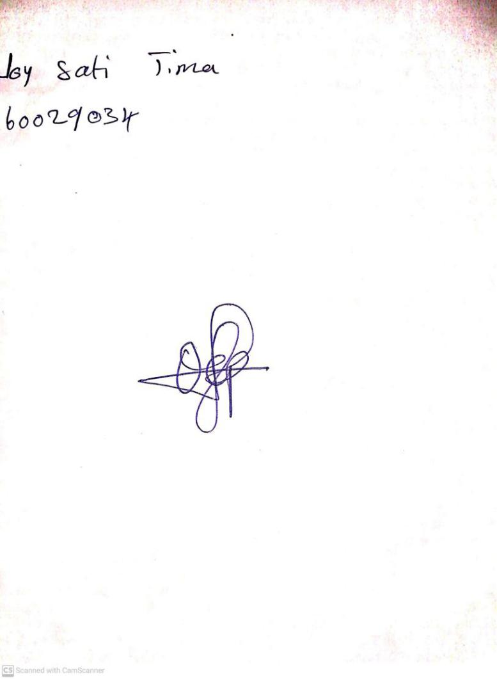

26TH January, 2024

Perpetual Ojoma Ocheja

Stream Head Nursery