**EMERALD ROYAL INTERNATIONAL SCHOOL MPAPE, ABUJA.**

**LESSON PLAN AND NOTE FOR WEEK 2 ENDING 03/05/2024**

**TERM: 3rd**

**WEEK: 2nd**

**DATE: 29/04/2024**

**CLASS: Nursery 2**

**SUBJECT: Social norms**

**TOPIC: Parental care: effects of Denial.**

**SUB—TOPIC: Meaning of Parental care, effect and important.**

**PERIOD: 2nd period after long break**

**TIME: 11:20—12: 00pm**

**DURATION: 40 minutes**

**NUMBER IN CLASS: 13**

**AVERAGE AGE: 5 years**

**SEX: Mixed**

**LEARNING OBJECTIVES: By the end of the lesson, the Pupils should be able to:**

**1. Explain the meaning of Parental care.**

**2. State the effect of Denial of Parental care.**

**3. Mention the important of Parental care.**

**RATIONALE: For pupils to know what is meant by Parental care.**

**PREVIOUS KNOWLEDGE: Pupils have learnt about our country in previous lesson.**

**INSTRUCTIONAL MATERIALS: Pictures of children suffering from lack of Parental care.**

**REFERENCE MATERIALS: Google. com**

**LESSON DEVELOPMENT**

|  |  |  |  |
| --- | --- | --- | --- |
| **Steps** | **Teacher's activities** | **Pupils' activities** | **Learning point** |
| **Introduction** | **Teacher introduces the lesson by asking pupils if they have ever seen anyone smoking cigarettes before?** | **Pupils answer the question ask by the teacher.** | **To prepare pupils minds for the lesson ahead.** |
| **Presentation step 1** | **Teacher explains the meaning of Parental care to pupils and then asks them to repeat after her.** | **Pupils pay attention to the teacher and repeat after her.** | **For proper understanding.** |
| **Step 2** | **Teacher states the effect of denail of parental care to pupils and also a asks hem to repeat after her.** | **Pupils listen to the teacher and repeat after her.** | **For better understanding.** |
| **Step 3** | **Teacher mentions the important of Parental care to pupils** | **Pupils listen attentively to the teacher.** | **To enhance Pupils listening skills.** |
| **Board summary** | **Teacher summarizes the lesson by writing the whole note of lesson on the board for pupils to copy into their books. That is;**  **PARENTAL CARE:**  **Parental care is any effort taken by parents to take care of the young ones in order to increase the chance of survival of the young ones and hence increase the reproduction rate of success. Or, Parental care is any behaviour that contributes to offspring survival.**  **EFFECT OF DENIAL OF PARENTAL CARE**  **A child without adequate and sustained Parental instruction or counselling is worthless and may slowly or rapidly grow into**  **1. Marijuana addiction**  **2. Vandalism and armed robbery.**  **3. Depression**  **4. Loneliness**  **5. Anger**  **6. Behavioural problems at school.**  **7. Low academic achievement motivation.**  **8. Misbehaviour**  **9. Stealing etc.**  **IMPORTANT OF PARENTAL CARE:**  **1. Helps the child exhibit confident social behaviours.**  **2. Promotes the child's mental and emotional development.** | **Pupils copy the note into their exercise books.** | **For onward study.** |
| **Evaluation** | **Teacher evaluates the lesson by asking pupils the following questions:**  **1. What is Parental care?**  **2. State the effects of Denial of Parental care.**  **3. Mention the important of Parental care.** | **Pupils answer the questions asked by the teacher.** | **To assess pupils level of understanding.** |
| **Conclusion** | **Teacher concludes the lesson by marking pupils books.** | **Pupils submit their books for marking..** | **For endorsement.** |
| **Assignment** | **Answer the following questions:**  **1. Explain the meaning of violence.**  **2. Mention 3 harmful effects of physical violence.** | **Pupils do their assignment at home.** | **To encourage learning at home.** |

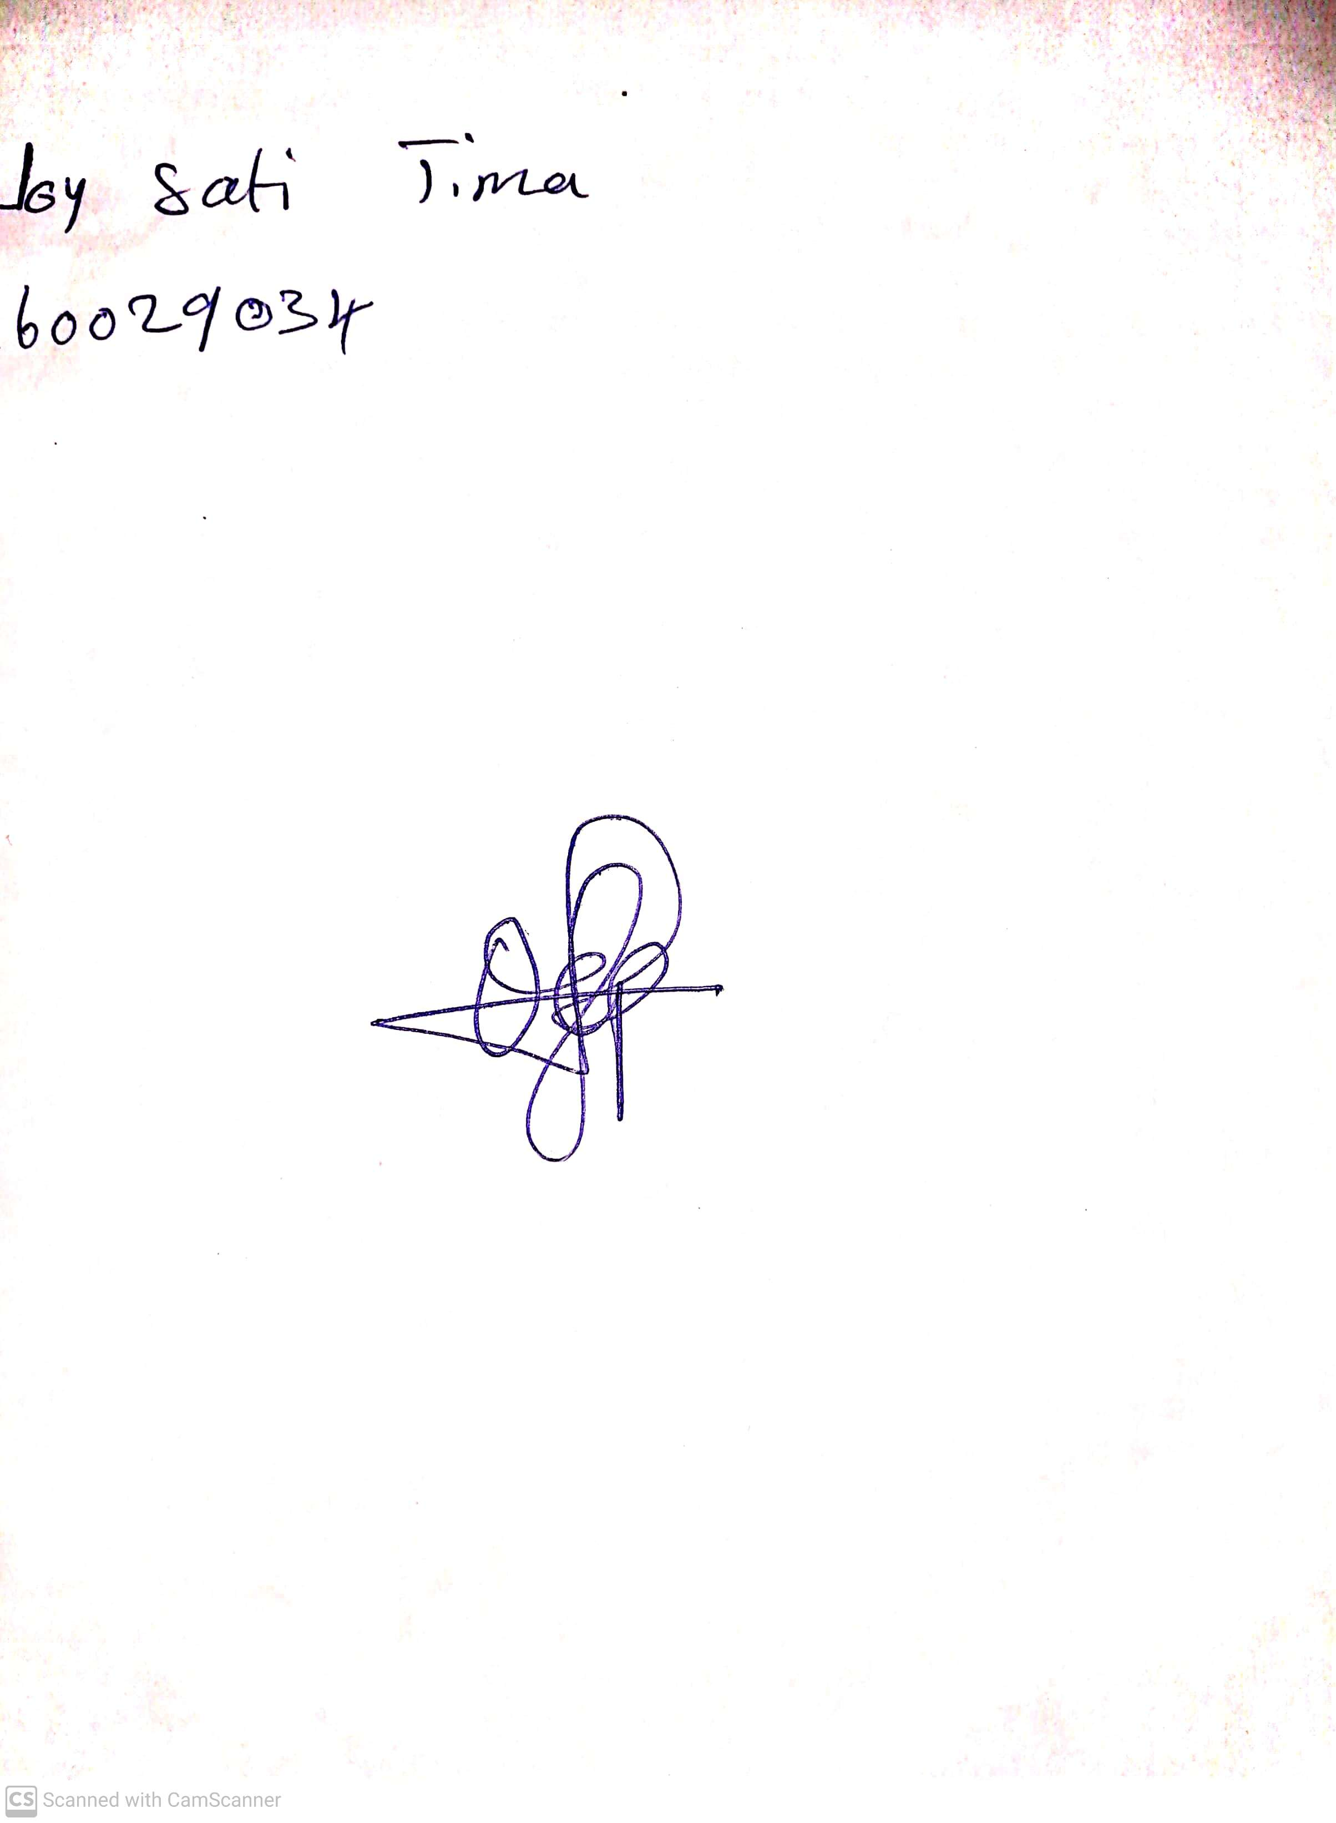

**26th April, 2024**

**Perpetual Ojoma Ocheja**

**Stream Head Nursery**