**EMERALD ROYAL INTERNATIONAL SCHOOL MPAPE, ABUJA**

**NURSERY 2 (TWO) SCHEME OF WORK**

**1ST TERM**

**PHONICS**

|  |  |
| --- | --- |
| **WEEKS** | **TOPICS** |
| **1-2** | **Letter sound /æ/.** |
| **3-4** | **Letter sound /b/** |
| **5-6** | **Letter sound /k/** |
| **7-8** | **Letter sound /d/** |
| **9-10** | **Letter sound /e/ and /f/** |
| **11-12** | **Letter sound /g/ and letter sound /h/** |
| **13** | **Letter sound /i/ and /ʤ/** |
| **14** | **Revision and Examination** |

**EMERALD ROYAL INTERNATIONAL SCHOOL MPAPE, ABUJA**

**NURSERY 2 (TWO) SCHEME OF WORK**

**2ND TERM**

**PHONICS**

|  |  |
| --- | --- |
| **WEEKS** | **TOPICS** |
| **1** | **Letter sound /k/** |
| **2** | **Letter sound /l/** |
| **3** | **Letter sound /m/** |
| **4-5** | **Letter sound /n/** |
| **6-7** | **Letter sound /o/** |
| **8-9** | **Letter sound /p/ and letter sound /kw/** |
| **10-11** | **Letter sound /r/ and letter sound /s/** |
| **12** | **Letter sound /t/** |
| **13-14** | **Revision/ Examination** |

**EMERALD ROYAL INTERNATIONAL SCHOOL MPAPE, ABUJA**

**NURSERY 2 (TWO) SCHEME OF WORK**

**3RD TERM**

**PHONICS**

|  |  |
| --- | --- |
| **WEEKS** | **TOPICS** |
| **1** | **Letter sound / u/** |
| **2** | **Letter sound /ʌ/** |
| **3-4** | **Letter sound /v/** |
| **5-6** | **Letter sound /w/** |
| **7-8** | **Letter sound /x/** |
| **9-10** | **Letter sound /y/ and /z/** |
| **11-12** | **Vowel and consonant letters.** |
| **13** | **Revision** |
| **14** | **Examination** |

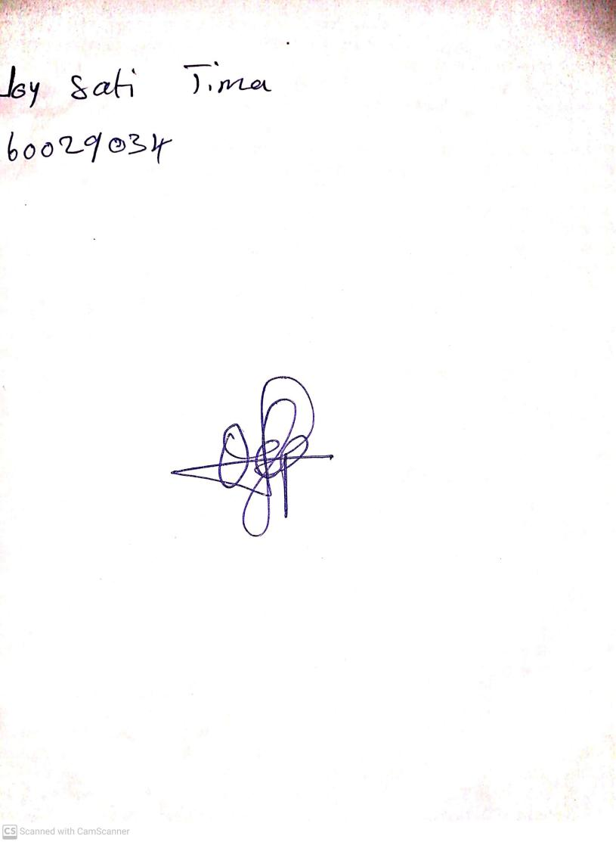

11TH OCTOBER, 2023

Perpetual Ojoma Ocheja

Stream Head Nursery