**EMERALD ROYAL INTERNATIONAL SCHOOL**

**MPAPE, ABUJA.**

**LESSON PLAN AND NOTE FOR WEEK 10 ENDING 15/11/2024**

**TERM: 1st**

**WEEK: 10th**

**DATE: 11/11/2024**

**CLASS: Nursery 2**

**SUBJECT: Nature studies**

**TOPIC: Garden tools.**

**SUB—TOPIC: Meaning of garden tools and examples.**

**PERIOD: 4th**

**TIME: 10:40—11:20am**

**DURATION: 40 minutes**

**NUMBER IN CLASS: 14**

**AVERAGE AGE: 5 years**

**SEX: Mixed**

**LEARNING OBJECTIVES: By the end of the lesson, the pupils should be able to:**

**1. Explain the meaning of garden tools.**

**2. Mention the examples of garden tools.**

**3. State the uses of garden tools.**

**RATIONALE: For pupils to know about garden tools.**

**PREVIOUS KNOWLEDGE: Pupils have in one way or the other seen a wheelbarrow or cut lass before.**

**INSTRUCTIONAL MATERIALS: A cutlass, shovel and gloves.**

**REFERENCE MATERIALS: Basic science and technology for Nursery schools book 3 by OPEMIPO DADA.**

**LESSON DEVELOPMENT**

|  |  |  |  |
| --- | --- | --- | --- |
| **Steps** | **Teacher's activities** | **Pupils' activities** | **Learning point** |
| **Introduction** | **Teacher introduces the lesson by reviewing the previous lesson.** | **Pupils pay attention to the teacher.** | **To prepare pupils minds for the lesson ahead.** |
| **Presentation step 1** | **Teacher explains the meaning of garden tools to pupils and then asks them to repeat after her.** | **Pupils listen to the teacher and repeat after her.** | **To improve pupils listening and speaking ability.** |
| **Step 2** | **Teacher mentions the examples of garden tools to pupils and also asks them to repeat after her.** | **Pupils pay attention to the teacher and repeat her.** | **To enhance pupils participation in the class.** |
| **Step 3** | **Teacher state the uses of garden tools to pupils and also asks them to repeat after her.** | **Pupils listen very attentively to the teacher and repeat after her.** | **To improve pupils speaking ability.** |
| **Board summary** | **Teacher writes the whole note of lesson on the board for pupils to copy into their books. That is;**  **Garden tools:**  **Garden tools are tools or materials that we use to keep our surroundings clean and do simple farm work.**  **Examples of garden tools are:**   1. **Hoe.** 2. **Trowel.** 3. **Spade.** 4. **Rake.** 5. **Gardening gloves.** 6. **Shovel.** 7. **Cutlass.** 8. **Wheelbarrow .** 9. **Watering can.** 10. **Axe .**   **Uses of garden tools are:**   1. **A cutlass is used for cutting grass.** 2. **A hoe is used for digging up soil.** 3. **A shovel is used for carrying soil.** 4. **An axe is used for cutting trees.** 5. **A rake is used for gathering dirt.** 6. **A water can is used to water flowers.** 7. **A wheelbarrow is used to carry dirt and tools.** | **Pupils copy the note into their exercise books.** | **For onward study.** |
| **Evaluation** | **Teacher evaluates the lesson by asking pupils the following questions;**   1. **What is Garden tools?** 2. **Mention the examples of garden tools.** 3. **State the uses of garden tools.** | **Pupils answer the questions asked by the teacher.** | **To assess pupils level of understanding.** |
| **Conclusion** | **Teacher concludes the lesson by marking pupils books.** | **Pupils submit their books for marking.** | **For endorsement.** |
| **Assignment** | **Summarize your note at home for examination.** | **Pupils read their books at home.** | **To encourage learning at home.** |

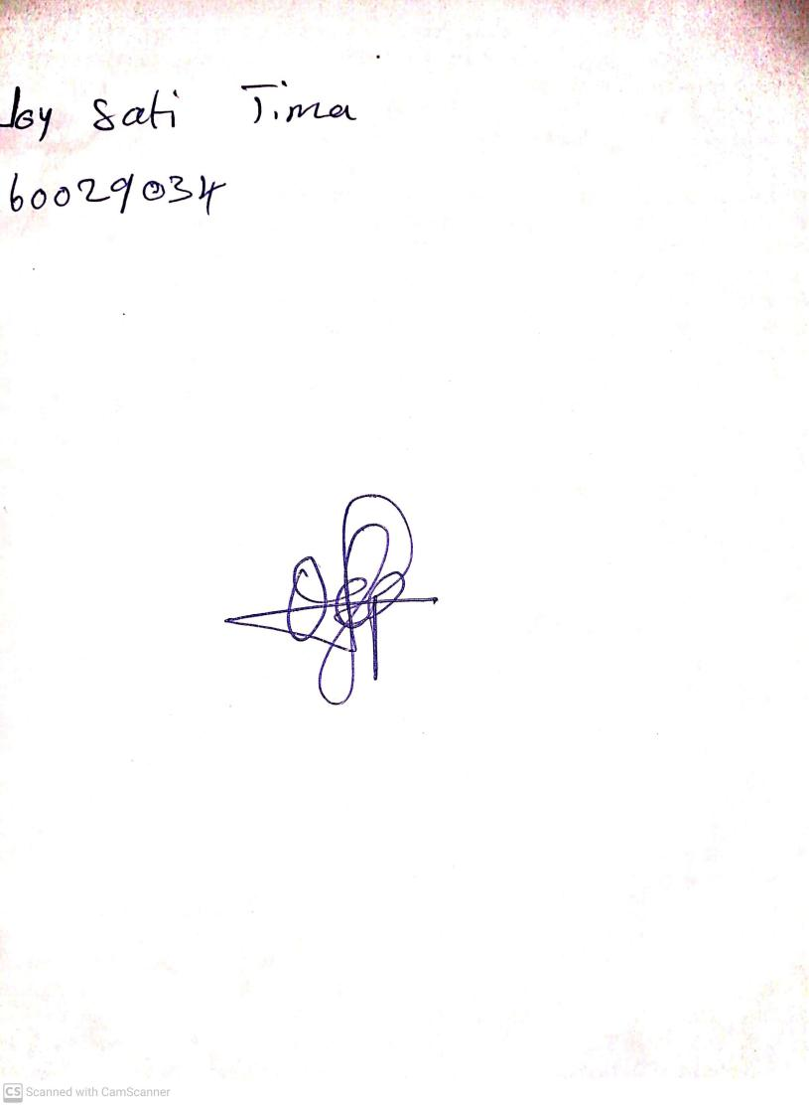

**1st November, 2024**

**Perpetual Ojoma Ocheja**

**Stream Head Nursery**