**EMERALD ROYAL INTERNATIONAL SCHOOL MPAPE, ABUJA.**

**LESSON PLAN AND NOTE FOR WEEK 2 PERIOD 1 ENDING 03/05/2024**

**TERM: 3RD**

**WEEK: 2ND**

**DATE: 29/04/2024**

**CLASS: NURSERY 2**

**SUBJECT: NUMBER WORK**

**TOPIC: NUMBERS 41- 45 .**

**SUB-TOPIC: IDENTIFY,COUNT AND WRITE NUMBER 41- 45**

**PERIOD: 1ST**

**TIME: O8:50-09:30.**

**DURATION: 40 MINUTES.**

**NUMBER IN CLASS: 13**

**AVERAGE AGE: 5 YEARS.**

**SEX: MIXED.**

**SPECIFIC OBJECTIVES: BY THE END OF THE LESSON,THE PUPILS SHOULD BE**

**ABLE TO:**

1. **COUNT NUMBER 41 - 45**
2. **WRITE NUMBER 41 - 45**

**RATIONALE: FOR PUPILS TO BE ABLE TO COUNT NUMBERS 41–45.**

**PREVIOU KNOWLEDGE: PUPILS HAVE LEARNT COUNTING OF NUMBERS 1- 40 IN PREVIOUS LESS0N.**

**INSTRUCTIONAL MATERIALS: NUMBER CHART .**

**REFERENCE MATERIALS: THE NEW MASTERING MATHEMATICS FOR NURSERY SCHOOLSBOOK 3 BY HENRY.Z.IDOGUN.**

**LESSON DEVELOPMENT**

|  |  |  |  |
| --- | --- | --- | --- |
| **STAGES/STEPS** | **TEACHER’S ACTIVITIES** | **PUPILS’ ACTIVITIES** | **LEARNING POINTS** |
| **INTRODUCTION** | **Teacher introduces the lesson by reviewing the previous lesson.** | **Pupil listen to the teacher.** | **To arouse pupils interest for the lesson ahead.** |
| **PRESENTATION**  **STEP 1** | **Teacher presents the lesson by counting numbers from 41- 45 and then asks pupils to repeat after.** | **Pupils count the numbers after the teacher.** | **For proper understanding of the lesson .** |
| **STEP 2** | **Teacher writes numbers on the board randomly for pupils to identify numbers 41- 45 among others. Ie, 1 3 4 8 41 6 42 9 10 43 2 44 7 15 45 19 20 13.** | **Pupils identify the numbers 41- 45 on the board.** | **For better understanding of the lesson.** |
| **BOARD SUMMARY** | **Teacher summarizes the lesson by writing the whole note of lesson on the board for pupils to copy into their books.that is,**  **COUNTING OF NUMBERS 41- 45**  **4 and 1= 41**  **4 and 2 = 42**  **4 and 3= 43**  **4 and 4 = 44**  **4 and 5 = 45.** | **Pupils copy the note into their exercise books.** | **For onwardstudy.** |
| **EVALUATION** | **Teacher asks pupils to count numbers 41- 45 on the board one after the other.** | **Pupils count numbers 41- 45 on the board one after another.** | **To assess pupils understanding of the lesson.** |
| **CONCLUSION** | **Teacher marks pupils books.** | **Pupils submit their books for marking.** | **For endorsement.** |
| **ASSIGNMENT** | **Identify, count and write numbers 45- 41.** | **Pupils do their assignment at home.** | **To encourage learning at home.** |

**LESSON PLAN AND NOTE FOR WEEK 2 PERIOD 2 ENDING 03/05/2024**

**TERM: 3RD**

**WEEK: 2ND**

**DATE: 30/05/2024**

**CLASS: NURSERY 2**

**SUBJECT: NUMBERWORK**

**TOPIC: NUMBERS 41- 45 .**

**SUB-TOPIC: IDENTIFY,COUNT AND WRITE NUMBER 45- 41**

**PERIOD: 2nd**

**TIME: O8:50-09:30.**

**DURATION: 40 MINUTES.**

**NUMBER IN CLASS: 13**

**AVERAGE AGE: 5 YEARS.**

**SEX: MIXED.**

**SPECIFIC OBJECTIVES: BY THE END OF THE LESSON,THE PUPILS SHOULD BE**

**ABLE TO:**

1. **COUNT NUMBERS 45 - 41**
2. **IDENTIFY NUMBERS 51 - 41**

**RATIONALE: FOR PUPILS TO KNOW BACKWARD COUNTING OF**

**NUMBERS 45–41.**

**PREVIOU KNOWLEDGE: PUPILS HAVE LEARNT COUNTING OF NUMBERS 41- 45 IN PREVIOUS LESS0N.**

**INSTRUCTIONAL MATERIALS: NUMBER CHART .**

**REFERENCE MATERIALS: THE NEW MASTERING MATHEMATICS FOR NURSERY SCHOOLSBOOK 3 BY HENRY.Z.IDOGUN.**

**LESSON DEVELOPMENT**

|  |  |  |  |
| --- | --- | --- | --- |
| **STAGES/STEPS** | **TEACHER’S ACTIVITIES** | **PUPILS’ ACTIVITIES** | **LEARNING POINTS** |
| **INTRODUCTION** | **Teacher introduces the lesson by asking pupils to count number 41-45.** | **Pupil count number 41-45..** | **To arouse pupils interest for the lesson ahead.** |
| **PRESENTATION**  **STEP 1** | **Teacher presents the lesson by counting numbers from 45- 41 and then asks pupils o repeat after.** | **Pupils count the numbers after the teacher.** | **For proper understanding of the lesson .** |
| **STEP 2** | **Teacher writes numbers 45- 41 on the board and then asks pupils to identify and count.** | **Pupils identify the numbers 54- 41 on the board and count.** | **For better understanding of the lesson.** |
| **BOARD SUMMARY** | **Teacher summarizes the lesson by writing the whole note of lesson on the board for pupils to copy into their books.that is,**  **COUNTING OF NUMBERS 45- 41.**  **45 44 43 42 41.** | **Pupils copy the note into their exercise books.** | **For onwardstudy.** |
| **EVALUATION** | **Teacher asks Pupils to count numbers 45- 41 on the board one after the other.** | **Pupils count numbers 45- 41 on the board one after another.** | **To assess pupils understanding of the lesson.** |
| **CONCLUSION** | **Teacher marks pupils books.** | **Pupils submit their books for marking.** | **For endorsement.** |
| **ASSIGNMENT** | **Identify, count and write numbers 1- 45.** | **Pupils do their assignment at home.** | **To encourage learning at home.** |

**LESSON PLAN AND NOTE FOR WEEK 2 PERIOD 3 ENDING 03/05/2024**

**TERM: 3RD**

**WEEK: 2ND**

**DATE: 03/05/2024**

**CLASS: NURSERY 2**

**SUBJECT: NUMBERWORK**

**TOPIC: NUMBERS 41- 45 .**

**SUB-TOPIC: IDENTIFY,COUNT AND WRITE NUMBER 41- 45**

**PERIOD: 3RD**

**TIME: 08:10- 08:50am**

**DURATION: 40 MINUTES.**

**NUMBER IN CLASS: 13**

**AVERAGE AGE: 5 YEARS.**

**SEX: MIXED.**

**SPECIFIC OBJECTIVES: BY THE END OF THE LESSON,THE PUPILS SHOULD**

**BE ABLE TO:**

**1.COUNT NUMBERS 1- 45**

**2. WRITE NUMBER 1- 45**

**RATIONALE: FOR PUPILS TO KNOW COUNTING OF NUMBERS 1- 45 .**

**PREVIOU KNOWLEDGE: PUPILS HAVE LEARNT COUNTING OF NUMBERS 1- 45 IN PREVIOUS LESS0N.**

**INSTRUCTIONAL MATERIALS: NUMBER CHART .**

**REFERENCE MATERIALS: THE NEW MASTERING MATHEMATICS FOR NURSERY**

**SCHOOLS BOOK 3 BY J.M OMOGBAI.**

**LESSON DEVELOPMENT**

|  |  |  |  |
| --- | --- | --- | --- |
| **STAGES/STEPS** | **TEACHER’S ACTIVITIES** | **PUPILS’ ACTIVITIES** | **LEARNING POINTS** |
| **INTRODUCTION** | **Teacher introduces the lesson by jumping and counting numbers 1- 45.** | **Pupils jump and count the numbers along with the teacher.** | **To arouse pupils interest for the lesson ahead.** |
| **PRESENTATION**  **STEP 1** | **Teacher presents the lesson by writing number 1- 45 on the board,count and then asks pupils to repeat after her.** | **Pupils listen to the teacher and repeat after her.** | **For proper understanding of the lesson .** |
| **STEP 2** | **Teacher guides pupils to count and identify the numbers on the board often and often.** | **Pupils count and identify the numbers on the board.** | **For better understanding of the lesson.** |
| **BOARD SUMMARY** | **Teacher summarizes the lesson by preparing pupils books for them to copy the note on the board.ie,**  **COUNTING AND WRITING OF NUMBERS 1- 45;**  **1 2 3 4 5 6 7 8 9 10 11 12 13 14 15 16 17 18 19 20 21 22 23 24 25 26 27 28 29 30 31 32 33 34 35 36 37 38 39 40 41 42 43 44 45.** | **Pupils copy the note into their exercise books.** | **For onwardstudy.** |
| **EVALUATION** | **Teacher evaluates the lesson by asking pupils to all stand and count the numbers on the board all together.** | **Pupils all stand and count the numbers on the board.** | **To create platform for slow learners.** |
| **CONCLUSION** | **Teacher concludes the lesson by marking pupils notes .** | **Pupils submit their books for marking.** | **For endorsement.** |
| **ASSIGNMENT** | **Fill in the missing numbers.**  **1 2 _ 4 _ 6 _ 8 _ 10 _ 12 _ 14 _ 16 _ 18 _ 20 _ 22 _ 24 _ 26 _ 28 _ 30 _ 32 _ 34 _ 36 _ 38 _ 40 _ 42 _ 44 _.** | **Pupils do their assignment at home.** | **To encourage learning at home.** |

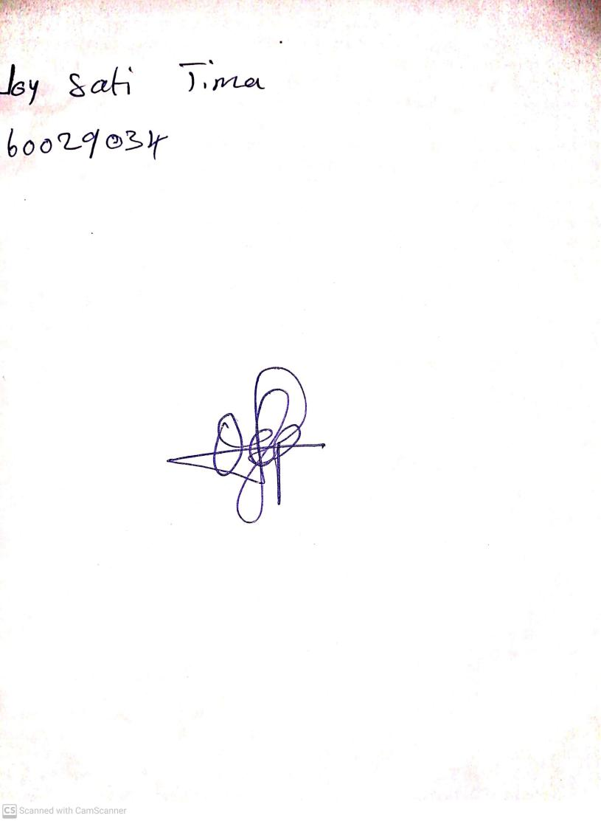

**26th April, 2024**

**Perpetual Ojoma Ocheja**

**Stream Head Nursery**