**LESSON PLAN AND NOTE FOR WEEK 7 ENDING 23/02/2024**

**Term 2nd term**

**Week 7th, 8th & 9th week**

**Date 20/02/2024, 28/02/2024, 06/03/2024**

**Class Nursery one**

**Subject Social Norms**

**Topic Culture**

**Sub-topics Meaning, Types and Elements of Culture.**

**Period 2nd period**

**Time 9:05 am**

**Duration 35 minutes**

**No in class 15**

**Average Age 3 years**

**Sex Mixed**

**Specific Objectives: By the end of the lesson the pupils should be able to;**

1. **Define of Culture.**
2. **Mention the types of Culture.**
3. **List the elements of Culture.**

**Rationale: To ensure the pupils define, lists types and elements of culture.**

**Previous knowledge: The pupils can mention the roles of daddy,mummy & children**

**Instructional Resources: Chart, board, marker.**

**Reference Materials: Online Research,chart,board.**

**LESSON PRESENTATION**

|  |  |  |  |
| --- | --- | --- | --- |
| **Steps** | **Teacher’s Activities** | **Pupils’ Activities** | **Learning points** |
| **Introduction** | **The teacher introduces the topic (Meaning & types of culture) to the pupils.** | **The pupils listen attentively to the teacher.** | **To arouse the interest of the pupils.** |
| **Step 1** | **The teacher starts by teaching the pupils the meaning of culture as “the total way of life of groups of people”.** | **The pupils repeat after the teacher the meaning of Culture.** | **For proper understanding.** |
| **Step 2** | **The teacher guides the pupils in mentioning the types of Culture which include:**  **Material Culture e.g money,clothing etc.**  **Non-material Culture e.g food, language, dancing etc** | **The pupils mention with the teacher the types of culture with their examples.** | **For better understanding.** |
| **Step 3** | **The teacher mention the elements of culture which include:**   1. **Language** 2. **Clothing** 3. **Music** 4. **Beliefs** 5. **Food etc.** | **The pupils mention together with their teacher the elements of culture.** | **For further understanding.** |
| **Summary** | **The teacher summarizes the lesson by defining Culture for the pupils.** | **The pupils can define culture.** | **For onward study.** |
| **Evaluation** | **Question:**   1. **Define Culture?** 2. **Mention the elements of culture.** 3. **Mention the 2 types of culture?** | **The pupils answer the question correctly.** | **To ascertain the pupils’ understanding.** |
| **Conclusion** | **The teacher summarizes, reacts & corrects the pupils.** | **The pupils gives answer to the teacher’s questions.** | **To consolidate the lesson.** |
| **Assignment** | **Question:**   1. **Define Culture?** 2. **Mention the elements of culture.** 3. **Mention the 2 types of culture?** 4. **What religion are you?** | **The pupils copy and do their homework at home.** | **To encourage learning while at home.** |

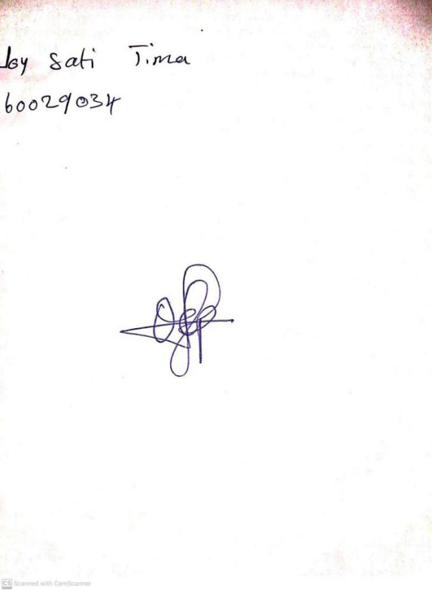

16TH February, 2024

Perpetual Ojoma Ocheja

Stream Head Nursery