**EMERALD ROYAL INTERNATIONAL SCHOOL**

**MPAPE, ABUJA.**

**LESSON PLAN AND NOTE FOR WEEK 1 ENDING 13/08/2024**

**TERM: 1st**

**WEEK: 1st**

**DATE: 09/09/2024**

**CLASS: Nursery 2**

**SUBJECT: Nature studies**

**TOPIC: First aid**

**SUB—TOPIC: Meaning of first aid and first aid kit.**

**PERIOD: 4th**

**TIME: 10:40—11:20am**

**DURATION: 40 minutes**

**NUMBER IN CLASS: 14**

**AVERAGE AGE: 5 years**

**SEX: Mixed**

**LEARNING OBJECTIVES: By the end of the lesson, the pupils should be able to:**

**1. Explain the meaning of first aid.**

**2. Identify a first aid kit.**

**RATIONALE: For pupils to know about first aid.**

**PREVIOUS KNOWLEDGE: Pupils have under go first aid treatment in one way or the other.**

**INSTRUCTIONAL MATERIALS: First aid kit.**

**REFERENCE MATERIALS: Basic science and technology for Nursery schools book 3 by OPEMIPO DADA.**

**LESSON DEVELOPMENT**

|  |  |  |  |
| --- | --- | --- | --- |
| **Steps** | **Teacher's activities** | **Pupils' activities** | **Learning point** |
| **Introduction** | **Teacher introduces the lesson by asking pupils the following question:**   1. **Have you ever been injured?** 2. **Did you receive first aid treatment ?** | **Pupils answer the question asked by the teacher.** | **To prepare pupils minds for the lesson ahead.** |
| **Presentation step 1** | **Teacher explains the meaning of first aid to pupils and then asks them to repeat after her.** | **Pupils listen to the teacher and repeat after her.** | **To improve pupils listening and speaking ability.** |
| **Step 2** | **Teacher draws the diagram of a first aid kit on the board for pupils to identify and then explain to pupils what the kit is used for. And also asks pupils to repeat after her.** | **Pupils pay attention to the teacher and repeat after the teacher.** | **To enhance pupils participation in the class.** |
| **Board summary** | **Teacher writes the whole note of lesson on the board for pupils to copy into their books. That is;**  **First aid:**  **First aid is the first treatment that is given to an injured or accident person before he or she is taken to the hospital.**  **First aid kit:**  **A first aid kit is a box, bag or pack that holds supplies used to treat minor injuries including cuts, scrampes, burns, bruises, and sprains.**    **Diagram of a first aid kit.** | **Pupils copy the note into their exercise books.** | **To build pupils writing ability.** |
| **Evaluation** | **Teacher evaluates the lesson by asking pupils the following questions;**  **1.What is first aid?**  **2. What is a first aid kit and it used?** | **Pupils answer the questions asked by the teacher.** | **To assess pupils level of understanding.** |
| **Conclusion** | **Teacher concludes the lesson by marking pupils books.** | **Pupils submit their books for marking.** | **For endorsement.** |
| **Assignment** | **1.Mention ten (10) items in first aid kit.**  **2. State the uses of the first aid items.** | **Pupils do their assignment at home.** | **To encourage learning at home.** |

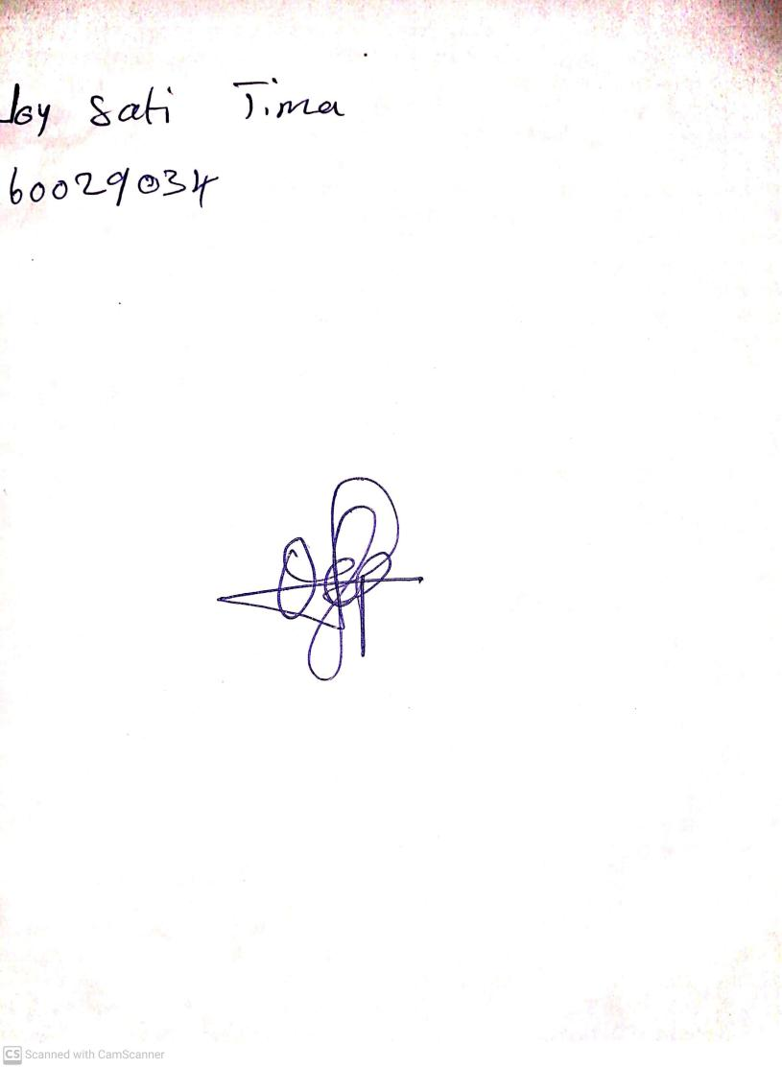

**13th September, 2024**

**Perpetual Ojoma Ocheja**

**Stream Head Nursery**