**EMERALD ROYAL INTERNATIONAL SCHOOL, MPAPE ABUJA**

**LESSON PLAN AND NOTE 1 FOR WEEK 4 ENDING FRIDAY, 2ND FEBRUARY, 2024**

**TERM:** FIRST TERM

**WEEK:** WEEK 4

**SUBJECT:** BASIC SCIENCE

**TOPIC:** IDENTIFICATION OF COLOURS

**SUB-TOPIC:** COLOURS OF TRAFFIC SIGNS

**DATE:** TUESDAY, 30TH AND WEDNESDAY, 31ST JANUARY, 2024

**TIME:** 08:45 – 09:25AM AND 09:25 – 09:55AM

**DURATION:** 40 MINUTES

**PERIOD:** 2ND AND 3RD

**CLASS:** NURSERY 3

**NUMBER IN CLASS:** TWELVE

**AVERAGE AGE:** FIVE

**SEX:** MIXED

**LEARNING OBJECTIVES:** By the end of the lesson, the pupils should be able to:

1. Give the meaning of traffic sign.
2. State the different road signs and their colours.

**RATIONALE:** for pupils to learn rainbow and its colours.

**PREVIOUS KNOWLEGDE:** pupils have learnt to identify different objects and their colours

**INSTRUCTIONAL MATERIALS:**

1. Flash cards.
2. Road chart.

**REFERENCE MATERIALS:**

Smart Basic Science and Technology book 1 by D. I. Bika, Cambridge University Press

**LESSON DEVELOPMENT**

|  |  |  |  |
| --- | --- | --- | --- |
| **STAGES/STEPS** | **TEACHER’S ACTIVITIES** | **PUPILS’ ACTIVITIES** | **LEARNING POINTS** |
| **INTRODUCTION** | Review previous knowledge | Respond to the teacher | To arouse the pupils’ interest. |
| **PRESENTATION**  **STEP 1** | Teaches pupils the description of a rainbow.  **Meaning of traffic sign**  Traffic signs are those signs or marks on the road that helps road users to know are to use the road so as to prevent accident from occurring. | Give the meaning of traffic signs | Meaning of traffic signs. |
| **STEP 2** | Guides pupils to state the different road traffic signs and their colours.  **Road traffic signs and their colours**   1. Pedestrian crossing: its is triangular in shape with red, white and black colour.   Screenshot_20231015-185438   1. U- turn: this is a road sign that indicate a U-turn for road users. It has a circular shape with red, white and black.   Screenshot_20231015-185635 | State the road traffic signs and their colours | Colours of road traffic signs. |
| **SUMMARY** | Summarises the lesson by emphasising on the main concept and writes note on the board | Listen and copy their notes | For onward study |
| **EVALUATION** | Asks pupils to:   1. Give the meaning of road traffic signs. 2. State road traffic signs and their colours. | Respond to the teacher’s question. | To test the pupils understanding on the lesson. |
| **CONCLUSION** | Summarizes, corrects and mark pupils’ notebooks | Submit their notebooks for marking. | Clarifying the concept. |
| **HOME WORK** | 1. Write out two road traffic signs and their colours. | Cope and return with task. | Extending lesson home. |

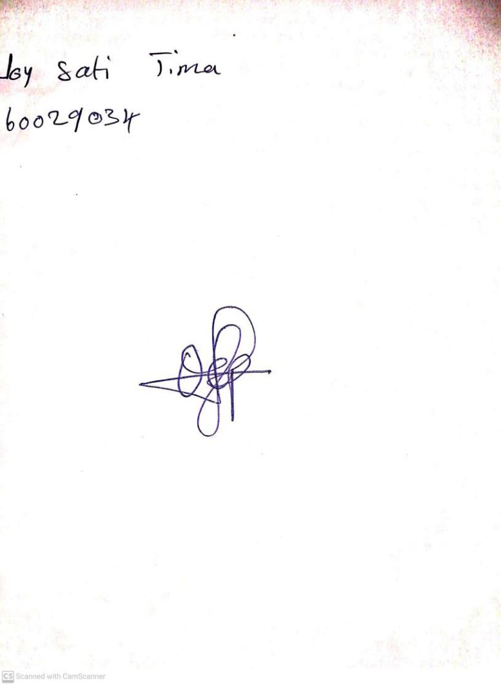

26TH January, 2024

Perpetual Ojoma Ocheja

Stream Head Nursery