**EMERALD ROYAL INTERNATIONAL SCHOOL, MPAPE ABUJA**

**LESSON PLAN AND NOTE 1 FOR WEEK 6 ENDING FRIDAY, 16TH FEBRUARY, 2024**

**TERM:** FIRST TERM

**WEEK:** WEEK 6

**SUBJECT:** BASIC SCIENCE

**TOPIC:** COLOUR IDENTIFICATION

**SUB-TOPIC:** COLOURS OF ROAD TRAFFIC SIGNS

**DATE:** TUESDAY, 13TH AND WEDNESDAY, 14TH FEBRUARY, 2024

**TIME:** 08:45 – 09:25AM AND 09:25 – 09:55AM

**DURATION:** 40 MINUTES

**PERIOD:** 2ND AND 3RD

**CLASS:** NURSERY 3

**NUMBER IN CLASS:** TWELVE

**AVERAGE AGE:** FIVE

**SEX:** MIXED

**LEARNING OBJECTIVES:** By the end of the lesson, the pupils should be able to:

1. Identify other road signs.
2. Identify the colours of the road signs.

**RATIONALE:** for pupils to learn identify other road signs and their colours.

**PREVIOUS KNOWLEGDE:** pupils have learnt about some road signs and their colours

**INSTRUCTIONAL MATERIALS:**

1. Flash cards.
2. Road chart.

**REFERENCE MATERIALS:**

Smart Basic Science and Technology book 1 by D. I. Bika, Cambridge University Press

**LESSON DEVELOPMENT**

|  |  |  |  |
| --- | --- | --- | --- |
| **STAGES/STEPS** | **TEACHER’S ACTIVITIES** | **PUPILS’ ACTIVITIES** | **LEARNING POINTS** |
| **INTRODUCTION** | Review previous knowledge | Respond to the teacher | To arouse the pupils’ interest. |
| **PRESENTATION**  **STEP 1** | Teaches and guides the pupils to identify road signs   1. Children crossing   Screenshot_20240319-142133   1. No entry   Screenshot_20240319-142226   1. U-turn   Screenshot_20240319-142029 | Identify the road signs. | Identification of road signs. |
| **STEP 2** | Teaches and explain the different road signs and their colours   1. Children crossing   Screenshot_20240319-142133.  The children crossing road sign indicate that children are crossing for motorist to slow down so as to prevent knocking down a child. The colour of the children crossing sign are yellow, black and white.   1. No entry   Screenshot_20240319-142226  The no entry road sign is a sign that shows that motorist are not allowed to enter. The colour of the sign are red and white.     1. U-turn   Screenshot_20240319-142029  The u-turn is a road sign that shows that there is a bend to turn either right or left. The colours are red, white and black. | Listen attentively and learn | For better understanding. |
| **SUMMARY** | Summarises the lesson by emphasising on the main concept and writes note on the board | Listen and copy their notes | For onward study |
| **EVALUATION** | Asks pupils to:   1. Identify the different road signs. 2. Mention the colours of each road signs. | Respond to the teacher’s question. | To test the pupils understanding on the lesson. |
| **CONCLUSION** | Summarizes, corrects and mark pupils’ notebooks | Submit their notebooks for marking. | Clarifying the concept. |
| **HOME WORK** | 1. Draw and colour a u-turn | Cope and return with task. | Extending lesson home. |

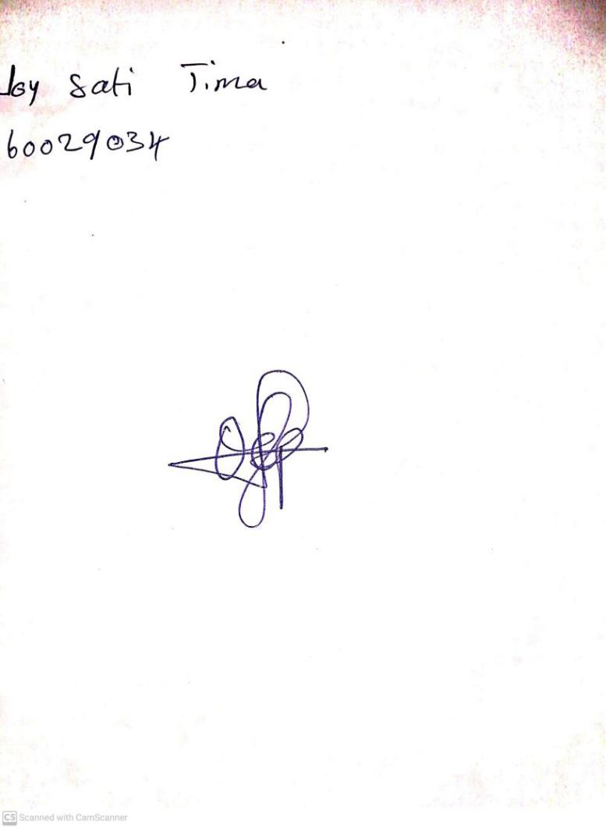

9TH FEBRUARY, 2024

Perpetual Ojoma Ocheja

Stream Head Nursery