**LESSON PLAN AND NOTE FOR WEEK 7 ENDING 16/6/2023**

**Term 3rd term**

**Week 7th week**

**Date 16th June, 2023**

**Class Nursery One**

**Subject Social Norms**

**Topic My Country.**

**Sub-topic Meaning of a NIGERIA.**

**Period 4th period**

**Time 10:40 am**

**Duration 35 minutes**

**No in class 18**

**Average Age 3 years**

**Sex Mixed**

**Specific Objectives: By the end of the lesson, the pupils should be able to:**

1. **Define NIGERIA.**
2. **Identify the ethnic group of their Nigeria.**

**Rationale: To ensure the pupils have knowledge of their Nigeria.**

**Previous Knowledge: The pupils can places in the environment.**

**Instructional Resources: Online research.**

**Reference Material: Smart Smart Civic Education by A.M Solu & T.Y Alabi, nursery 2**

**LESSON PRESENTATION**

|  |  |  |  |
| --- | --- | --- | --- |
| **Steps** | **Teacher’s Activities** | **Pupils’ Activities** | **Learning Points** |
| **Introduction** | **The teacher introduces the topic (my country) by telling the pupils that NIGERIA is the name of their country.** | **The pupils listen actively to their teacher.** | **To arouse the pupils’ interest.** |
| **Step 1** | **The teacher guides the pupils to define Nigeria as “a country located in west Africa and it has 36 states”.** | **The pupils listens and repeats after the teacher the meaning of Nigeria.** | **For proper understanding.** |
| **Step 2** | **The teacher leads the pupils to identify (3) three Nigeria’s ethnic group**  **IGBO**  **HAUSA**  **YORUBA** | **The pupils mention the three Nigeria’s ethnic group with the teacher.** | **For better understanding.** |
| **Summary** | **The teacher summarizes the lesson by explaining NIGERIA as a country.** | **The pupils understands the lesson.** | **For onward study.** |
| **Evaluation** | **Question:**  **Define Country?**  **Mention the three ethnic group of Nigeria.** | **The pupils answer the question correctly.** | **To ascertain the pupils’ understanding.** |
| **Conclusion** | **The teacher summarizes the lesson to the pupils.** | **The pupils gives answers to the teacher.** | **To consolidate the lesson.** |
| **Assignment** | **Question:**  **Rhyme Nigeria’s anthem?** | **The pupils copy and do their homework .** | **To encourage learning while at home.** |

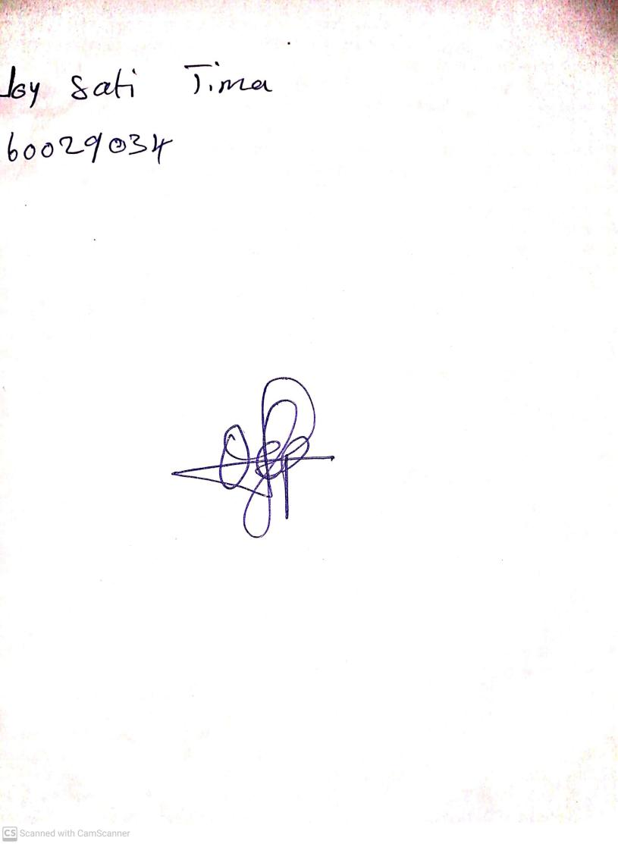

10th May, 2023

Perpetual Ojoma

Stream Head Nursery