**EMERALD ROYAL INTERNATIONAL SCHOOL MPAPE, ABUJA**

**LESSON PLAN AND NOTE FOR WEEK 8 ENDING 01/03/2024**

**TERM: 2nd**

**WEEK: 8th**

**DATE: 26/02/2024**

**CLASS: Nursery 2**

**SUBJECT: Letter work**

**TOPIC: Consonant Digraph 1**

**SUB—TOPIC: Meaning and example of digraphs.**

**PERIOD: 3rd**

**TIME: 09:30—10:10am**

**DURATION: 40 minutes**

**NUMBER IN CLASS: 13**

**AVERAGE AGE: 5 years**

**SEX: Mixed**

**LEARNING OBJECTIVES: By the end of the lesson, the Pupils should be able to:**

**1. Define consonant digraphs.**

**2. Explain the example of consonant digraphs.**

**RATIONALE: For Pupils to know what consonant digraphs means and Examples.**

**PREVIOUS KNOWLEDGE: Pupils have learnt initial and final consonant blends.**

**INSTRUCTIONAL MATERIALS: Phone.**

**REFERENCE MATERIALS: My choice of English language stage 3 by J.F. OMOTAYO**

**LESSON DEVELOPMENT**

|  |  |  |  |
| --- | --- | --- | --- |
| **Steps** | **Teacher's activities** | **Pupils' activities** | **Learning point** |
| **Introduction** | **Teacher reviews the previous lesson.** | **Pupils pay attention to the teacher.** | **To arouse pupils interest for the lesson ahead.** |
| **Presentation step 1** | **Teacher defines the meaning of consonant digraphs to pupils and asks them to repeat after her.** | **Pupils listen to the teacher and repeat after her.** | **For proper understanding.** |
| **Step 2** | **Teacher explains at least one example of consonant digraphs to pupils and also asks them to repeat after her.** | **Pupils pay attention to the teacher and repeat after her.** | **For better understanding.** |
| **Board summary** | **Teacher writes the whole note of lesson on the board for pupils to copy. As;**  **CONSONANT DIGRAPHS**  **Consonant digraphs are two or more consonants that , together represent one sound.**  **Example: 'p' and 'h' form the grapheme 'ph' that can represent the /f/ sound in words such as “nephew” and “phone”.** | **Pupils copy the note into their books.** | **For onward study.** |
| **Evaluation** | **Teacher asks Pupils one after the other to define consonant digraphs.** | **Pupils define consonant digraphs one after another.** | **To create platform for slow learners.** |
| **Conclusion** | **Teacher concludes the lesson by marking pupils books.** | **Pupils submit their books for marking.** | **For endorsement.** |
| **Assignment** | **1. Generate words with consonant digraphs 'ck'**  **2. Consonant digraphs' ph'** | **Pupils do their assignment at home.** | **To encourage learning at home** |

**LESSON PLAN AND NOTE FOR WEEK 8 ENDING 01/03/2024**

**TERM: 2nd**

**WEEK: 8th**

**DATE: 29/02/2024**

**CLASS: Nursery 2**

**SUBJECT: ` Letter work**

**TOPIC: Consonant Digraphs 1.**

**SUB—TOPIC: Generating words with consonant digraphs' ck' and 'ph'.**

**PERIOD: 2nd**

**TIME: 08:50—09:30am**

**DURATION: 40 minutes**

**NUMBER IN CLASS: 13**

**AVERAGE AGE: 5 years**

**SEX: Mixed**

**LEARNING OBJECTIVES: By the end of the lesson, the Pupils should be able to:**

**1. Generate words with consonant digraphs 'ck'**

**2. Mention words with consonant digraphs 'ph'**

**RATIONALE: For Pupils to know how to pronounce words with consonant digraphs ck and ph.**

**PREVIOUS KNOWLEDGE: Pupils have learnt the meaning and example of consonant digraphs**

**INSTRUCTIONAL MATERIALS: Char of words with consonant digraphs .**

**REFERENCE MATERIALS: My choice of English language stage 3 by JF OMOTAYO**

**LESSON DEVELOPMENT**

|  |  |  |  |
| --- | --- | --- | --- |
| **Steps** | **Teacher's activities** | **Pupils' activities** | **Learning point** |
| **Introduction** | **Teacher introduces the lesson by asking pupils to Define consonant digraphs.** | **Pupils define consonant digraphs.** | **To prepare pupils minds for the lesson ahead.** |
| **Presentation step 1** | **Teacher generates words with consonant digraphs 'ck' to pupils and then asks them to repeat after her.** | **Pupils listen attentively to the teacher and repeat after her.** | **For proper understanding.** |
| **Step 2** | **Teacher mentions words with consonant digraphs 'ph' to pupils and also asks them to repeat after her.** | **Pupils pay attention to the teacher and repeat after her.** | **For better understanding.** |
| **Board summary** | **Teacher summarizes the lesson by writing the whole note of lesson on the board for pupils to copy into their books. That is; CONSONANT DIGRAPHS 'CK' AND 'PH' .**  **Consonant digraphs 'ck' are:**  **1. Clock**  **2. Black**  **3. Rock**  **4. Check**  **5. Stick etc.**  **Consonant digraphs 'ph' are:**  **1. Phone**  **2. Phonics**  **3. Phase**  **4. Phrase**  **5. Physics**  **6. Graph**  **7. Alpha**  **8. Morph**  **9. Photo**  **10. Phobia etc.** | **Pupils copy the note into their exercise books.** | **For onward study.** |
| **Evaluation** | **Teacher evaluates the lesson by going through the note on the board over again and then ask Pupils to read one after another.** | **Pupils pay attention to the teacher as she reads and then go to the board one after another and read.** | **To create platform for slow learners.** |
| **Conclusion** | **Teacher concludes the lesson by marking pupils books.** | **Pupils submit their books for marking.** | **For endorsement.** |
| **Assignment** | **1. Generate Words with consonant digraphs ‘sh’.**  **1. Make words with consonant digraphs ‘ch’** | **Pupils do their assignment at home.** | **To encourage learning at home.** |

**LESSON PLAN AND NOTE FOR WEEK 8 ENDING 01/03/2024**

**TERM: 2nd**

**WEEK: 8th**

**DATE : 01/03/2023**

**CLASS: Nursery 2**

**SUBJECT: Letter work**

**TOPIC: Consonant Digraphs 1**

**SUB—TOPIC: Consonant digraphs ‘sh’ and ‘ch’**

**PERIOD: 3rd**

**TIME: 09:30–10:10am**

**DURATION: 40 minutes**

**NUMBER IN CLASS: 13**

**AVERAGE AGE: 5 years**

**SEX: Mixed**

**LEARNING OBJECTIVES: By the end of the lesson, the Pupils should be able to:**

**1. Generate words with consonant digraphs ‘sh’**

**2. Make words with consonant digraphs ‘ch’**

**RATIONALE: For Pupils to km know more of consonant digraphs words.**

**PREVIOUS KNOWLEDGE: Pupils have learnt consonant digraphs ‘ck’ and ‘ph’**

**INSTRUCTIONAL MATERIALS: A chart of words with consonant digraphs ‘sh’ and ‘ch’**

**REFERENCE MATERIALS: My choice of English language stage 3 by JM OMOTAYO**

**LESSON DEVELOPMENT**

|  |  |  |  |
| --- | --- | --- | --- |
| **Steps** | **Teacher's activities** | **Pupils' activities** | **Learning point** |
| **Introduction** | **Teacher introduces the lesson by asking pupils to mention words with consonant digraphs ck and ph .** | **Pupils listen to the teacher and answer the question.** | **To prepare pupils minds for the lesson ahead.** |
| **Presentation step 1** | **Teacher generates words with consonant digraphs ‘sh’ and asks Pupils to repeat after her.** | **Pupils listen to the teacher and repeat after her.** | **For proper understanding.** |
| **Step 2** | **Teacher makes words with consonant digraphs ‘ch’and also asks Pupils to repeat after her.** | **Pupils pay attention to the teacher and repeat after her.** | **For better understanding.** |
| **Board summary** | **Teacher writes the whole note on the board for pupils to copy. That is;**  **CONSONANT DIGRAPHS ‘SH’ ARE:**  **(1) Shoe (2) Shut (3)shirt (4) brush (5)wash (6) shadow (7) shed (8) shock(9) she (10) shack (11) shop (12) shelf (13) shell (14) push (15)mash (16) crash etc.**  **CONSONANT DIGRAPHS ‘CH’ ARE:**  **(1) church (2) school (3) chain (4) chair (5) chart (6) chase (7) chess (8) chest (9) chance (10)check(11) match (12) catch (13) patch (14) teach (15)lunch (16)punch etc.** | **Pupils copy the note into their exercise books.** | **For onward study.** |
| **Evaluation** | **Teacher asks pupils to read the comments digraphs on the board one after another.** | **Pupils go to the board one after another and read.** | **To enhance Pupils participation in the class.** |
| **Conclusion** | **Teacher concludes the lesson by marking pupils books.** | **Pupils submit their books for marking.** | **For endorsement.** |
| **Assignment** | **Make 5 words each with the following digraphs**  **1. nd**  **2. ng**  **3. ft**  **4. st**  **5. lf** | **Pupils do their assignment at home.** | **To encourage learning at home.** |

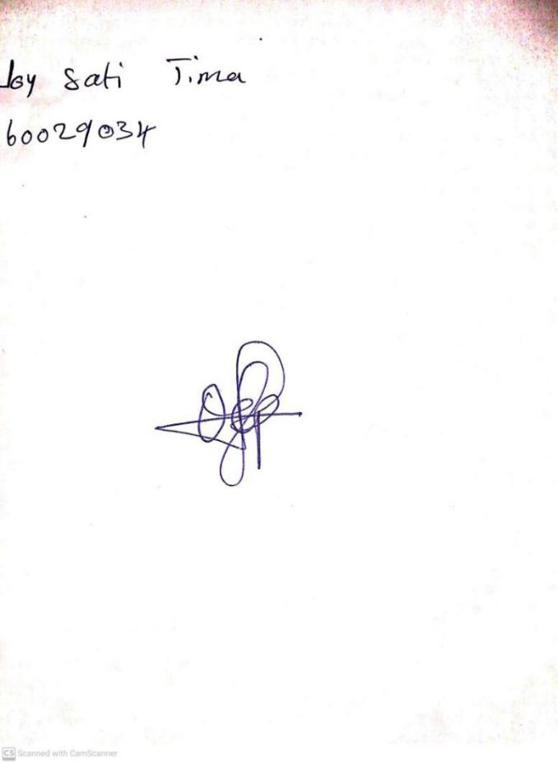

**26TH FEBRUARY, 2024**

**Perpetual Ojoma Ocheja**

**Stream Head Nursery**