**LESSON PLAN FOR WEEK 1 ENDING 13th JANUARY, 2023**

|  |  |
| --- | --- |
| TERM | 2ND |
| WEEK | 1 |
| DATE | 9th-13th January, 2023 |
| SUBJECT | Social Studies |
| TOPIC | Positive Group Behaviour |
| SUB-TOPIC | Meaning and Characteristics of a Group |
| PERIOD | Ist |
| TIME | 8:10-8:50 |
| DURATION | 40 Minutes |
| CLASS | JSS2 |
| NO IN CLASS | 11 |
| AVERAGE AGE | 10-11 Years |
| SEX | Mixed |
| LEARNING OBJECTIVES | By the end of the lesson, Scholars should be able to:  i.Define a group.  ii.State the characteristics of a group. |
| RATIONALE | To ensure that the students understand a group set up and how a group operates. |
| PREVIOUS KNOWLEDGE | The students have seen different types of groups and also members of such groups. |
| INSTRUCTIONAL RESOURCES | Charts from textbook explaining the topic. |
| REFERENCE MATERIALS | Social Studies for JSS 1 (GBENGA M.B) |

**LESSON DEVELOPMENT**

|  |  |  |  |
| --- | --- | --- | --- |
| STEPS | TEACHER’S ACTIVITIES | SCHOLARS’ ACTIVITIES | LEARNING POINTS |
| Introducion | The teacher starts the lesson thus: Throughout the life of man. He belonged to one group or the other, man is first is the first part of family group and he also belongs to other secondary groups. | The scholars listen to the teacher. | This is to introduce the lesson to the teachers. |
| Step 1 | The teacher now introduces and defines a group as two or more persons who are linked by a common purpose or interest. He states that “One of the key reasons for the group is to achieve a particular objective. | The students listen and ask questions. | The aim is to ensure that the scholars understand a group. |
| Step 2 | The teacher now leads who? to mention the characteristics of a group. The teacher then explains the characters. | The scholars mention the characteristics of a group as:  1.Shared values  2.Coomon goals  3.Specific number of individuals.  4.Clearly defined status  5.Common symbols  6.Sense of unity and solidarity  7.Group norms  8.Similar behaviors. | The characteristics will enable the scholars to identify a group. |
| Board summary | To ensure the scholars to understand what?, the teacher summarises the lesson. He states that a group may contain two or more people. He states that what? have existed through ages and it will continue to exist. Also, a group exists mainly through social needs or common interests. He then answers the scholars’ questions. | The scholars listen, make contributions and asks the teacher questions. | This is to afford the scholars the chance to ask questions and enable the slow learners the chance to learn better. |
| Evaluation | The teacher tests the scholars thus:  i.What is a group?  ii.Mention five characteristics of a group. | The students answer the questions. | This sis to ascertain the scholar’s level of understanding. |
| Conclusion | The teacher now copies notes for the scholars on the board. | The scholars copy the notes to submit it to the teacher for endorsement. | This will help the scholars to read and study at home. |
| Assignment | The teacher gives the scholars home work:  State five importance of a group. | The scholars copy the home work to do it at home. | To encourage continuity of learning. |

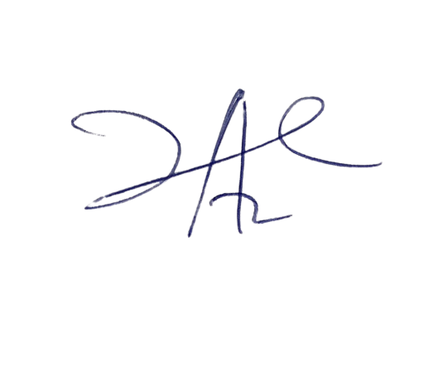

16/2/2023

Head Instructor

NOTE: Take note of the highlighted items and make the necessary correction.

Please, effect simile corrections on other subsequent lesson note to avoid repetition.