**EMERALD ROYAL INTERNATIONAL SCHOOL**

**MPAPE, ABUJA.**

**LESSON PLAN AND NOTE FOR WEEK 6 PERIOD 1 ENDING 09/06/2023**

TERM: 3RD

WEEK: 6TH

DATE: 05/06/2023

CLASS: NURSERY 2

SUBJECT: NUMBER WORK

TOPIC: NUMBER 46-50 .

SUB-TOPIC: COUNTING OF AND WRITING NUMBER 46-50

PERIOD: 1ST.

TIME: O8:50-09:30.

DURATION: 40 MINUTES.

NUMBER IN CLASS: 17

AVERAGE AGE: 5 YEARS.

SEX: MIXED.

SPECIFIC OBJECTIVES: BY THE END OF THE LESSON,THE PUPILS SHOULD BE

ABLE TO:

1. COUNT NUMBER 46-50.
2. WRITE NUMBER 46-50.

RATIONALE: FOR PUPILS TO BE ABLE TO COUNT AND WRITE NUMBER

46–50

PREVIOU KNOWLEDGE: PUPILS HAVE LEARNT COUNTING OF NUMBERS 1-45 IN

PREVIOUS LESSON.

INSTRUCTIONAL MATERIALS: NUMBER CHART FROM 1-50

REFERENCE MATERIALS: THE NEW MASTERING MATHEMATICS FOR NURSERY SCHOOLSBOOK 3 BY HENRY.Z.IDOGUN.

**LESSON DEVELOPMENT**

|  |  |  |  |
| --- | --- | --- | --- |
| STAGES/STEPS | TEACHER’S ACTIVITIES | PUPILS’ ACTIVITIES | LEARNING POINTS |
| INTRODUCTION | Teacher introduces the lesson by singing a number rhyme for the pupils. | Pupils sing the rhyme along with the teacher. | To arouse pupils interest in the lesson. |
| PRESENTATION  STEP 1 | Teacher writes numbers 46-50 on the board, counts and then asks pupils to repeat after her. I.e,  46 47 48 49 50. | Pupils count numbers 46-50 after the teacher. | For proper understanding of the lesson . |
| STEP 2 | Teacher prepares pupils books for them to count and copy the numbers on the board into their exercise books. | Pupils count and copy the numbers into their exercise books. I.e,  46 47 48 49 50. | For better understanding of the lesson. |
| BOARD SUMMARY | Teacher summarizes the lesson by going through the lesson on the board over and over again. | Pupils pay attention to the teacher. | To create platform for slow learners. |
| EVALUATION | Teacher asks Pupils to identify and count numbers 46-50 on the board one after the other. | Pupils count numbers 46 - 50 on the board one after another. | To assess pupils understanding of the lesson. |
| CONCLUSION | Teacher marks pupils books. | Pupils submit their books for marking. | For endorsement. |
| ASSIGNMENT | Identify, count and write numbers 1 -50 | Pupils do their assignment at home. | To encourage learning at home. |

**LESSON PLAN AND NOTE FOR WEEK 6 PERIOD 2 ENDING 09/06/2023**

TERM: 3RD

WEEK: 6 TH

DATE: 06/06/2023

CLASS: NURSERY 2

SUBJECT: NUMBERWORK

TOPIC: NUMBERS 46-50 .

SUB-TOPIC: IDENTIFY,COUNT AND WRITE NUMBER 1–50

PERIOD: 2nd

TIME: O8:50-09:30.

DURATION: 40 MINUTES.

NUMBER IN CLASS: 17

AVERAGE AGE: 5 YEARS.

SEX: MIXED.

SPECIFIC OBJECTIVES: BY THE END OF THE LESSON,THE PUPILS SHOULD BE

ABLE TO:

1. IDENTIFY AND COUNT NUMBERS 1-50

2. WRITE NUMBERS 1-50

RATIONALE: FOR PUPILS TO KNOW COUNTING AND WRITING OF

NUMBERS.

PREVIOU KNOWLEDGE: PUPILS HAVE LEARNT COUNTING AND WRITING OF

NUMBERS 46-50 IN PREVIOUS LESSON.

INSTRUCTIONAL MATERIALS: NUMBER CHART .

REFERENCE MATERIALS: THE NEW MASTERING MATHEMATICS FOR NURSERY SCHOOLSBOOK 3 BY HENRY.Z.IDOGUN.

**LESSON DEVELOPMENT**

|  |  |  |  |
| --- | --- | --- | --- |
| STAGES/STEPS | TEACHER’S ACTIVITIES | PUPILS’ ACTIVITIES | LEARNING POINTS |
| INTRODUCTION | Teacher introduces the lesson by asking pupils to count number 1-50. | Pupil count number 1-50 | To arouse pupils interest for the lesson ahead. |
| PRESENTATION  STEP 1 | Teacher presents the lesson by counting numbers 1-50 from the chart and then asks pupils to repeat after her. | Pupils count the numbers after the teacher. | For proper understanding of the lesson . |
| STEP 2 | Teacher writes numbers 1-50 on the board and then asks pupils to identify and count. | Pupils identify the numbers 1-50 on the board and count. | For better understanding of the lesson. |
| BOARD SUMMARY | Teacher summarizes the lesson by writing the whole note of lesson on the board for pupils to copy into their books.that is,  COUNTING OF NUMBERS 1-50.  1 2 3 4 5 6 7 8 9 10 11 12 13 14 15 16 17 18 19 20 21 22 23 24 25 26 27 28 29 30 31 32 33 34 35 36 37 38 39 40 41 42 43 44 45 46 47 48 49 50. | Pupils copy the note into their exercise books. | For onwardstudy. |
| EVALUATION | Teacher asks Pupils to all stand and count numbers 1-50 on the board | Pupils count numbers 1-50 on the board all together. | To assess pupils understanding of the lesson. |
| CONCLUSION | Teacher marks pupils books. | Pupils submit their books for marking. | For endorsement. |
| ASSIGNMENT | Count and write number 1-50 | Pupils do their assignment at home. | To encourage learning at home. |

**LESSON PLAN AND NOTE FOR WEEK 6 PERIOD 3 ENDING 09/06/2023**

TERM: 3RD

WEEK: 6 ST

DATE: 09/06/2023

CLASS: NURSERY 2

SUBJECT: NUMBER WORK

TOPIC: NUMBER 46-50 .

SUB-TOPIC: COUNTING BACKWARD FROM 50–46

PERIOD: 3RD.

TIME: O8:50-09:30.

DURATION: 40 MINUTES.

NUMBER IN CLASS: 17

AVERAGE AGE: 5 YEARS.

SEX: MIXED.

SPECIFIC OBJECTIVES: BY THE END OF THE LESSON,THE PUPILS SHOULD BE

ABLE TO:

1. COUNT NUMBER 50-46

2. WRITE NUMBER 50-46

RATIONALE: FOR PUPILS TO BE ABLE TO RECALL NUMBERS 46-50.

PREVIOU KNOWLEDGE: PUPILS HAVE LEARNT COUNTING OF NUMBERS IN

PREVIOUS TERM.

INSTRUCTIONAL MATERIALS: NUMBER CHART FROM 1-50.

REFERENCE MATERIALS: THE NEW MASTERING MATHEMATICS FOR NURSERY SCHOOLSBOOK 3 BY HENRY.Z.IDOGUN.

**LESSON DEVELOPMENT**

|  |  |  |  |
| --- | --- | --- | --- |
| STAGES/STEPS | TEACHER’S ACTIVITIES | PUPILS’ ACTIVITIES | LEARNING POINTS |
| INTRODUCTION | Teacher introduces the lesson by reviewing the previous lesson. | Pupil listen to the teacher. | To arouse pupils interest for the lesson ahead. |
| PRESENTATION  STEP 1 | Teacher writes numbers 50-46 on the board, counts and then asks pupils to repeat after her. I.e, 50 49 48 47 46. | Pupils count numbers 50-46 after the teacher. | For proper understanding of the lesson . |
| STEP 2 | Teacher prepares pupils books for them to count and copy the numbers on the board into their exercise books. | Pupils count and copy the numbers into their exercise books. I.e,  50 49 48 47 46. | For better understanding of the lesson. |
| BOARD SUMMARY | Teacher summarizes the lesson by going through the lesson on the board over and over again. | Pupils pay attention to the teacher. | For more understanding of the lesson. |
| EVALUATION | Teacher asks Pupils to count numbers 50-46 on the board one after the other. | Pupils count numbers 50-46 on the board one after another. | To assess pupils understanding of the lesson. |
| CONCLUSION | Teacher marks pupils books. | Pupils submit their books for marking. | For endorsement. |
| ASSIGNMENT | Identify, count and write numbers 1- 50. | Pupils do their assignment at home. | To encourage learning at home. |

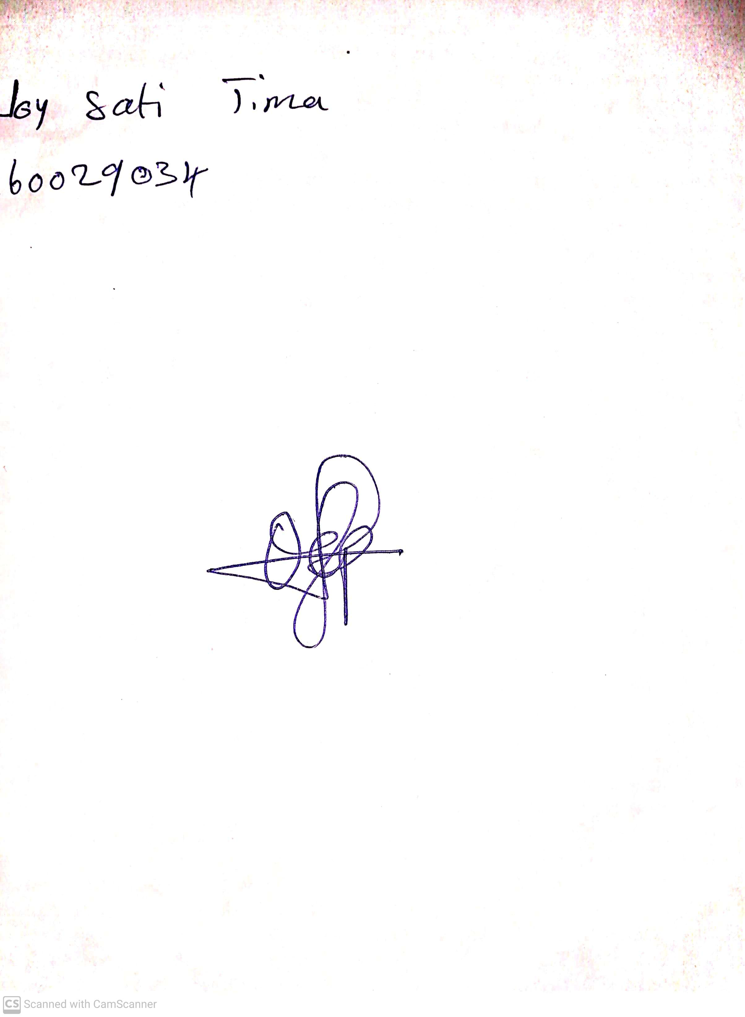

14th May, 2023

Perpetual Ojoma

Stream Head Nursery