**EMERALD ROYAL INTERNATIONAL SCHOOL**

**MPAPE, ABUJA.**

**LESSON PLAN AND NOTE FOR WEEK 1 ENDING 26TH APRIL,2024.**

TERM : Third term.

WEEK : 1

SUBJECT: Social Norms

TOPIC: Being friendly

SUB-TOPIC: Learning to be friendly and take turns.

DATE: 24 /4/2024

DURATION: 40 minutes

TIME: 10:40-11:20

PERIOD: 4th

CLASS: pre-nursery

NUMBER OF PUPILS: 19

AVERAGE AGE: 2

SEX: Mixed

SPECIFIC OBJECTIVES: By the end of the lesson, the pupils should be able to:-

1. Exhibit a friendly attitude towards one another.

2. Learn to take turns when playing on the slide.

RATIONALE: For pupils to be friendly and social.

PREVIOUS KNOWLEDGE: Pupils have been playing together.

INSTRUCTIONAL MATERIALS: Slide and rhymes

REFERENCE: Smart start Civic education for nursery Schools book 1 by T.Y. Alabi and A. M. Solu.

LESSON DEVELOPMENT

|  |  |  |  |
| --- | --- | --- | --- |
| Stages/steps | Teacher's activities | Pupils' activities | Learning points |
| Introduction | Teacher introduces the lesson by singing nursery rhymes for the pupils | Pupils sing the rhymes along with the teacher. | To get pupils attention for the lesson. |
| Presentation  Step 1 | Teacher takes the pupils outdoor to play on the slide. During the cause of playing, teacher explains to the pupils that they should always play together and have fun. | The pupils play outdoor together. | To improve pupils motor skills. |
| Step 2 | During the cause of the outdoor game, teacher encourages the pupils to take turns while playing on the slide and playing with building blocks. | Pupils play together and also take turns on the slide and on building blocks. | To enhance pupils groose motor skills. |
| Summary | Teacher summarizes the lesson by singing this rhyme:-  Row row your boat. | Pupils sing the rhyme along with the teacher. | To ensure better understanding of the lesson. |
| Evaluation | Teacher puts building blocks on the mat and step back ward to watch how the pupils will relate to each other. | Pupils relate to each other in a friendly way. | To assess pupils level of understanding of the lesson. |
| Conclusion | Teacher ends the lesson by singing:-  " I love you". | Pupils sing the rhyme along with the teacher. | To consolidate the lesson. |

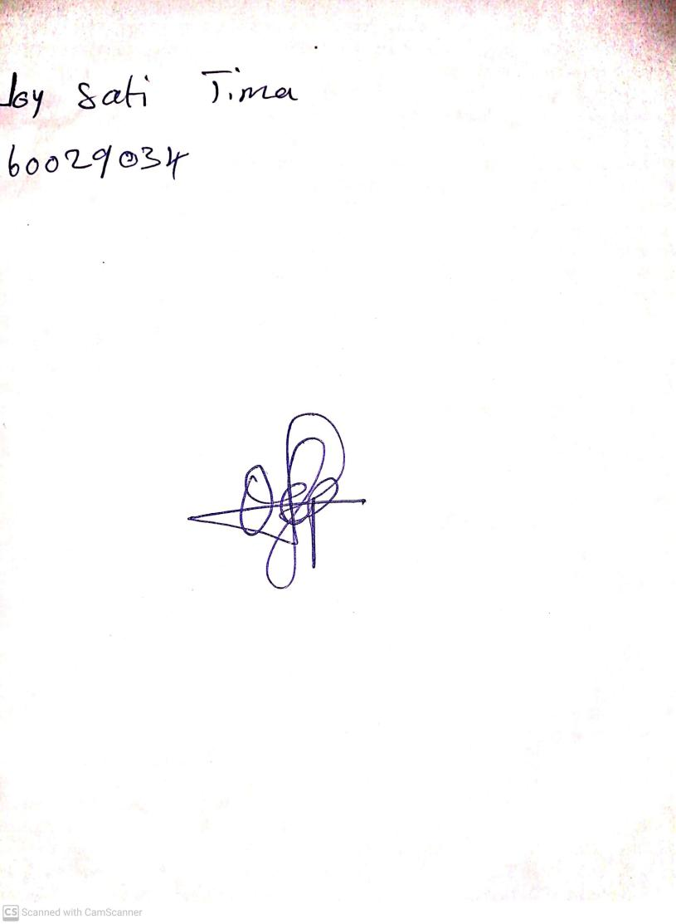

**19th April, 2024**

**Perpetual Ojoma Ocheja**

**Stream Head Nursery**