**EMERALD ROYAL INTERNATIONAL SCHOOL MPAPE, ABUJA.**

**LESSON PLAN AND NOTE FOR WEEK 3 1ST PERIOD ENDING 10/05/2024**

**TERM: 3rd**

**WEEK: 3rd**

**DATE: 06/05/2024**

**CLASS: Nursery 2**

**SUBJECT: Number work**

**TOPIC: Greater than (>) and less than (<)**

**SUB–TOPIC: Meaning of greater than (>) sign and examples.**

**PERIOD: 1st**

**TIME: 08:50–09:30 am**

**DURATION: 40 minutes**

**NUMBER IN CLASS: 13**

**AVERAGE AGE: 5 years**

**SEX: Mixed**

**LEARNING OBJECTIVES: By the end of the lesson, the Pupils should be able to:**

**1. Explain the meaning of greater than sign.**

**2. Identify the examples of greater than**

**RATIONALE: For Pupils to be able to know what its means by greater than.**

**PREVIOUS KNOWLEDGE: Pupils have learnt counting of numbers 1–45**

**INSTRUCTIONAL MATERIALS: Picture of a folded right elbow.**

**REFERENCE MATERIALS: New method mathematics for primary schools book 3 by C.F Oredugba, R.Ohuche etel**

**LESSON DEVELOPMENT**

|  |  |  |  |
| --- | --- | --- | --- |
| **STAGES/ STEPS** | **TEACHER'S ACTIVITIES** | **PUPILS' ACTIVITIES** | **LEARNING POINT** |
| **Introduction** | **Teacher introduces the lesson by asking pupils to all stand up and fold their right elbow and then say, greater than.** | **Pupils all stand up and do according to the instructions and say , greater than.** | **To arouse pupils interest for the lesson.** |
| **Presentation step 1** | **Teacher explains the meaning of greater than sign to pupils and then asks them to repeat after her.** | **Pupils listen to the teacher and repeat after her..** | **For proper understanding.** |
| **Step 2** | **Teacher then writes the examples of numbers on the board for pupils to identify the numbers that are greater than the other.** | **Pupils pay attention to the board and identify the numbers.** | **For better understanding.** |
| **Board summary** | **Teacher summarizes the lesson by writing the whole note of lesson on the board for pupils to copy. That is;**  **WHAT IS GREATER THAN SIGN?**    **“>”is greater than sign, it means that the value on the right side is greater than the value on the left side.**  **For example,**  **1. 9 > 1 which means 9 is greater than 1.**  **2. 8 > 6**  **3. 7 > 3**  **4. 10 > 5**  **5. 2 > 1**  **6. 1 > 0** | **Pupils copy the note into their exercise books.** | **For onward study.** |
| **Evaluation** | **Teacher asks the following questions;**  **1. What is greater than sign?**  **2. What is the symbol for the following**  **A. 5 — 2**  **B. 8 — 4**  **C. 3 — 1**  **D. 9 — 8**  **E. 6 — 4** | **Pupils answer the questions asked by the teacher.** | **To assess Pupils level of understanding.** |
| **Conclusion** | **Teacher concludes the lesson by marking pupils books.** | **Pupils submit their books for marking.** | **Fo endorsement.** |
| **Assignment** | **Answer the questions below.** | **Pupils do their assignment at home.** | **To encourage learning at home.** |

**LESSON PLAN AND NOTE FOR WEEK 3 2ND PERIOD ENDING 10/05/2024**

**TERM: 3rd**

**WEEK: 3**

**DATE: 07/05/2024**

**CLASS: Nursery 2**

**SUBJECT: Number work**

**TOPIC: Greater than (>) and less than (<)**

**SUB—TOPIC: Meaning of less than sign (>) and examples.**

**PERIOD: 2nd**

**TIME: 08:50—09:30**

**DURATION: 40 minutes**

**NUMBER IN CLASS: 13**

**AVERAGE AGE: 5 years**

**SEX: Mixed**

**LEARNING OBJECTIVES: By the end of the lesson, the Pupils should be able to:**

**1. Explain the meaning of less than sign**

**2 . Identify the examples of less than**

**RATIONALE: For Pupils to be able to know what its means by less than.**

**PREVIOUS KNOWLEDGE: Pupils have learnt about greater than in previous lesson.**

**INSTRUCTIONAL MATERIALS: Picture of a folded left elbow.**

**REFERENCE MATERIALS: New method mathematics for primary schools book 3 by C.F Oredugba, R.Ohuche etel**

**LESSON DEVELOPMENT**

|  |  |  |  |
| --- | --- | --- | --- |
| **STAGES/ STEPS** | **TEACHER'S ACTIVITIES** | **PUPILS' ACTIVITIES** | **LEARNING POINT** |
| **Introduction** | **Teacher introduces the lesson by asking pupils to all stand up and fold their left elbow and then say, less than.** | **Pupils all stand up and do according to the instructions and say , less than.** | **To arouse pupils interest for the lesson.** |
| **Presentation step 1** | **Teacher explains the meaning of less than sign to pupils and then asks them to repeat after her.** | **Pupils listen to the teacher and repeat after her..** | **For proper understanding.** |
| **Step 2** | **Teacher then writes the examples of numbers on the board for pupils to identify the numbers that are less than the other.** | **Pupils pay attention to the board and identify the numbers.** | **For better understanding.** |
| **Board summary** | **Teacher summarizes the lesson by writing the whole note of lesson on the board for pupils to copy. That is;.**  **WHAT IS LESS THAN SIGN?**    **“<”is less than sign, it means that the value on the left side is less than the value on the right side.**  **For example,**  **1. 15 < 16 which means 15 is less than 16.**  **2. 1 < 3**  **3. 4 < 7**  **4. 8 < 10**  **5. 3 < 4**  **6. 1< 2** | **Pupils copy the note into their exercise books.** | **For onward study.** |
| **Evaluation** | **Teacher asks the following questions;**  **1. What is less than sign?**  **2. Fill in the correct sign for the following**  **A. 1 — 2**  **B. 4 — 6**  **C. 3 — 4**  **D. 6 — 9**  **E. 5 — 6 etc** | **Pupils answer the questions asked by the teacher.** | **To assess Pupils level of understanding.** |
| **Conclusion** | **Teacher concludes the lesson by marking pupils books.** | **Pupils submit their books for marking.** | **Fo endorsement.** |
| **Assignment** | **Count and answer the following:** | **Pupils do the5r assignment at home.** | **To encourage learning at home.** |

**LESSON PLAN AND NOTE FOR WEEK 3 3RD PERIOD ENDING 10/05/2024**

**TERM: 3rd**

**WEEK: 3**

**DATE: 10/05/2024**

**CLASS: Nursery 2**

**SUBJECT: Number work**

**TOPIC: Greater than (>) and less than (<)**

**SUB—TOPIC: Identify and solve numbers with greater than and less than.**

**PERIOD: 3rd**

**TIME: 08:10—08:50 am**

**DURATION: 40 minutes**

**NUMBER IN CLASS: 13**

**AVERAGE AGE: 5 years**

**SEX: Mixed**

**LEARNING OBJECTIVES: By the end of the lesson, the Pupils should be able to:**

**1. Identify numbers that are greater than the order.**

**2. Mention numbers that are less than the order**

**3. Solve questions on greater than and less than.**

**RATIONALE: For Pupils to know more about the topic.**

**PREVIOUS KNOWLEDGE: Pupils have learnt about greater than and less than in previous lesson.**

**INSTRUCTIONAL MATERIALS: Picture of a folded left elbow and a folded right elbow.**

**REFERENCE MATERIALS: New method mathematics for primary schools book 3 by C.F Oredugba, R.Ohuche etel**

**LESSON DEVELOPMENT**

|  |  |  |  |
| --- | --- | --- | --- |
| **STAGES/ STEPS** | **TEACHER'S ACTIVITIES** | **PUPILS' ACTIVITIES** | **LEARNING POINT** |
| **Introduction** | **Teacher introduces the lesson by asking pupils to all stand up and fold their left elbow and right elbow and then say, less than, greater than.** | **Pupils all stand up and do according to the instructions and say , less than, greater than.** | **To arouse pupils interest for the lesson.** |
| **Presentation step 1** | **Teacher writes some numbers on the board for pupils to identify the numbers that are greater than the others. As;**  **1 and 3**  **6 and 5**  **8 and 6**  **1 and 2.** | **Pupils listen to the teacher and identify.as;**  **1 and 3 = 3 > 1**  **6 and 5 = 6 > 5**  **8 and 6 = 8 > 6**  **1 and 2 = 2 > 1** | **For proper understanding.** |
| **Step 2** | **Teacher guides pupils to mention numbers that are less than the others. As,**  **1 and 3**  **6 and 5**  **8 and 6**  **1 and 2.** | **Pupils mention the numbers that are less than the others. That is;**  **1 and 3 = 1 < 3**  **6 and 5 = 5 < 6**  **8 and 6 = 6 < 8**  **1 and 2 = 1 < 2** | **To enhance Pupils participation in class.** |
| **Step 3** | **Teacher then write some questions on the board and solve. That is;**  **What is the symbol for the following numbers?**  **1. 10 and 5**  **2. 5 and 10**  **3. 6 and 4**  **4. 4 and 6**  **Solution**  **1. 10 and 5 = 10 > 5**  **2. 5 and 10 = 5 < 10**  **3. 6 and 4 = 6 > 4**  **4. 4 and 6 = 4 < 6** | **Pupils pay attention to the board .** | **For better understanding.** |
| **Board summary** | **Teacher summarizes the lesson by going through the lesson on the board over and over again and then prepares pupils books for them to copy the note on the board.** | **Pupils listen to the teacher and copy the note into their exercise books.** | **For onward study.** |
| **Evaluation** | **Teacher asks the following questions;**  **Fill in the correct symbol.**  **1) 3 ____ 5**  **2) 1 ____ 3**  **3) 7 ____ 4**  **4) 10 ____ 5**  **5) 5 ____ 4**  **6) 4 ____5**  **7) 8 ____ 10**  **8) 5 ____ 8**  **9) 9 ____ 8**  **10) 1 ____ 0** | **Pupils answer the questions ask by the teacher.** | **To assess Pupils level of understanding.** |
| **Conclusion** | **Teacher concludes the lesson by marking pupils books.** | **Pupils submit their books for marking.** | **Fo endorsement.** |
| **Assignment** | **Section A:**  **Copy and complete. Use the correct symbol: <, > or =**  **1) 7_____ 6**  **2) 8_____ 7**  **3) 0_____ 4**  **4) 1 + 3**  **5) 2 ____ 5**  **Section B:**    **Section C:** | **Pupils do their assignment at home.** | **To encourage learning at home.** |

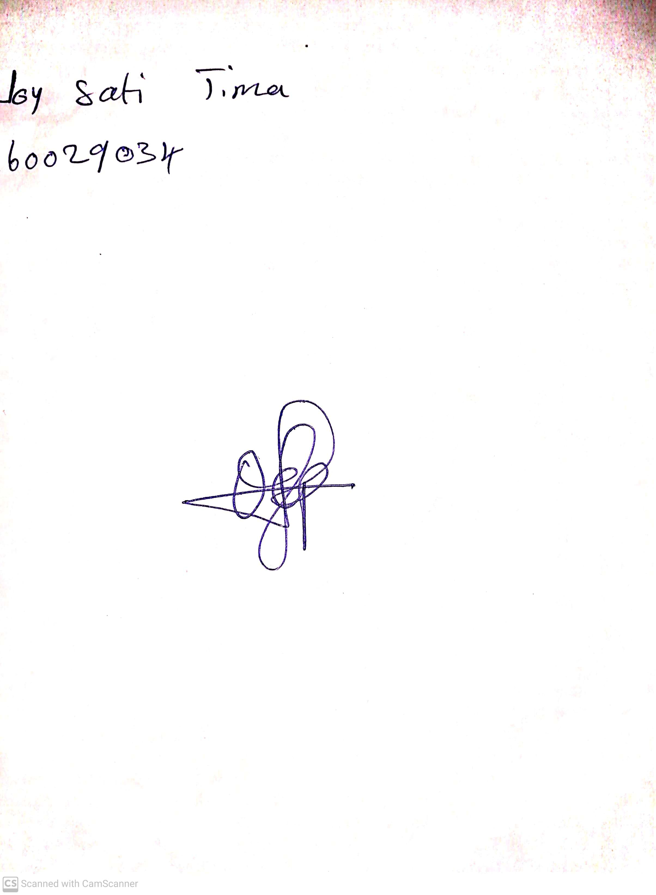

**3rd May, 2024**

**Perpetual Ojoma Ocheja**

**Stream Head Nursery**