**LESSON PLAN AND NOTE 1 FOR WEEK 4 ENDING 04/10/2024**

**Term 1st term**

**Week 4th week**

**Date 1st October,2024**

**Class Nursery One**

**Subject Number Work**

**Topic Counting numbers 1-40.**

**Sub-topic Count numbers 1-20**

**Period 2nd period**

**Time 8:50 am**

**Duration 35 minutes**

**No in class 15**

**Average Age 3 years**

**Sex Mixed**

**Specific Objectives: By the end of the lesson ,the pupils should be able to:**

1. **Count numbers 1-20.**
2. **Identify numbers 1-20.**
3. **Write numbers 1-20.**

**Rationale: To make sure the pupils count numbers 1-40.**

**Previous Knowledge: The pupils can match and fill in missing numbers.**

**Instructional Resources: Chart, board, marker, etc.**

**Reference Material: The new mastering mathematics.**

**LESSON PRESENTATION**

|  |  |  |  |  |
| --- | --- | --- | --- | --- |
| **Steps** | **Teacher’s Activities** | **Pupils’ Activities** | **Learning Points** | |
| **Introduction** | **The teacher introduces the topic (counting numbers 1-40) to the pupils by rhyming it.** | **The pupils with the teacher rhyme the numbers 1-40.** | **To arouse the pupils’ interest.** | |
| **Step 1** | **The teacher assists the pupils to count numbers 1-20**  **1 2 3 4 5**  **6 7 8 9 10**  **11 12 13 14 15**  **16 17 18 19 20** | **The pupils counts numbers 1-20 with their teacher.** | | **For proper understanding.** |
| **Step 2** | **The teacher leads the pupils to identify numbers 1-20**  **2 5 15 13**  **18 9 4 17 19**  **16 3 20** | **The pupils participate with the teacher in identifying numbers 1-20.**  **2 5 15 13**  **18 9 4 17 19**  **16 3 20** | | **For better understanding.** |
| **Step 3** | **The teacher guides the pupils to write numbers 1-20 inside their notebooks.** | **The pupils write numbers 1-20 as the teacher guides them.** | | **For further understanding** |
| **Summary** | **The teacher summarizes the lesson by counting numbers 1-20.** | **The pupils have master and count numbers 1-20.** | | **For onward study.** |
| **Evaluation** | **Count numbers 1-20**  **1 2 3 4 5**  **6 7 8 9 10**  **11 12 13 14 15**  **16 17 18 19 20**  **Identify numbers 1-20.**  **Write numbers 1-20 inside their notebooks.** | **The pupils answers the question correctly.** | | **To ascertain the pupils’ understanding.** |
| **Conclusion** | **The teacher summarizes, reacts and corrects the lesson.** | **The pupils gives answers to the teacher’s questions** | | **To consolidate the lesson** |
| **Assignment** | **Count numbers 1-20**  **1 2 3 4 5**  **6 7 8 9 10**  **11 12 13 14 15**  **16 17 18 19 20**  **Identify numbers 1-20.**  **Write the following numbers below**   |  |  | | --- | --- | | **1** | **2** | |  |  | | **3** | **4** | |  |  | | **5** | **6** | |  |  | | **7** | **8** | |  |  | | **9** | **10** | |  |  | | **The pupils copy and do their homework at home.** | | **To encourage learning while at home.** |

**LESSON PLAN AND NOTE 2 FOR WEEK 4 ENDING 04/10/2024**

**Term 1st term**

**Week 4th week**

**Date 3rd October,2024**

**Class Nursery One**

**Subject Number Work**

**Topic Counting numbers 1-40.**

**Sub-topic Count numbers 21-40**

**Period 4th period**

**Time 10:40 am**

**Duration 35 minutes**

**No in class 15**

**Average Age 3 years**

**Sex Mixed**

**Specific Objectives: By the end of the lesson ,the pupils should be able to:**

1. **Count numbers 21-40.**
2. **Identify numbers 21-40.**
3. **Write numbers 21-40.**

**Rationale: To make sure the pupils count numbers 140.**

**Previous Knowledge: The pupils knows how to count numbers 1-20.**

**Instructional Resources: Chart, board, marker, etc.**

**Reference Material: The new mastering mathematics.**

**LESSON PRESENTATION**

|  |  |  |  |
| --- | --- | --- | --- |
| **Steps** | **Teacher’s Activities** | **Pupils’ Activities** | **Learning Points** |
| **Introduction** | **The teacher introduces the topic (counting numbers 1-40) to the pupils by rhyming it.** | **The pupils with the teacher rhyme the numbers 1-40.** | **To arouse the pupils’ interest.** |
| **Step 1** | **The teacher assists the pupils to count numbers 21-40**  **21 22 23 24 25**  **26 27 28 29 30**  **31 32 33 34 35**  **36 37 38 39 40** | **The pupils counts numbers 21-40 with their teacher.** | **For proper understanding.** |
| **Step 2** | **The teacher leads the pupils to identify numbers 21-40**  **25 32 26 37**  **29 27 30 40** | **The pupils participate with the teacher in identifying numbers 21-40.**  **25 32 26 37**  **29 27 30 40** | **For better understanding.** |
| **Step 3** | **The teacher guides the pupils to write numbers 21-40 inside their notebooks.** | **The pupils write numbers 21-40 as the teacher guides them.** | **For further understanding** |
| **Summary** | **The teacher summarizes the lesson by counting numbers 21-40** | **The pupils have master and count numbers 21-40.** | **For onward study.** |
| **Evaluation** | **Count numbers 21-40**  **21 22 23 24 25**  **26 27 28 29 30**  **31 32 33 34 35**  **36 37 38 39 40**  **Identify numbers 21-40.**  **Write numbers 21-40 inside their notebooks.** | **The pupils answers the question correctly.** | **To ascertain the pupils’ understanding.** |
| **Conclusion** | **The teacher summarizes, reacts and corrects the lesson.** | **The pupils gives answers to the teacher’s questions** | **To consolidate the lesson** |
| **Assignment** | **Count numbers 21-40**  **21 22 23 24 25**  **26 27 28 29 30**  **31 32 33 34 35**  **36 37 38 39 40**  **Identify numbers 21-40.**  **Write the following numbers below**   |  |  | | --- | --- | | **31** | **32** | |  |  | | **33** | **34** | |  |  | | **35** | **36** | |  |  | | **37** | **38** | |  |  | | **39** | **40** | |  |  | | **The pupils copy and do their homework at home.** | **To encourage learning while at home.** |

**LESSON PLAN AND NOTE 3 FOR WEEK 4 ENDING 04/10/2024**

**Term 1st term**

**Week 4th week**

**Date 4th October,2024**

**Class Nursery One**

**Subject Number Work**

**Topic Counting numbers 1-40.**

**Sub-topic Matching numbers 30-40**

**Period 2nd period**

**Time 8:50 am**

**Duration 35 minutes**

**No in class 15**

**Average Age 3 years**

**Sex Mixed**

**Specific Objectives: By the end of the lesson ,the pupils should be able to:**

1. **Match numbers 30-40.**
2. **Fill in the numbers 35-40.**

**Rationale: To make sure the pupils match numbers 1-40.**

**Previous Knowledge: The pupils knows how to count numbers 20-40.**

**Instructional Resources: Chart, board, marker, etc.**

**Reference Material: The new mastering mathematics.**

**LESSON PRESENTATION**

|  |  |  |  |
| --- | --- | --- | --- |
| **Steps** | **Teacher’s Activities** | **Pupils’ Activities** | **Learning Points** |
| **Introduction** | **The teacher introduces the topic (counting numbers 1-40) to the pupils by rhyming it.** | **The pupils with the teacher rhyme the numbers 1-40.** | **To arouse the pupils’ interest.** |
| **Step 1** | **The teacher assists the pupils to match numbers 30-40**  **30 40**  **31 39**  **32 38**  **33 37**  **34 36**  **35 35**  **36 34**  **37 33**  **38 32**  **39 31**  **40 30** | **The pupils match numbers 30-40 with their teacher.**  **30 40**  **31 39**  **32 38**  **33 37**  **34 36**  **35 35**  **36 34**  **37 33**  **38 32**  **39 31**  **40 30** | **For proper understanding.** |
| **Step 2** | **The teacher leads the pupils to fill in the numbers 35-40**  **35 ____ 37 ______ 39**  **____** | **The pupils participate with the teacher in filling in the missing numbers 35-40.**  **35 36 37**  **38 39 40** | **For better understanding.** |
| **Summary** | **The teacher summarizes the lesson by counting numbers**  **1-40** | **The pupils have master and count numbers 1-40.** | **For onward study.** |
| **Evaluation** | **Match numbers 30-40**  **30 40**  **31 39**  **32 38**  **33 37**  **34 36**  **35 35**  **36 34**  **37 33**  **38 32**  **39 31**  **40 30**  **Count numbers 1-40.**  **Fill in the numbers 35-40**  **35 ____ 37 ______ 39**  **____** | **The pupils answers the question correctly.** | **To ascertain the pupils’ understanding.** |
| **Conclusion** | **The teacher summarizes, reacts and corrects the lesson.** | **The pupils gives answers to the teacher’s questions** | **To consolidate the lesson** |
| **Assignment** | **Match numbers 30-40**  **30 40**  **31 39**  **32 38**  **33 37**  **34 36**  **35 35**  **36 34**  **37 33**  **38 32**  **39 31**  **40 30**  **Fill in the missing numbers below**  **21 ____ 23 ____ 25**  **____27 ____ 29 ____**  **31 ____ 33 _____ 35**  **____ 37 ____ 39 ____** | **The pupils copy and do their homework at home.** | **To encourage learning while at home.** |

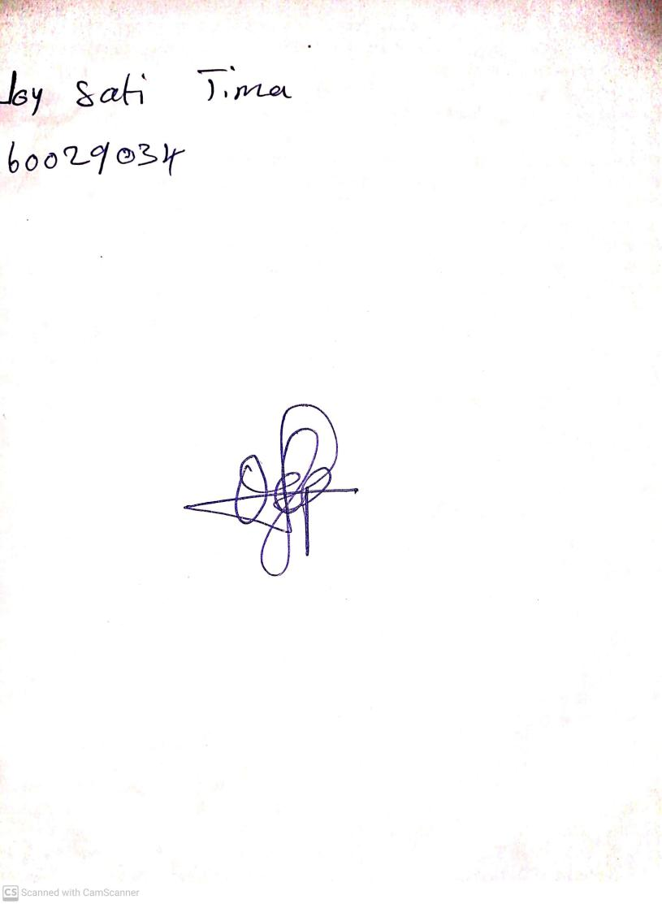

4th October, 2024

Perpetual Ojoma Ocheja

Stream Head Nursery