L**EMERALD ROYAL INTERNATIONAL SCHOOL, MPAPE ABUJA**

**LESSON PLAN AND NOTE FOR WEEK 1 ENDING 20th JANUARY, 2023**

**TERM:** SECOND TERM

**WEEK:** WEEK 2

**DATE** : 16th - 20th January 2023

**SUBJECT:** chemistry

**CLASS : SS 1**

**TOPIC :**  chemical combination

**SUB - TOPIC: 1**. weak bond

1. System of naming compounds

**PERIOD : 5th**

**TIME :** 11 :10 - 11: 50

**DURATION** : 40 minutes

**AVERAGE AGE** : 14 years

**SEX:** mixed

**LEARNING OBJECTIVES:** by the end of the lesson,the students, should be able to;

1. List the weak and strong bond.

**RATIONALE:** the students should understand the system of naming compounds.

**PREVIOUS KNOWLEDGE:** The students have been taught the first twenty element.

**INSTRUCTIONAL MATERIALS:** chart showing the first twenty element.

**Reference Material:** new school chemistry for senior secondary schools by Osei- Yaw Ababio.

**LESSON DEVELOPMENT**

|  |  |  |  |
| --- | --- | --- | --- |
| **STAGES** | **TEACHER’S ACTIVITIES** | **PUPILS ACTIVITIES** | **LEARNING POINT** |
| **INTRODUCTION** | The teacher introduces the lesson by reviewing the previous lesson. | The students were active. | To arouse the students interest. |
| **PRESENTATION**  **STEP 1** | The teacher lists the types of weak and strong bonds. | The students pay attention. | To keep them focus. |
| **STEP 2** | The teacher asks the students to give examples of strong and weak bonds. | The students give examples of strong and weak bond. | To encourage critical thinking. |
| **STEP 3** | The teacher explains steps in naming of compounds. | The students were active. | To keep them focus. |
| **BOARD SUMMARY** | TYPES OF BOND   1. Coordinate covalent bonding ( dative covalent) - The shared paired electron in coordinate covalent bond is donated by only one of the participants such a pair of electron is called the lone pair. Therefore one of the reactants in a coordinate covalent combination must have a lone pair. The coordinate covalent bond is represented by an arrow pointing from the donor atom to the acceptor atom.   Ammonia and water molecules possess lone pair and so readily enter into coordinate covalent combination.  Compound containing coordinate and covalent bonds have properties which are very similar to purely covalent compounds. The presence of a coordinate bond tends to make a compound less volatile.   1. Metallic bond - some metals have one or two valence electron which are loosely bond to the atom. These electron move among atoms in the metal. The force of attraction which holds metal atom together in crystal lattice are called matallic bond.. | The students ask questions for further clarification. | To create room for slow learners. |
| **Evaluation** | The teacher evaluates the students with the following questions:   1. state the modern periodic law. 2. State the formula to determine the maximum number of shells an element can have. 3. Configure the following; 4. Carbon 5. Neon 6. Calcium 7. State and explain electrovalent and covalent bond. 8. State at least 3 characteristics of electrovalent and covalent compounds. | The students attempt the questions. | To ascertain their level of understanding. |
| **Conclusion** | The teacher concludes by coping the note on the board. She checks and marks the note. | The students copy the note on the board. | For future use. |
| **Assignment** | 1. Configure the following compounds; 2. Silicon 3. Phosporus 4. Sulphur 5. Argon 6. Potassium. | The students did and submit their assignment for marking and correction. | To encourage the students to study at home. |

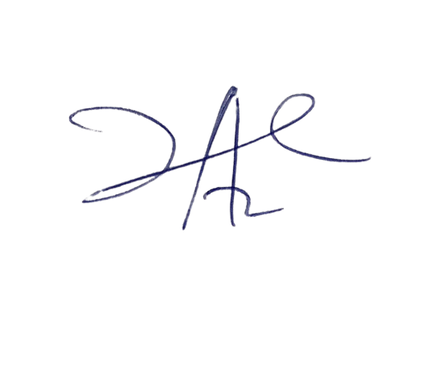

4/3/2023

Principal Head Instructor