LESSON PLAN AND NOTE FOR WEEK 4 ENDING 06/10/2023

TERM: 1st

WEEK: 4th

DATE: 02/10/2023

CLASS: Nursery 2

SUBJECT: Nature studies

TOPIC: Body care for cuts.

SUB—TOPIC: Meaning of cut and reasons for caring or cuts.

PERIOD: 4th

TIME: 10:40—11:20am

DURATION: 40 minutes

NUMBER IN CLASS: 14

AVERAGE AGE: 5 years

SEX: Mixed

LEARNING OBJECTIVES: By the end of the lesson, the pupils should be able to:

1. Explain the meaning of cut.
2. Mention the first aid treatment for cuts

3. State the reasons for caring for cuts.

RATIONALE: For pupils to know why we should always care for our wounds.

PREVIOUS KNOWLEDGE: Pupils have learnt how to care for their body in Previous lesson.

INSTRUCTIONAL MATERIALS: cotton wool, water and bandage.

REFERENCE MATERIALS: Basic science and technology for Nursery schools book 3 by OPEMIPO DADA.

LESSON DEVELOPMENT

|  |  |  |  |
| --- | --- | --- | --- |
| Steps | Teacher's activities | Pupils' activities | Learning point |
| Introduction | Teacher introduces the lesson by reviewing the previous lesson. | Pupils pay attention to the teacher. | To prepare pupils minds for the lesson ahead. |
| Presentation step 1 | Teacher explains the meaning of cut to pupils and then asks them to repeat after her. | Pupils listen to the teacher and repeat after her. | To improve pupils listening and speaking ability. |
| Step 2 | Teacher mentions the first aid treatment for cuts to pupils and also asks them to repeat after her. | Pupils listen very attentively to the teacher and repeat after her. | To improve pupils speaking ability. |
| Step 3 | Teacher States the reasons why we should care for cut to pupils and also asks them to repeat after her. | Pupils pay attention to the teacher and repeat her. | To enhance pupils participation in the class. |
| Board summary | Teacher writes the whole note of lesson on the board for pupils to copy into their books. That is;  Body care for cuts:  A cut is an opening on the body made with a sharp object like a knife, scissors or razor blade.  Sample first aid treatment for cuts:   1. Stop the bleeding by pressing on the cut with a clean cloth. 2. Wash the cut with warm water. 3. Clean the cut with cotton wool soaked in iodine or antiseptic wash. 4. Cover the cut with a plaster or bandage.   Why we care for cut:   1. To reduce the risk of infections. 2. To stop the bleeding. 3. To promote healing etc. | Pupils copy the note into their exercise books. | For onward study. |
| Evaluation | Teacher evaluates the lesson by asking pupils the following questions;   1. What is a cut? 2. Mention the first aid treatment for cuts. 3. What are the reasons why we care for cut? | Pupils answer the questions asked by the teacher. | To assess pupils level of understanding. |
| Conclusion | Teacher concludes the lesson by marking pupils books. | Pupils submit their books for marking. | For endorsement. |
| Assignment | 1. Define wound. 2. Mention at least 5 first aid treatment for wounds. | Pupils do their assignment at home. | To encourage learning at home. |

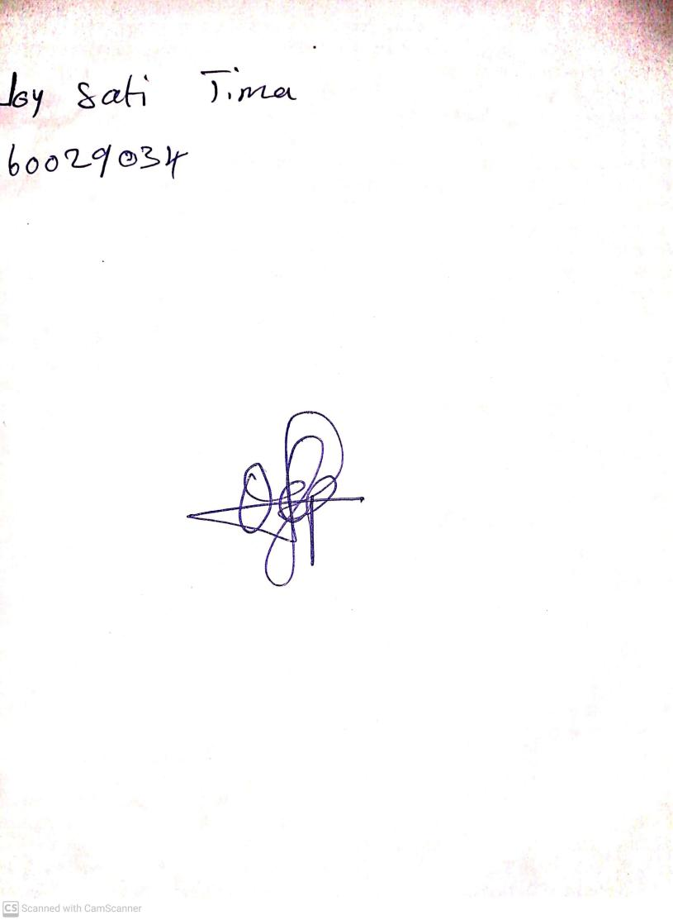

27th August, 2023

Perpetual Ojoma Ocheja

Stream Head Nursery