**LESSON PLAN AND NOTE 1 FOR WEEK 6 ENDING 18/10/2024**

**Term 1st  term**

**Week 6th  week**

**Date 14th October,2024**

**Class Nursery one**

**Subject Letter work**

**Topic Matching letter Uu - Zz with picture words.**

**Sub-topic Matching letter Uu - Vv with picture words.**

**Period 2nd period**

**Time 8:50 am**

**Duration 35 minutes**

**No in class 15**

**Average Age 3 years**

**Sex Mixed**

**Specific Objectives: By the end of the lesson the pupils should be able to;**

1. **Match letter Uu - Vv with picture words.**
2. **Write letter Uu - Vv.**

**Rationale: To make sure the pupils match and write Uu - Vv.**

**Previous knowledge: The pupils can match letters Pp - Tt with picture words.**

**Instructional Resources: Chart, board, marker, exercise books, pencils.**

**Reference Materials: Online Research,chart,board.**

**LESSON PRESENTATION**

|  |  |  |  |
| --- | --- | --- | --- |
| **Steps** | **Teacher’s Activities** | **Pupils’ Activities** | **Learning points** |
| **Introduction** | **The teacher introduces the topic (Matching letter Uu - Zz with picture words) to the pupils.** | **The pupils listen attentively to the teacher.** | **To arouse the interest of the pupils.** |
| **Step 1** | **The teacher leads the pupils to to associate letter Uu - Vv with picture words.**  **Uu image of van**  **Vv image of an umbrella** | **The pupils associate pictures with words along with the teacher.**  **Uu image of van**  **Vv image of an umbrella** | **For proper understanding.** |
| **Step 2** | **The teacher guides the pupils to write capital and small letter Uu - Vv inside their notebooks.**   |  |  | | --- | --- | | **Uu** | **Uu** | |  |  | | **Vv** | **Vv** | |  |  | | **The pupils writes capital and smallletter Uu - Vv inside their notebooks.** | **For better understanding.** |
| **Summary** | **The teacher summarizes the lesson by sounding the capital and small letter Uu - Vv for the pupils.** | **The pupils sounds along with their teacher capital and small letter Uu - Vv.** | **For onward study.** |
| **Evaluation** | 1. **Associate letter Uu - Vv with picture words.**   **Uu image of van**  **Vv image of an umbrella**   1. **Write the capital and small letters below:**  |  |  | | --- | --- | | **Uu** | **Uu** | |  |  | | **The pupils answer the question correctly.** | **To ascertain the pupils’ understanding.** |
| **Conclusion** | **The teacher summarizes, reacts & corrects the pupils.** | **The pupils answer to the teacher’s questions.** | **To consolidate the lesson.** |
| **Assignment** | 1. **Write the capital and small letters below:**  |  |  | | --- | --- | | **Uu** | **Uu** | |  |  |  1. **Associate picture words to their letters below:**   **Uu image of van**  **Vv image of an umbrella** | **The pupils copy and do their homework at home.** | **To encourage learning while at home.** |

**LESSON PLAN AND NOTE 2 FOR WEEK 6 ENDING 18/10/2024**

**Term 1st  term**

**Week 6th  week**

**Date 16th October,2024**

**Class Nursery one**

**Subject Letter work**

**Topic Matching letter Uu - Zz with picture words.**

**Sub-topic Matching letter Ww - Xx with picture words.**

**Period 4th period**

**Time 10:40 am**

**Duration 35 minutes**

**No in class 15**

**Average Age 3 years**

**Sex Mixed**

**Specific Objectives: By the end of the lesson the pupils should be able to;**

1. **Match letter Ww - Xx with picture words.**
2. **Write letter Ww - Xx.**

**Rationale: To make sure the pupils match and write Ww - Xx.**

**Previous knowledge: The pupils can match letters Uu - Vv with picture words.**

**Instructional Resources: Chart, board, marker, exercise books, pencils.**

**Reference Materials: Online Research,chart,board.**

**LESSON PRESENTATION**

|  |  |  |  |
| --- | --- | --- | --- |
| **Steps** | **Teacher’s Activities** | **Pupils’ Activities** | **Learning points** |
| **Introduction** | **The teacher introduces the topic (Matching letter Uu - Zz with picture words) to the pupils.** | **The pupils listen attentively to the teacher.** | **To arouse the interest of the pupils.** |
| **Step 1** | **The teacher leads the pupils to to associate letter Ww - Xx with picture words.**  **Xx image of window**  **Ww image of xylophone** | **The pupils associate pictures with words letter Ww - Xx along with the teacher.**  **Xx image of window**  **Ww image of xylophone** | **For proper understanding.** |
| **Step 2** | **The teacher guides the pupils to write capital and small letter Ww - Xx inside their notebooks.**   |  |  | | --- | --- | | **Ww** | **Ww** | |  |  | | **Xx** | **Xx** | |  |  | | **The pupils writes capital and small letter Ww - Xx inside their notebooks.** | **For better understanding.** |
| **Summary** | **The teacher summarizes the lesson by sounding the capital and small letter Ww - Xx for the pupils.** | **The pupils sounds along with their teacher capital and small letter Ww - Xx.** | **For onward study.** |
| **Evaluation** | 1. **Associate letter Ww - Xx with picture words.**   **Xx image of window**  **Ww image of xylophone**   1. **Write the capital and small letters below:**  |  |  | | --- | --- | | **Xx** | **Xx** | |  |  | | **The pupils answer the question correctly.** | **To ascertain the pupils’ understanding.** |
| **Conclusion** | **The teacher summarizes, reacts & corrects the pupils.** | **The pupils answer to the teacher’s questions.** | **To consolidate the lesson.** |
| **Assignment** | 1. **Write the capital and small letters below:**  |  |  | | --- | --- | | **Xx** | **Xx** | |  |  |  1. **Associate picture words to their letters below:**   **Xx image of window**  **Ww image of xylophone** | **The pupils copy and do their homework at home.** | **To encourage learning while at home.** |

**LESSON PLAN AND NOTE 3 FOR WEEK 6 ENDING 18/10/2024**

**Term 1st  term**

**Week 6th  week**

**Date 18th October,2024**

**Class Nursery one**

**Subject Letter work**

**Topic Matching letter Uu - Zz with picture words.**

**Sub-topic Matching letter Yy - Zz with picture words.**

**Period 2nd period**

**Time 8:50 am**

**Duration 35 minutes**

**No in class 15**

**Average Age 3 years**

**Sex Mixed**

**Specific Objectives: By the end of the lesson the pupils should be able to;**

1. **Match letter Yy - Zz with picture words.**
2. **Write letter Yy - Zz .**

**Rationale: To make sure the pupils match and write Yy - Zz .**

**Previous knowledge: The pupils can match with picture words letters Ww - Xx.**

**Instructional Resources: Chart, board, marker, exercise books, pencils.**

**Reference Materials: Online Research,chart,board.**

**LESSON PRESENTATION**

|  |  |  |  |
| --- | --- | --- | --- |
| **Steps** | **Teacher’s Activities** | **Pupils’ Activities** | **Learning points** |
| **Introduction** | **The teacher introduces the topic (Matching letter Uu - Zz with picture words) to the pupils.** | **The pupils listen attentively to the teacher.** | **To arouse the interest of the pupils.** |
| **Step 1** | **The teacher leads the pupils to to match letter Yy - Zz with picture words.**  **Zz image of a yam**  **Yy image of a zebra** | **The pupils match pictures with words letters Yy - Zz along with the teacher.**  **Zz image of a yam**  **Yy image of a zebra** | **For proper understanding.** |
| **Step 2** | **The teacher guides the pupils to write capital and small letter Yy - Zz inside their notebooks.**   |  |  | | --- | --- | | **Yy** | **Yy** | |  |  | | **Zz** | **Zz** | |  |  | | **The pupils writes capital and smallletter Yy - Zz inside their notebooks.** | **For better understanding.** |
| **Summary** | **The teacher summarizes the lesson by sounding the capital and small letter Yy - Zz for the pupils.** | **The pupils sounds along with their teacher capital and small letter Yy - Zz.** | **For onward study.** |
| **Evaluation** | 1. **Match letter Yy - Zz with picture words.**   **Zz image of a yam**  **Yy image of a zebra**   1. **Write the capital and small letters below:**  |  |  | | --- | --- | | **Yy** | **Yy** | |  |  | | **The pupils answer the question correctly.** | **To ascertain the pupils’ understanding.** |
| **Conclusion** | **The teacher summarizes, reacts & corrects the pupils.** | **The pupils answer to the teacher’s questions.** | **To consolidate the lesson.** |
| **Assignment** | 1. **Write the capital and small letters below:**  |  |  | | --- | --- | | **Yy** | **Yy** | |  |  |  1. **Associate picture words to their letters below:**   **Zz image of a yam**  **Yy image of a zebra** | **The pupils copy and do their homework at home.** | **To encourage learning while at home.** |

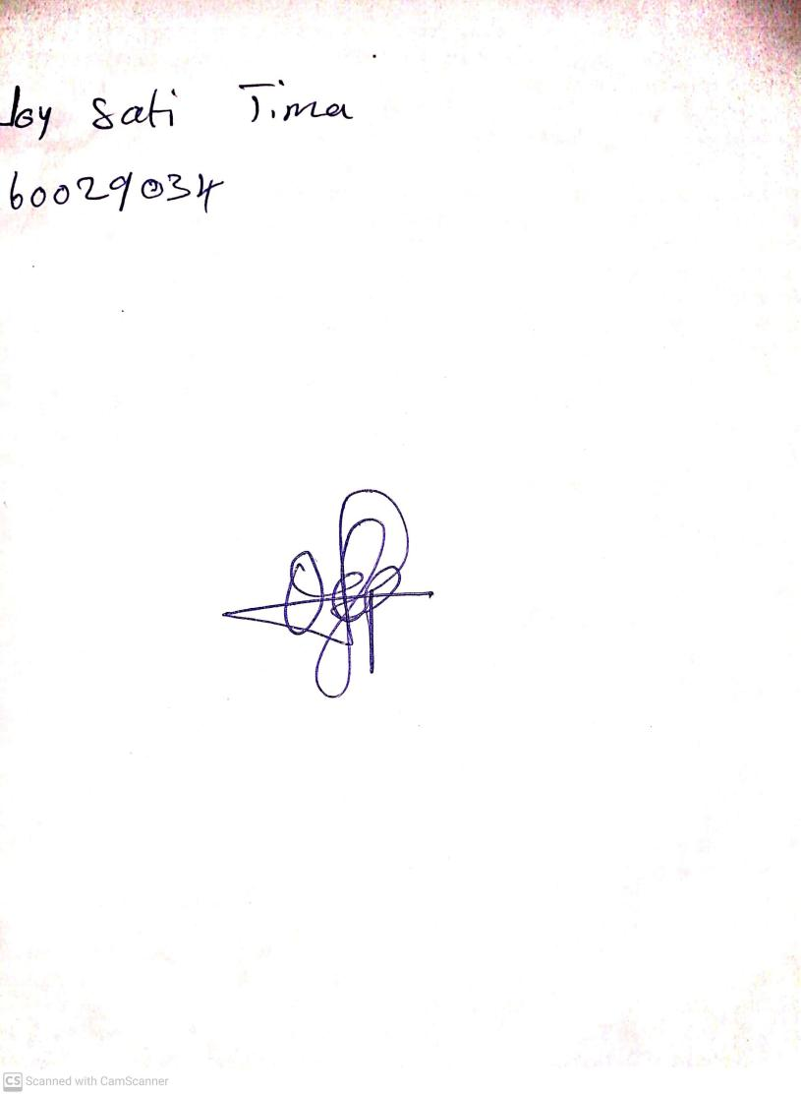

18th October, 2024

Perpetual Ojoma Ocheja

Stream Head Nursery