**LESSON PLAN AND NOTE 1 FOR WEEK 8 ENDING 3/11/2023**

**Term 1st  term**

**Week 8th week**

**Date 31st November,2023**

**Class Nursery one**

**Subject Letter work**

**Topic Tracing letter Kk - Pp.**

**Sub-topic Trace letter Kk , Ll.**

**Period 2nd period**

**Time 8:50 am**

**Duration 35 minutes**

**No in class 15**

**Average Age 3 years**

**Sex Mixed**

**Specific Objectives: By the end of the lesson the pupils should be able to;**

1. **Sound letter Kk , Ll.**
2. **Identify letter Kk , Llc.**
3. **Trace letter Kk , Ll.**

**Rationale: To make sure the pupils sound trace and identify letter Kk-Pp.**

**Previous knowledge: The pupils can trace letter Aa-Jj.**

**Instructional Resources: Chart, board, marker, exercise books, pencils.**

**Reference Materials: Online Research,chart,board.**

**LESSON PRESENTATION**

|  |  |  |  |
| --- | --- | --- | --- |
| **Steps** | **Teacher’s Activities** | **Pupils’ Activities** | **Learning points** |
| **Introduction** | **The teacher introduces the topic (Tracing of letters Kk - Pp) to the pupils by rhyming it.** | **The pupils listen attentively to the teacher.** | **To arouse the interest of the pupils.** |
| **Step 1** | **The teacher assists the pupils to sound letters Kk , Ll**  **K k**  **L l** | **The pupils individually sound the letters Kk , Ll.** | **For proper understanding.** |
| **Step 2** | **The teacher leads the pupils to identify letter Kk , Ll .**  **Kk Ll** | **The pupils identify the letter Kk , Ll after the teacher.** | **For better understanding.** |
| **Step 3** | **The teacher guides the pupils in tracing letters Kk , Ll inside their notebooks**  **untraced letter Kk**  **untraced letter Ll** | **The pupils trace the letters Kk , Ll as the teacher guides them.** | **For further understanding.** |
| **Summary** | **The teacher summarizes the lesson by sounding capital and small letter Kk , Ll.** | **The pupils can sound capital and small letter Kk , Ll.** | **For onward study.** |
| **Evaluation** | **The teacher asks the pupils to:**   1. **Sound the letters below?**     **Kk Ll**   1. **Identify these letters below?**   **Kk Ll**     1. **Trace the letters Kk and Ll below?**   **untraced letter Kk**  **untraced letter Ll** | **The pupils answer the question correctly.** | **To ascertain the pupils’ understanding.** |
| **Conclusion** | **The teacher summarizes, reacts & corrects the pupils.** | **The pupils answer to the teacher’s questions.** | **To consolidate the lesson.** |
| **Assignment** | **Sound the letters below?**    **Kk Ll**  **Identify these letters below?**  **Kk Ll**  **Trace capital and small letter Kk, Ll?**  **untraced letter Kk**  **untraced letter Ll** | **The pupils copy and do their homework at home.** | **To encourage learning while at home.** |

**LESSON PLAN AND NOTE 2 FOR WEEK 8 ENDING 3/11/2023**

**Term 1st  term**

**Week 8th week**

**Date 1st  November,2023**

**Class Nursery one**

**Subject Letter work**

**Topic Tracing letter Kk - Pp.**

**Sub-topic Trace letter Mm, Nn.**

**Period 4th period**

**Time 10:40 am**

**Duration 35 minutes**

**No in class 15**

**Average Age 3 years**

**Sex Mixed**

**Specific Objectives: By the end of the lesson the pupils should be able to;**

1. **Sound letter Mm, Nn.**
2. **Identify letter Mm, Nn.**
3. **Trace letter Mm, Nn.**

**Rationale: To make sure the pupils trace and identify letter Kk-Pp.**

**Previous knowledge: The pupils can trace and identify letter Kk, Ll.**

**Instructional Resources: Chart, board, marker, exercise books, pencils.**

**Reference Materials: Online Research,chart,board.**

**LESSON PRESENTATION**

|  |  |  |  |
| --- | --- | --- | --- |
| **Steps** | **Teacher’s Activities** | **Pupils’ Activities** | **Learning points** |
| **Introduction** | **The teacher introduces the topic (Tracing letter Kk-Pp) to the pupils by rhyming them.** | **The pupils listen attentively to the teacher.** | **To arouse the interest of the pupils.** |
| **Step 1** | **The teacher assists the pupils to sound letter Mm, Nn.**  **Mm Nn** | **The pupils individually sound the letters Mm, Nn.** | **For proper understanding.** |
| **Step 2** | **The teacher leads the pupils to identify letter Mm, Nn.**    **Mm Nn** | **The pupils identify the letter Mm, Nn after the teacher.** | **For better understanding.** |
| **Step 3** | **The teacher guides the pupils in tracing letters Mm, Nn**  **untraced letter Mm**  **untraced letter Nn** | **The pupils trace the letters Mm, Nn as the teacher guides them.** | **For further understanding.** |
| **Summary** | **The teacher summarizes the lesson by sounding letters Mm, Nn to the pupils.** | **The pupils can sound letters Mm, Nn.** | **For onward study.** |
| **Evaluation** | **The teacher asks the pupils to:**   1. **Sound the letters below?**   **Mm Nn**   1. **Identify these letters below?**   **Mm Nn**   1. **Trace the letters below?**   **untraced letter Mm**  **untraced letter Nn** | **The pupils answer the question correctly.** | **To ascertain the pupils’ understanding.** |
| **Conclusion** | **The teacher summarizes, reacts & corrects the pupils.** | **The pupils answer to the teacher’s questions.** | **To consolidate the lesson.** |
| **Assignment** | **Sound the letters below?**  **Mm Nn**  **Identify these letters below?**  **Mm Nn**  **Trace capital and small letter Mm, Nn?**  **untraced letter Mm**  **untraced letter Nn** | **The pupils copy and do their homework at home.** | **To encourage learning while at home.** |

**LESSON PLAN AND NOTE 3 FOR WEEK 8 ENDING 3/11/2023**

**Term 1st  term**

**Week 8th week**

**Date 3rd November,2023**

**Class Nursery one**

**Subject Letter work**

**Topic Tracing letter Kk - Pp.**

**Sub-topic Trace letter Oo, Pp.**

**Period 2nd period**

**Time 8:50 am**

**Duration 35 minutes**

**No in class 15**

**Average Age 3 years**

**Sex Mixed**

**Specific Objectives: By the end of the lesson the pupils should be able to;**

1. **Sound letter Oo, Pp.**
2. **Identify letter Oo, Pp.**
3. **Trace letter Oo, Pp.**

**Rationale: To make sure the pupils trace and identify letter Kk-Pp.**

**Previous knowledge: The pupils can trace and identify letter Mm, Nn.**

**Instructional Resources: Chart, board, marker, exercise books, pencils.**

**Reference Materials: Online Research,chart,board.**

**LESSON PRESENTATION**

|  |  |  |  |
| --- | --- | --- | --- |
| **Steps** | **Teacher’s Activities** | **Pupils’ Activities** | **Learning points** |
| **Introduction** | **The teacher introduces the topic (Tracing letter Kk-Pp) to the pupils by rhyming them.** | **The pupils listen attentively to the teacher.** | **To arouse the interest of the pupils.** |
| **Step 1** | **The teacher assists the pupils to sound letter Oo, Pp.**  **Oo Pp** | **The pupils individually sound the letters Oo, Pp.** | **For proper understanding.** |
| **Step 2** | **The teacher leads the pupils to identify letter Oo, Pp.**    **Oo Pp** | **The pupils identify the letter Oo, Pp after the teacher.** | **For better understanding.** |
| **Step 3** | **The teacher guides the pupils in tracing letters Oo, Pp**  **untraced letter Oo**  **untraced letter Pp** | **The pupils trace the letters Oo, Pp as the teacher guides them.** | **For further understanding.** |
| **Summary** | **The teacher summarizes the lesson by sounding letters Oo, Pp to the pupils.** | **The pupils can sound letters Oo, Pp.** | **For onward study.** |
| **Evaluation** | **The teacher asks the pupils to :**   1. **Sound the letters below?**   **Oo Pp**   1. **Identify these letters below?**   **Oo Pp**   1. **Trace the letters below?**   **untraced letter Oo**  **untraced letter Pp** | **The pupils answer the question correctly.** | **To ascertain the pupils’ understanding.** |
| **Conclusion** | **The teacher summarizes, reacts & corrects the pupils.** | **The pupils answer to the teacher’s questions.** | **To consolidate the lesson.** |
| **Assignment** | **Sound the letters below?**  **Oo Pp**  **Identify these letters below?**  **Oo Pp**  **Trace capital and small letter Oo, Pp?**  **untraced letter Oo**  **untraced letter Pp** | **The pupils copy and do their homework at home.** | **To encourage learning while at home.** |

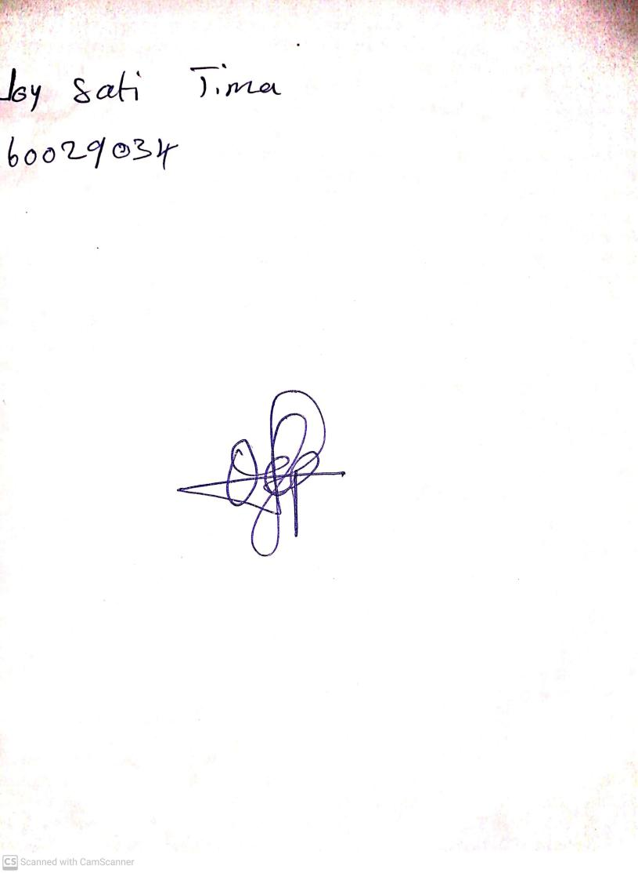

3RD OCTOBER, 2023

Perpetual Ojoma Ocheja

Stream Head Nursery