**EMERALD ROYAL INTERNATIONAL SCHOOL MPAPE, ABUJA**

**NURSERY 2 (TWO) SCHEME OF WORK**

**1ST TERM**

**MORAL INSTRUCTIONS**

|  |  |  |
| --- | --- | --- |
| **WEEKS** | **TOPICS** | **CONTENT/ACTIVITIES** |
| **1** | **Gender issues in child care: play** | **-Simple meaning of play.**  **-Meaning of gender.**  **-Identify self as male or female.** |
| **2** | **Gender issues in child care: games** | **-Functions of games in our society.**  **-Some local game e.g suwe, tenten.** |
| **3** | **Sharing** | **-simple meaning of sharing.**  **-items e.g pencils, erasers, seat, umbrella etc.** |
| **4** | **Songs** | **-Meaning of songs.**  **-Organise singing activities for children irrespective of their sex.** |
| **5** | **Folk tales** | **- Tell stories that will make pupils to appreciate one another irrespective of their sex.** |
| **6** | **Making polite request to others.** | **- The use of “please---, “kindly allow me to ----, “can I ----?** |
| **7** | **Natural shapes** | **- Different shapes in the environment e.g full moon - circle, lips-oval, nose- triangle, finger- cylinder etc.** |
| **8** | **Natural colours** | **- Identify some natural colours in the environment e.g, wool-white, rose/hibiscus flower-red, leaf-green, sky-blue, egg yolk/ripe mango-yellow etc.** |
| **9** | **Responsibility** | **- Simple meaning of responsibility. E.g, do not litter class, street, road, gutter or places of worship, punctuality- getting to functions early, playing safely etc.** |
| **10** | **Showing gratefulness to others** | **- The use of ‘Thank you’ I’m very happy, I’m glad, it’s okay!, I’m satisfied.** |
| **11** | **Rendering apologies** | **- The use of ‘I’m sorry’, please forgive me, please I’m wrong, oh it is a mistake, pardon me, I made a mistake.** |
| **12** | **Revision** |  |
| **13** | **Examination** |  |

**EMERALD ROYAL INTERNATIONAL SCHOOL MPAPE, ABUJA**

**NURSERY 2 (TWO) SCHEME OF WORK**

**2ND TERM**

**MORAL INSTRUCTIONS**

|  |  |  |
| --- | --- | --- |
| **WEEKS** | **TOPICS** | **CONTENT/ACTIVITIES** |
| **1** | **Revision** | **Revision of 1st term’s work** |
| **2** | **Punctuality** | **Simple meaning of punctuality. E.g school, places of worship etc.** |
| **3** | **Responsibilities : home** | **- e.g sweeping, dusting, washing etc.**  **- materials for cleaning e.g broom, brush, napkin etc.** |
| **4** | **Responsibilities : school** | **- class arrangement, returning lost items, caring for junior pupils in the school etc.** |
| **5** | **Responsibilities : religious places** | **Pupils should take care of personal and communal belongings at the places of worship.** |
| **6** | **Care for public property** | **-e.g closing unused water taps, switching off electric lights not needed, etc.** |
| **7** | **Responsibilities : religious places** | **- Discuss some items to take care of in the places of worship.** |
| **8** | **Obedience** | **-simple meaning of obedience.**  **-Actions of obedience e.g doing home work, leaving playground after lunch break, obeying traffic rules etc.** |
| **9** | **Self control** | **-simple meaning of self control.**  **-Actions to show self control e,g**  **To keep away from fighting, telling lies, stealing etc.** |
| **10** | **Good habits: Taking excuse to enter/leave a house or room.** | **Explain the disadvantages of not doing so.** |
| **11-12** | **Revision** |  |
| **13-14** | **Examination** |  |

**EMERALD ROYAL INTERNATIONAL SCHOOL MPAPE, ABUJA**

**NURSERY 2 (TWO) SCHEME OF WORK**

**3RD TERM**

**MORAL INSTRUCTIONS**

|  |  |  |
| --- | --- | --- |
| **WEEKS** | **TOPICS** | **CONTENT/ACTIVITIES** |
| **1** | **Revision** | **Revision of 2nd term’s work** |
| **2** | **Orderliness: Home** | **- Simple meaning of orderliness.**  **-maintain orderliness in bathroom, toilet, kitchen etc.** |
| **3** | **Orderliness: Neatness** | **- Simple meaning of neatness.**  **-importance of neatness in the house.** |
| **4** | **Orderliness: School** | **-Simple meaning of orderliness at schools. Places to maintain laws of orderliness e.g school assembly, play ground, stairways,books store etc.** |
| **5** | **Orderliness: Community** | **- Meaning of orderliness in the community. E.g bank, local market.** |
| **6** | **Orderliness: Community** | **-Take turns in a queue.** |
| **7** | **Maintaining a neat appearance always.** | **-Advantages of appearing neat always.** |
| **8** | **Cooperation: Schools** | **-Meaning of cooperation between pupils and the school authority. E.g.** |
| **9** | **Cooperation: Home** | **-Meaning of cooperation between children and their parents.**  **-Example of cooperation between children and parents on food, schooling, health etc.** |
| **10** | **Good Habits: saving for tomorrow** | **-Appreciate and practice savings.**  **-The need to save food, clothes,books,money etc, for our future use and that of others.** |
| **11-12** | **Revision** |  |
| **13-14** | **Examination** |  |

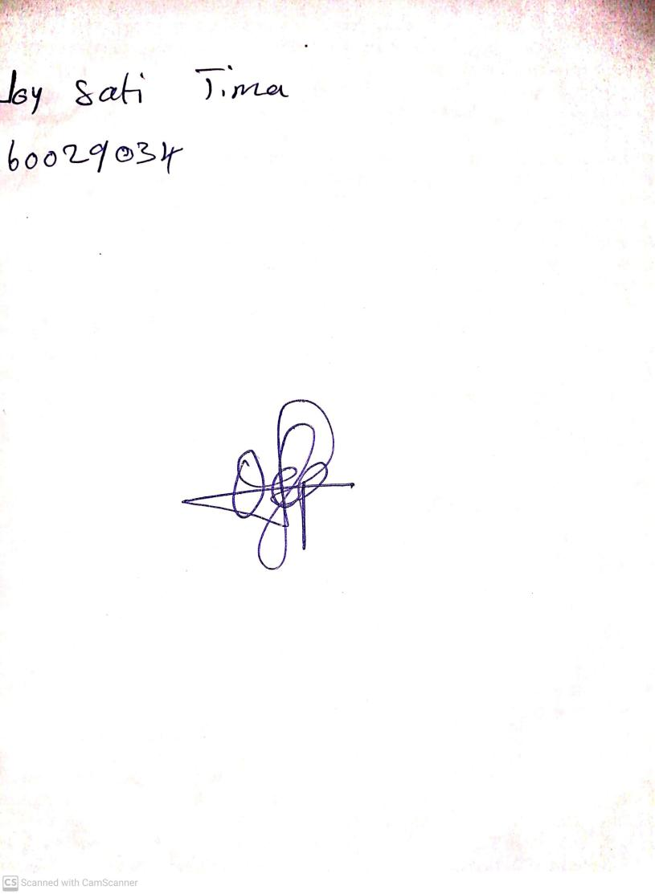

11TH OCTOBER, 2023

Perpetual Ojoma Ocheja

Stream Head Nursery