EMERALD ROYAL INTERNATIONAL SCHOOL

MPAPE, ABUJA.

LESSON PLAN AND NOTE FOR WEEK 4 ENDING 5TH OCTOBER,2023

TERM: First term.

WEEK: Four

SUBJECT: Nature studies.

TOPIC: Uses of sense organs.

SUB-TOPIC: Identification of the sense organs of the body.

DATE: 1/10/2023

DURATION: 40 minutes

TIME: 08:50-09:30

PERIOD: 3rd

CLASS: Pre-nursery

NUMBER OF PUPILS: 10

AVERAGE AGE: 2 years

SEX: Mixed

SPECIFIC OBJECTIVES: By the end of the lesson, the pupils should be able to:-

I Identify the sense organs.

2. Mention the names of the Sense organs.

RATIONALE: For Pupils to identify their sense organs.

PREVIOUS KNOWLEDGE: Pupils have been making use of their body parts to hear,see taste e.t.c.

INSTRUCTIONAL MATERIALS: Charts video clips.

REFERENCE: Showers kiddies books Elementary science book nursery 1 by Showers kiddies books.

LESSON DEVELOPMENT

|  |  |  |  |
| --- | --- | --- | --- |
| Stages/steps | Teacher's activities | Pupils' activities | Learning points |
| Introduction | Teacher introduces the lesson by asking the pupils to touch their body parts. | Pupils listen and touch their body parts as instructed by the teacher. | To arouse the interest of the pupils. |
| Presentation  Step 1 | Teacher models the pupils to identify some sensitive parts of their body such as-: eyes,skin,ear .e.t.c. | Pupils identify the sensitive parts of their body such as-: eyes,skin,ear as sense organs. | For better understanding of the lesson. |
| Step 2 | Teacher mentions the names of the sense organs such as:-  --- Eyes.  --- Ear.  --- Skin.  --- Tongue.  --- Nose . | Pupils listen to the teacher as she mention the sense . | For better understanding of the lesson. |
| Summary | Teacher summarizes the lesson by going over the lesson again for better understanding of the lesson. | Pupils listen attentively to the teacher as she is going over the lesson again. | To ensure better understanding. |
| Evaluation | Teacher asks the Pupils to :-  1. Identify two sense organs in their body parts.   1. Mention the names of the sense organs. | Pupils answer the teacher's questions correctly. | To ascertain the level of pupils understanding of the lesson. |
| Conclusion | Teacher concludes the lesson by singing nursery rhymes for the pupils. | Pupils sing along with the teacher. | For onwards learning. |
| Assignment | Teacher asks the pupils to circle the sense organs in this diagram. | Pupils do the assignment at home. | To encourage Learning at home. |

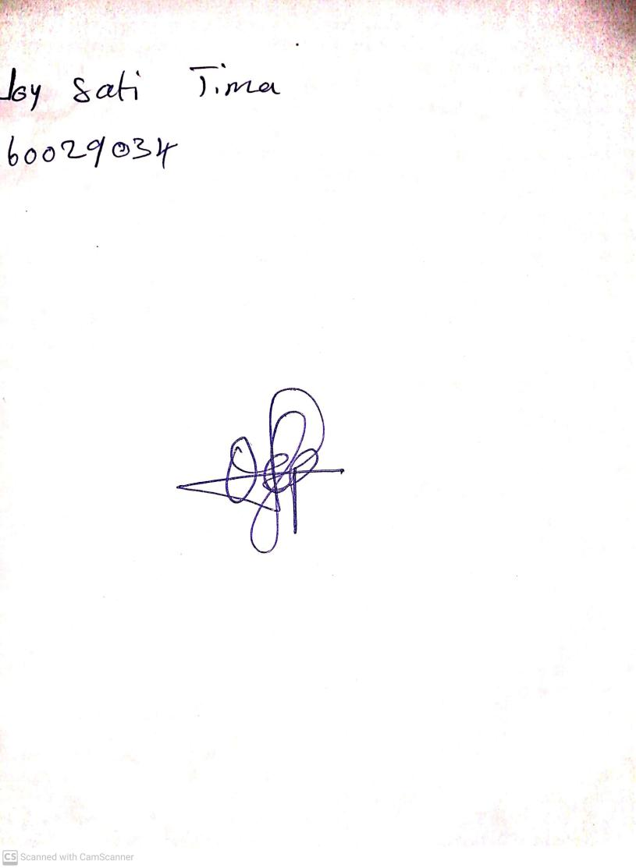

20th August, 2023

Perpetual Ojoma Ocheja

Stream Head Nursery