**EMERALD ROYAL INTERNATIONAL SCHOOL MPAPE, ABUJA**

**LESSON PLAN AND NOTE FOR WEEK 6 PERIOD 1 ENDING 16/02/2024**

**TERM: 2nd**

**WEEK: 6th**

**DATE: 12/02/2024**

**CLASS: Nursery 2**

**SUBJECT: Number work**

**TOPIC: Ascending order of numbers**

**SUB—TOPIC: Meaning of Ascending order and examples of numbers in Ascending order.**

**PERIOD: 3rd**

**TIME: 08:50 — 09:30am**

**DURATION: 40 minutes**

**NUMBER IN CLASS: 13**

**AVERAGE AGE: 5 years**

**SEX: Mixed**

**LEARNING OBJECTIVES: By the end of the lesson, the Pupils should be able to:**

**1. Explain the meaning of numbers in Ascending order.**

**2. Identify the examples of numbers in Ascending order.**

**RATIONALE: For pupils to know what Ascending order of numbers means.**

**PREVIOUS KNOWLEDGE: Pupils have learnt the meaning and examples of descending order of numbers in previous lesson.**

**INSTRUCTIONAL MATERIALS: ` A chart of numbers in Ascending order.**

**REFERENCE MATERIALS: My choice of mathematics stage 3.**

**LESSON DEVELOPMENT**

|  |  |  |  |
| --- | --- | --- | --- |
| **stages/steps** | **Teacher's activities** | **Pupils' activities** | **Learning point** |
| **Introduction** | **Teacher introduces the lesson by reviewing the previous Lesson descending order of numbers.** | **Pupils pay attention to the teacher.** | **To arouse pupils interest for the lesson ahead.** |
| **Presentation step 1** | **Teacher explains the meaning of Ascending order of numbers and then asks Pupils to repeat after her.** | **Pupils listen attentively to the teacher and repeat after her.** | **For proper understanding.** |
| **Step 2** | **Teacher mention the examples of Ascending order of numbers to pupils and also asks them to repeat after her.** | **Pupils repeat the examples of Ascending order of numbers after the teacher.** | **For better understanding.** |
| **Board summary** | **Teacher writes the whole note of lesson on the board for pupils to copy into their books. That is;**  **ASCENDING ORDER OF NUMBERS**  **When numbers are arranged from the smallest to the biggest, it is called Ascending order.**  **EXAMPLES**  **1). 1 2 3 4 5**  **2). 7 8 9 10 11**  **3). 10 20 30 40 50 etc.** | **Pupils copy the note into their exercise books** | **For onward study.** |
| **Evaluation** | **Teacher writes numbers on the board for pupils to arrange in Ascending order one after the other. As;**  **1).6 8 7 10 9**  **2). 4 3 5 2 1**  **3). 7 5 6 8 4**  **4). 9 6 5 7 8**  **5). 3 6 7 4 5 etc.** | **Pupils go to the board one after the other and arrange the numbers in Ascending order.** | **To assess Pupils level of understanding.** |
| **Conclusion** | **Teacher concludes the lesson by marking pupils books.** | **Pupils submit their books for marking.** | **For endorsement.** |
| **Assignment (home work)** | **Arrange these numbers in Ascending order**  **1). 5,3,2,4,1**  **2). 8,9,6,5,7**  **3). 12,10,11,8,9**  **4). 20,25,23,24,21**  **5). 50,30,40,10,20** | **Pupils do their assignment at home.** | **To encourage learning at home.** |

**LESSON NOTE/PLAN FOR WEEK 6 PERIOD 2 ENDING 16/02/2024**

**TERM: 2ND**

**WEEK: 6TH**

**DATE: 15/02/2024**

**CLASS: Nursery 2**

**SUBJECT: Number work**

**TOPIC: Ascending order of numbers**

**SUB—TOPIC: Arranging numbers in Ascending order.**

**PERIOD : 2nd**

**TIME: 08:50—09:30am**

**DURATION: 40 minutes**

**NUMBER IN CLASS: 13**

**AVERAGE AGE: 5 years**

**SEX: Mixed**

**LEARNING OBJECTIVES: By the end of the lesson, the Pupils should be able to:**

**1). Identify numbers.**

**2). Arrange numbers in Ascending order.**

**RATIONALE: For pupils to be able to arrange numbers from the smallest to biggest.**

**PREVIOUS KNOWLEDGE: Pupils have learnt the meaning and examples of numbers in Ascending order.**

**INSTRUCTIONAL MATERIALS: A chart of numbers in Ascending order.**

**REFERENCE MATERIALS: My choice of mathematics stage 3.**

**LESSON DEVELOPMENT**

|  |  |  |  |
| --- | --- | --- | --- |
| **Steps** | **Teacher's activities** | **Pupils' activities** | **Learning point** |
| **Introduction** | **Teacher introduces the lesson by going through the previous Lesson on meaning and examples of Ascending order of numbers.** | **Pupils pay attention to the teacher.** | **To arouse pupils interest for the lesson ahead.** |
| **Presentation step 1** | **Teacher writes some numbers on the board for pupils to identify. That is;**  **1). 16 14 13 15 12**  **2). 26 24 23 22 25**  **3). 46 49 50 47 48**  **4). 5 2 3 4 1**  **5). 9 7 5 8 6 etc.** | **Pupils identify the numbers on the board.** | **To improve Pupils ability to identify numbers.** |
| **Step 2** | **Teacher guides pupils to arrange the numbers on the board in Ascending order.** | **Pupils arrange the numbers on the board in Ascending order. That is;**  **1). 16 14 13 15 12**  **= 12 13 14 15 16**  **2). 26 24 23 22 25**  **= 22 23 24 25 26**  **3). 46 49 50 47 48**  **= 46 47 48 49 50**  **4). 5 2 3 4 1**  **= 1 2 3 4 5**  **5). 9 7 5 8 6**  **= 5 6 7 8 9** | **To enhance Pupils thinking ability.** |
| **Board summary** | **Teacher summarizes the lesson by writing the whole note of lesson on the board for pupils to copy into their books. That is;**  **ARRANGING NUMBERS IN ASCENDING ORDER**  **Examples**  **1). 16 14 13 15 12**  **= 12 13 14 15 16**  **2). 26 24 23 22 25**  **= 22 23 24 25 26**  **3). 46 49 50 47 48**  **= 46 47 48 49 50**  **4). 50 30 40 10 20**  **= 10 20 30 40 50**  **5). 25 10 5 15 20**  **= 5 10 15 20 25** | **Pupils copy the note into their exercise books.** | **Fo onward study.** |
| **Evaluation** | **Teacher evaluates the lesson by writing numbers on the board for pupils to arrange one after another.**  **1). 10, 5 , 6 , 3 , 2**  **2). 15 , 16 , 18 , 14 , 13**  **3). 30 , 10 , 20 , 50, 40**  **4). 11 , 12, 14 , 13, 10 etc.** | **Pupils arrange the numbers on the board one after another.** | **To assess Pupils level of understanding.** |
| **Conclusion** | **Teacher concludes the lesson by marking pupils books.** | **Pupils submit their books for marking** | **For endorsement.** |
| **Assignment (home work)** | **Arrange in Ascending order**  **1). 13,15,16,17,14**  **2). 26,24,23,22,25**  **3). 23,25,24,22,26**  **4). 96,94,93,95,92**  **5). 79,76,75,78,77**  **6). 52,54,53,55,51** | **Pupils do their assignment at home.** | **To encourage learning at home.** |

**LESSON NOTE/ PLAN FOR WEEK 6 PERIOD 3 ENDIND 16/02/2024**

**TERM: 2nd**

**WEEK: 6th**

**DATE: 16/02/2024**

**CLASS : Nursery 2**

**SUBJECT : Number work**

**TOPIC : Ascending order of numbers**

**SUB—TOPIC: Arranging numbers in Ascending order**

**PERIOD: 3rd**

**TIME: 08: 10—08:50am**

**DURATION: 40 minutes**

**NUMBER IN CLASS: 13**

**AVERAGE AGE : 5 years**

**SEX: Mixed**

**LEARNING OBJECTIVES: By the end of the lesson, the Pupils should be able to:**

**1). Identify numbers.**

**2). Arrange numbers in Ascending order.**

**RATIONALE: For pupils to be conversant with numbers in Ascending order.**

**PREVIOUS KNOWLEDGE: Pupils have been arranging numbers in Ascending order.**

**INSTRUCTIONAL MATERIALS : A chart of numbers in Ascending order.**

**REFERENCE MATERIALS: My choice of mathematics stage 3.**

**LESSON DEVELOPMENT**

|  |  |  |  |
| --- | --- | --- | --- |
| **Steps** | **Teacher's activities** | **Pupils' activities** | **Learning point** |
| **Introduction** | **Teacher introduces the lesson by singing nursery number rhymes.** | **Pupils sing the rhymes along with the teacher.** | **To arouse pupils interest for the lesson ahead.** |
| **Presentation step 1** | **Teacher writes numbers on the board for pupils to identify. That is;**  **1). 15 17 16 19 18**  **2). 20 22 24 25 23**  **3). 32 35 34 33 36**  **4). 29 28 31 30 32**  **5). 23 25 26 24 22** | **Pupils pay attention to the teacher and identify the numbers on the board.** | **For proper understanding.** |
| **Step 2** | **Teacher guides pupils to arrange the numbers on the board in Ascending order** | **Pupils arrange the numbers in Ascending order, ie;**  **1). = 15 16 17 18 19**  **2). = 20 22 23 24 25**  **3). = 32 33 34 35 36**  **4). = 28 29 30 31 32**  **5). = 22 23 24 25 26** | **For better understanding.** |
| **Board summary** | **Teacher summarizes the lesson by preparing pupils books for them to copy the note on the board into their books.** | **Pupils copy the note on the board into their exercise books.** | **For onward study.** |
| **Evaluation** | **Teacher evaluates the lesson by going through the lesson over again.** | **Pupils listen attentively to the teacher.** | **To create platform for slow learners.** |
| **Conclusion** | **Teacher concludes the lesson by marking pupils books.** | **Pupils submit their books for marking.** | **For endorsement.** |
| **Assignment (home work)** | **Arrange the following numbers in Ascending order**  **1). 123 129 127 128**  **2). 163 165 162 164**  **3). 138 137 139 136**  **4). 51 50 49 47**  **5). 12 13 11 15**  **6). 23 25 26 24**  **7). 5 3 4 2**  **8). 3 5 7 9**  **9). 43 45 41 47**  **10). 12 14 13 15** | **Pupils do their assignment at home.** | **To encourage learning at home.** |

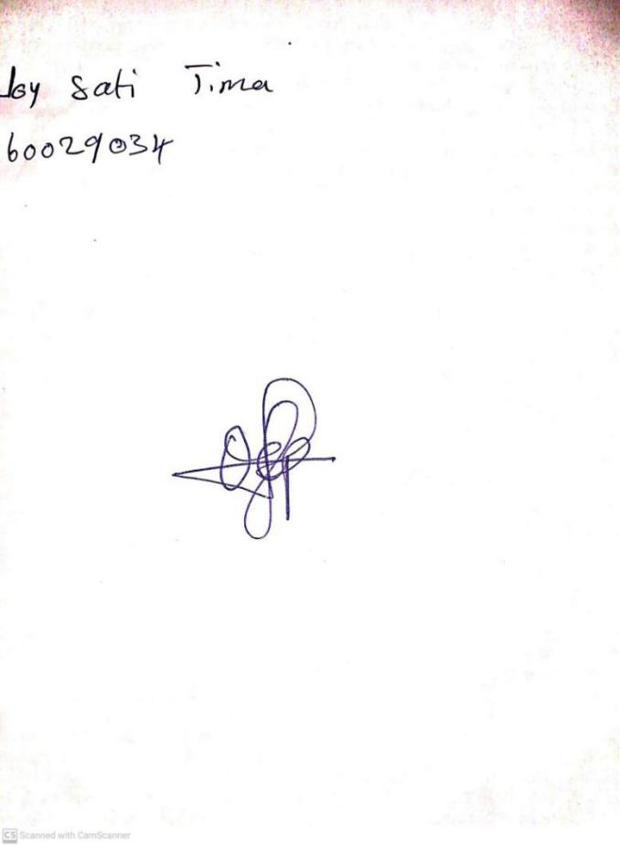

**9TH FEBRUARY, 2024**

**Perpetual Ojoma Ocheja**

**Stream Head Nursery**