**EMERALD ROYAL INTERNATIONAL SCHOOL MPAPE, ABUJA**

**NURSERY 2 (TWO) SCHEME OF WORK**

**1ST TERM**

**SOCIAL NORMS**

|  |  |  |
| --- | --- | --- |
| **WEEKS** | **TOPICS** | **CONTENT/ACTIVITIES** |
| **1** | **My rights** | **Explain rights and important.** |
| **2** | **Child abuse practices** | **Simple meaning, various child abuse** |
| **3** | **Forms of child abuse** | **Explains the forms of child abuse.**  **Ways of preventing child abuse.** |
| **4** | **Stigmatization** | **Explains stigmatization, effect e.g**  **Low self-esteem, lack of self- confidence, fear etc.** |
| **5** | **My responsibilities (at home)** | **Explains responsibilities in simple terms** |
| **6** | **My responsibilities (in school and my society)** | **Describes pupils responsibilities in school, explains pupils responsibilities in the society.** |
| **7** | **Saving** | **List and discuss things that must be saved like: money etc.** |
| **8** | **Harmful traditional practices** | **Explain the topic in simple terms**  **Examples and explain them..** |
| **9** | **Public places** | **Explain what public places is and examples,**  **Explain activities carried out in public places,** |
| **10-11** | **Religions in my country** | **Explain , types etc.** |
| **12** | **Revision** |  |
| **13** | **Examination** |  |

**EMERALD ROYAL INTERNATIONAL SCHOOL MPAPE, ABUJA**

**NURSERY 2 (TWO) SCHEME OF WORK**

**2ND TERM**

**SOCIAL NORMS**

|  |  |  |
| --- | --- | --- |
| **WEEKS** | **TOPICS** | **CONTENT/ACTIVITIES** |
| **1** | **Revision** | **Revision of 1st terms work** |
| **2** | **Peace education** | **Explain the need to live with others peacefully.** |
| **3** | **Emotions** | **Simple meaning of emotion.**  **Explain difference emotion that can be expressed.** |
| **4** | **My neighbours** | **Simple meaning of neighbour** |
| **5** | **Good behaviour (at public places)** | **Simple meaning of behaving well.**  **Ways of behaving well.** |
| **6** | **Occupations of my parents.** | **Work mummy and daddy do for a living and their work places.** |
| **7** | **Occupations of other people** | **Works other people do for a living.** |
| **8** | **States and capital** | **Introduce by telling pupils the name of our country with the use of map.** |
| **9** | **My hairstyle** | **Meaning and types** |
| **10** | **My country** | **Leads pupils to recite the National Anthem,National pledge, and importance of National pledge.** |
| **11-12** | **Revision** |  |
| **13** | **Examination** |  |

**EMERALD ROYAL INTERNATIONAL SCHOOL MPAPE, ABUJA**

**NURSERY 2 (TWO) SCHEME OF WORK**

**3RD TERM**

**SOCIAL NORMS**

|  |  |  |
| --- | --- | --- |
| **WEEKS** | **TOPICS** | **CONTENT/ACTIVITIES** |
| **1** | **Revision** | **Revision of 2nd terms work** |
| **2** | **Parental care: Effects of denial** | **Simple meaning , effect and important** |
| **3** | **Violence (physical)** | **Meaning, harmful effect and examples.** |
| **4** | **Violence(mental)** | **Definition of violence, mental violence, harmful effect and examples.** |
| **5** | **Care of children with special needs** | **Meaning of children with special needs.**  **Care for special needs.** |
| **6** | **Love and care for orphaned and vulnerable children** | **Simple meaning of the following,**  **Orphaned children, vulnerable children and various ways of caring for them.** |
| **7** | **Living with people with HIV/AIDS** | **Meaning of HIV/AIDS, ways it can be contacted.** |
| **8** | **My Country 2** | **Explain what Coat of Arms stands for and various characters seen in the Coat of Arms and Nigerian map.** |
| **9** | **Some basic home appliances.** | **List, describe some electrical and non-electrical home appliances.**  **Examples iron, kettle etc.** |
| **10-11** | **Revision** |  |
| **12-13** | **Examination** |  |

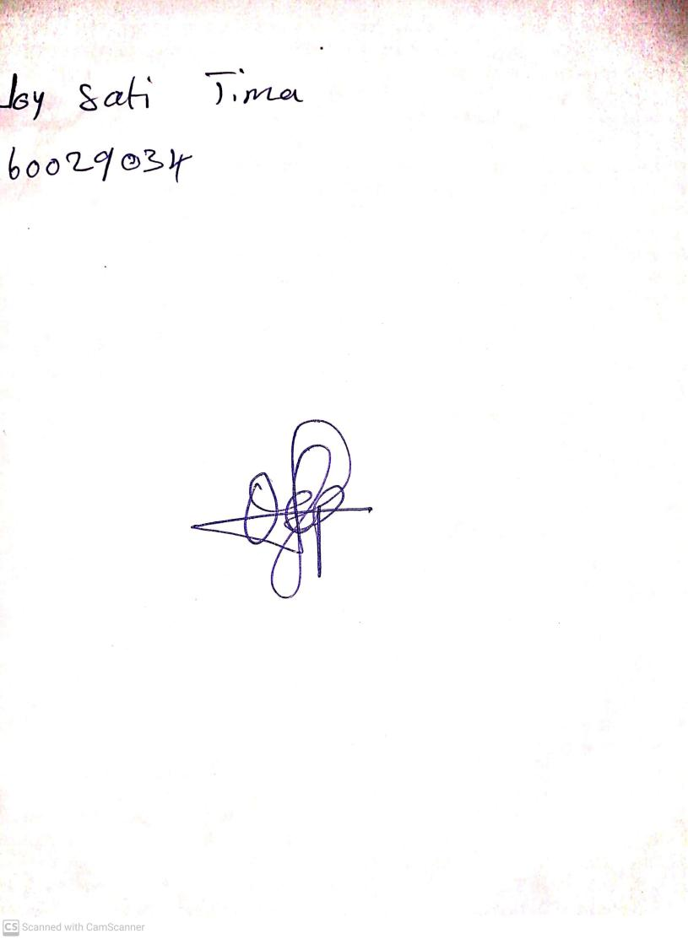

11TH OCTOBER, 2023

Perpetual Ojoma Ocheja

Stream Head Nursery