**LESSON PLAN AND NOTE 1 FOR WEEK 3 ENDING 27/09/2024**

**Term 1st  term**

**Week 3rd  week**

**Date 23rd September,2024**

**Class Nursery one**

**Subject Letter work**

**Topic Matching letter Aa - Jj with picture words.**

**Sub-topic Matching letter Aa - Cc with picture words.**

**Period 2nd period**

**Time 8:50 am**

**Duration 35 minutes**

**No in class 15**

**Average Age 3 years**

**Sex Mixed**

**Specific Objectives: By the end of the lesson the pupils should be able to;**

1. **Match letter Aa - Cc with picture words.**
2. **Write letter Aa - Cc.**

**Rationale: To make sure the pupils match and write Aa - Cc.**

**Previous knowledge: The pupils can write letters Aa - Bb.**

**Instructional Resources: Chart, board, marker, exercise books, pencils.**

**Reference Materials: Online Research,chart,board.**

**LESSON PRESENTATION**

|  |  |  |  |
| --- | --- | --- | --- |
| **Steps** | **Teacher’s Activities** | **Pupils’ Activities** | **Learning points** |
| **Introduction** | **The teacher introduces the topic (Matching letter Aa - Jj with picture words) to the pupils.** | **The pupils listen attentively to the teacher.** | **To arouse the interest of the pupils.** |
| **Step 1** | **The teacher leads the pupils to to associate letter Aa - Cc with picture words.**  **Cc download (2)**  **Aa download (3)**  **Bb download (4)** | **The pupils associate pictures with words along with the teacher.**  **Cc download (2)**  **Aa download (3)**  **Bb download (4)** | **For proper understanding.** |
| **Step 2** | **The teacher guides the pupils to write capital and small letter Aa - Cc inside their notebooks.**   |  |  | | --- | --- | | **Aa** | **Aa** | |  |  | | **Bb** | **Bb** | |  |  | | **Cc** | **Cc** | |  |  | | **The pupils writes capital and smallletter Aa - Cc inside their notebooks.** | **For better understanding.** |
| **Summary** | **The teacher summarizes the lesson by sounding the capital and small letter Aa - Cc for the pupils.** | **The pupils sounds along with their teacher capital and small letter Aa - Cc.** | **For onward study.** |
| **Evaluation** | 1. **Associate letter Aa - Cc with picture words.**   **Cc download (2)**  **Aa download (3)**  **Bb download (4)**   1. **Write the capital and small letters below:**  |  |  | | --- | --- | | **Bb** | **Bb** | |  |  | | **The pupils answer the question correctly.** | **To ascertain the pupils’ understanding.** |
| **Conclusion** | **The teacher summarizes, reacts & corrects the pupils.** | **The pupils answer to the teacher’s questions.** | **To consolidate the lesson.** |
| **Assignment** | 1. **Write the capital and small letters below:**  |  |  | | --- | --- | | **Bb** | **Bb** | |  |  |  1. **Associate picture words to their letters below:**   **Cc download (2)**  **Aa download (3)**  **Bb download (4)** | **The pupils copy and do their homework at home.** | **To encourage learning while at home.** |

**LESSON PLAN AND NOTE 2 FOR WEEK 3 ENDING 27/09/2024**

**Term 1st  term**

**Week 3rd  week**

**Date 25th September,2024**

**Class Nursery one**

**Subject Letter work**

**Topic Matching letter Aa - Jj with picture words.**

**Sub-topic Matching letter Dd - Ff with picture words.**

**Period 4th period**

**Time 10:40 am**

**Duration 35 minutes**

**No in class 15**

**Average Age 3 years**

**Sex Mixed**

**Specific Objectives: By the end of the lesson the pupils should be able to;**

1. **Match letter Dd - Ff with picture words.**
2. **Write letter Dd - Ff.**

**Rationale: To make sure the pupils match and write Dd - Ff.**

**Previous knowledge: The pupils can match letters Aa - Cc with picture words.**

**Instructional Resources: Chart, board, marker, exercise books, pencils.**

**Reference Materials: Online Research,chart,board.**

**LESSON PRESENTATION**

|  |  |  |  |
| --- | --- | --- | --- |
| **Steps** | **Teacher’s Activities** | **Pupils’ Activities** | **Learning points** |
| **Introduction** | **The teacher introduces the topic (Matching letter Aa - Jj with picture words) to the pupils.** | **The pupils listen attentively to the teacher.** | **To arouse the interest of the pupils.** |
| **Step 1** | **The teacher leads the pupils to to associate letter Dd - Ff with picture words.**  **Ff image of a fan**  **Dd image of an egg**  **Ee image of a dog** | **The pupils associate pictures with words letter Dd - Ff along with the teacher.**  **Ff image of a fan**  **Dd image of an egg**  **Ee image of a dog** | **For proper understanding.** |
| **Step 2** | **The teacher guides the pupils to write capital and small letter Dd - Ff inside their notebooks.**   |  |  | | --- | --- | | **Dd** | **Dd** | |  |  | | **Ee** | **Ee** | |  |  | | **Ff** | **Ff** | |  |  | | **The pupils writes capital and smallletter Dd - Ff inside their notebooks.** | **For better understanding.** |
| **Summary** | **The teacher summarizes the lesson by sounding the capital and small letter Dd - Ff for the pupils.** | **The pupils sounds along with their teacher capital and small letter Dd - Ff.** | **For onward study.** |
| **Evaluation** | 1. **Associate letter Dd - Ff with picture words.**   **Ff image of a fan**  **Dd image of an egg**  **Ee image of a dog**   1. **Write the capital and small letters below:**  |  |  | | --- | --- | | **Dd** | **Dd** | |  |  | | **Ee** | **Ee** | |  |  | | **Ff** | **Ff** | |  |  | | **The pupils answer the question correctly.** | **To ascertain the pupils’ understanding.** |
| **Conclusion** | **The teacher summarizes, reacts & corrects the pupils.** | **The pupils answer to the teacher’s questions.** | **To consolidate the lesson.** |
| **Assignment** | 1. **Write the capital and small letters below:**  |  |  | | --- | --- | | **Dd** | **Dd** | |  |  | | **Ee** | **Ee** | |  |  | | **Ff** | **Ff** | |  |  |  1. **Associate picture words to their letters below:**   **Ff image of a fan**  **Dd image of an egg**  **Ee image of a dog** | **The pupils copy and do their homework at home.** | **To encourage learning while at home.** |

**LESSON PLAN AND NOTE 3 FOR WEEK 3 ENDING 27/09/2024**

**Term 1st  term**

**Week 3rd  week**

**Date 27th September,2024**

**Class Nursery one**

**Subject Letter work**

**Topic Matching letter Aa - Jj with picture words.**

**Sub-topic Matching letter Gg - Jj with picture words.**

**Period 2nd period**

**Time 8:50 am**

**Duration 35 minutes**

**No in class 15**

**Average Age 3 years**

**Sex Mixed**

**Specific Objectives: By the end of the lesson the pupils should be able to;**

1. **Match letter Gg - Jj with picture words.**
2. **Write letter Gg - Jj .**

**Rationale: To make sure the pupils match and write Gg - Jj .**

**Previous knowledge: The pupils can match with picture words letters Dd - Ff.**

**Instructional Resources: Chart, board, marker, exercise books, pencils.**

**Reference Materials: Online Research,chart,board.**

**LESSON PRESENTATION**

|  |  |  |  |
| --- | --- | --- | --- |
| **Steps** | **Teacher’s Activities** | **Pupils’ Activities** | **Learning points** |
| **Introduction** | **The teacher introduces the topic (Matching letter Aa - Jj with picture words) to the pupils.** | **The pupils listen attentively to the teacher.** | **To arouse the interest of the pupils.** |
| **Step 1** | **The teacher leads the pupils to to associate letter Gg - Jj with picture words.**  **Hh image of toy gun**    **Gg image of a house**  **Jj image of an ink**  **Ii image of a jug** | **The pupils associate pictures with words along with the teacher.**  **Hh image of toy gun**    **Gg image of a house**  **Jj image of an ink**  **Ii image of a jug** | **For proper understanding.** |
| **Step 2** | **The teacher guides the pupils to write capital and small letter Gg - Jj inside their notebooks.**   |  |  | | --- | --- | | **Gg** | **Gg** | |  |  | | **Hh** | **Hh** | |  |  | | **Ii** | **Ii** | |  |  | | **Jj** | **Jj** | |  |  | | **The pupils writes capital and smallletter Gg - Jj inside their notebooks.** | **For better understanding.** |
| **Summary** | **The teacher summarizes the lesson by sounding the capital and small letter Gg - Jj for the pupils.** | **The pupils sounds along with their teacher capital and small letter Gg - Jj .** | **For onward study.** |
| **Evaluation** | 1. **Associate letter Gg - Jj with picture words.**   **Hh image of toy gun**    **Gg image of a house**  **Jj image of an ink**  **Ii image of a jug**   1. **Write the capital and small letters below:**  |  |  | | --- | --- | | **Gg** | **Gg** | |  |  | | **Jj** | **Jj** | |  |  | | **The pupils answer the question correctly.** | **To ascertain the pupils’ understanding.** |
| **Conclusion** | **The teacher summarizes, reacts & corrects the pupils.** | **The pupils answer to the teacher’s questions.** | **To consolidate the lesson.** |
| **Assignment** | 1. **Write the capital and small letters below:**  |  |  | | --- | --- | | **Gg** | **Gg** | |  |  | | **Jj** | **Jj** | |  |  |  1. **Associate picture words to their letters below:**   **Hh image of toy gun**    **Gg image of a house**  **Jj image of an ink**  **Ii image of a jug** | **The pupils copy and do their homework at home.** | **To encourage learning while at home.** |

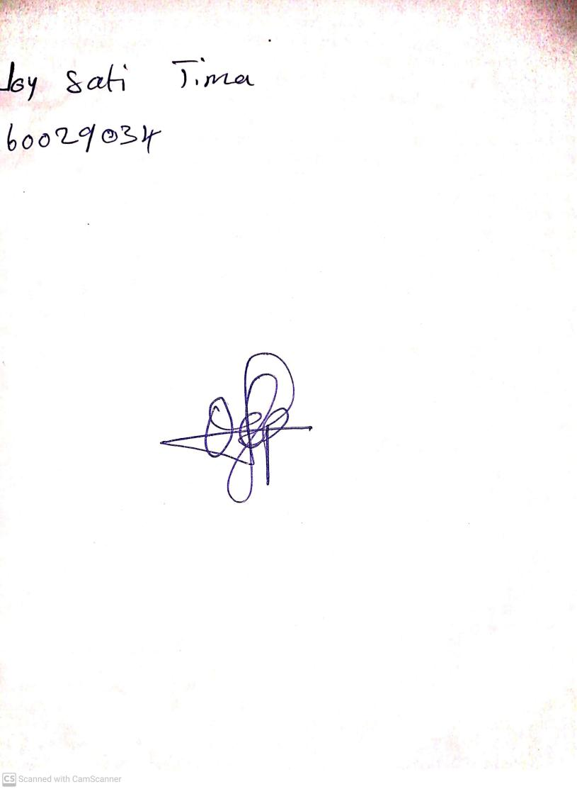

27th September, 2024

Perpetual Ojoma Ocheja

Stream Head Nursery