**LESSON PLAN AND NOTE FOR WEEK 6 ENDING 31/5/2024**

**Term 3rd term**

**Week 6th week**

**Date 29th  May,2024**

**Class Nursery one**

**Subject Nature studies**

**Topic Animals and their young ones**

**Sub-topic Naming different animals and their young ones.**

**Period 2nd period**

**Time 9:05 am**

**Duration 35 minutes**

**No in class 14**

**Average Age 3 years**

**Sex Mixed.**

**Specific Objectives: By the end of the lesson, the pupils should know how to:**

1. **Name different animals and their young ones.**
2. **Identify the different animals and their young ones.**

**Rationale: To help the pupils have knowledge of animals&their young ones**

**Previous Knowledge: The pupils have knowledge of Animals.**

**Instructional Resources: Online Research,Animals and their young ones chart.**

**Reference Materials: Online Research, Elementary Science by Showers Kiddies.**

**LESSON PRESENTATION**

|  |  |  |  |
| --- | --- | --- | --- |
| **Steps** | **Teacher’s Activities** | **Pupils’ Activities** | **Learning Points** |
| **Introduction** | **The teacher introduces the topic (Animals and their young ones ) by showing the pupils pictures of different kinds of animals and their young ones.** | **The pupils participates in seeing animals and their young ones.** | **To arouse the interest of the pupils.** |
| **Step 1** | **The teacher starts the lesson by teaching and listing the pupils animals and their young ones e.g**   |  |  | | --- | --- | | **Animals** | **Young ones** | | **Goat** | **Kid** | | **Lion** | **Cub** | | **Cow** | **Calf** | | **Cat** | **Kitten** | | **Duck** | **Duckling etc.** | | **The pupils listen attentively to the teacher and repeats after the teacher names of animals and their young ones.** | **For proper understanding.** |
| **Step 2** | **The teacher leads the pupils to identify animals and their young ones.** | **The pupils identify animals and their young ones with their teacher.** | **For better understanding.** |
| **Summary** | **The teacher summarizes the lesson by making the sound of animals for the pupils e.g**  **Cat sound MEOWS**  **Cow sound MOOO**  **Dogs barks**  **Goat bleats** | **The pupils with fun participates with the teacher in sounding animals.** | **For onward study.** |
| **Evaluation** | **Question:**  **What sound does Cow make?**  **Identify the young ones of a dog?** | **The pupils answer the question correctly.** | **To ascertain the pupils’ understanding.** |
| **Conclusion** | **The teacher summarizes, reacts, and corrects the pupils.** | **The pupils gives answers to the teacher’s question.** | **To consolidate the lesson.** |
| **Assignment** | **Question:**  **What sound does the below animals make?**  **Cow ________**  **Dog ________**  **Goat _________**  **Mention the two animals and their young ones?** | **The pupils copy and do their homework at home.** | **To encourage learning while at home.** |

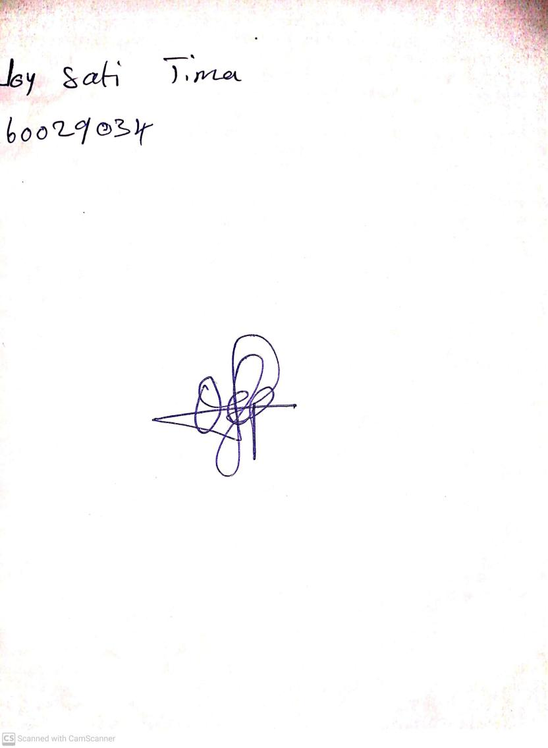

24th May, 2024

Perpetual Ojoma Ocheja

Stream Head Nursery