LESSON PLAN FOR WEEK 5, ENDING 2nd June, 2023.

|  |  |
| --- | --- |
| TERM | 3rd |
| WEEK | 5th |
| DATE | 1st June, 2023 |
| CLASS | SS1 |
| SUBJECT | History |
| TOPIC | Early European contact with the coastal states |
| SUB-TOPIC | Contact with the coastal states |
| PERIOD | 2nd |
| TIME | 8:50am-9:20am |
| DURATION | 40 Minutes |
| NO IN CLASS | 2 |
| AVERAGE AGE | 14years |
| SEX | Male |
| SPECIFIC OBJECTIVES | By the end of the lesson, scholars should be able to:   1. Explain the early European contact with the coastal states 2. lists the coastal states the Europeans had contact with and identify them on them on the map. |
| RATIONALE | To acquaint the scholars with the early European contact with the coastal states |
| PREVIOUS KNOWLEDGE | Scholars can explain the Nigerian contact with the external world |
| INSTRUCTIONAL RESOURCES | Charts from textbook explaining the topic. |
| REFERENCE MATERIAL | A History of Nigeria for Schools and Colleges.  GIC Eluwa (2017_. |

LESSON DEVELOPMENT

|  |  |  |  |
| --- | --- | --- | --- |
| STEPS | TEACHER’S ACTIVITIES | SCHOLARS’ ACTIVITIES | LEARNING POINTS |
| Introduction | The teacher introduces the topic by revising the previous topic with the scholars | The scholars respond and answer questions asked by the teacher. | To arouse scholars’ understanding of the topic. |
| Step 1 | The teacher explains THE EARLY European contact | The scholars pay attention. | To enhance proper understanding of the topic. |
| Step 2 | The teacher lists the coastal states the Europeans had contact with and identify them on them on the map. | The scholars listen and ask questions. | To encourage critical thinking on the topic. |
| Board summary | The teacher summarizes the lesson thus:  **The early European contact with the coastal states.**  Around the 15th century, Europeans explorers started travelling to different part of the world, including Africa. One of the first European to reach Nigeria was a Portuguese explorer named Rui de Sequira. In 1472, he landed in what is known as Lagos, which was then a small fishing village.  The first set of Europeans to explore the coastal of Nigeria were the Portuguese. By 1472, they had explored the Bights of Benin during the reign of Oba Ozolua. He traded in pepper with the people of Ughoton  In the early part of the 16th century, they explored and traded with the with the Itsekiri people. Articles of trade were glass, beads, perfumes etc they arrived Lagos in the 18th century trading at Badagry and Lagos ports.  Among the coastal states were   1. Itsekiri 2. Lagos 3. Calabar | The scholars copy notes into their notebooks. | For future references. |
| Evaluation | Evaluates the lesson thus:   1. Explain the early European contact with the coastal states 2. Lists the coastal states the Europeans had contact with and identify them on them on the map. | Respond to the questions asked | To ascertain the attainment of the stated behavioral objectives |
| Conclusion | Concludes the lesson by marking and correcting the scholars’ notebooks | Do the necessary corrections | For consolidation purpose |
| Assignment | The teacher gives assignment as follows:   1. List the coastal states that had early contact with the Europeans 2. What are the reasons for the contact | Copy and attempt the given assignments | For continuity of learning |

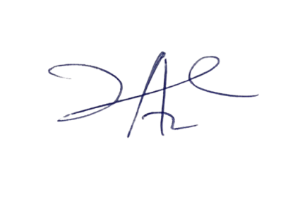

23/6/2023

Principal Head Instuctor