**LESSON PLAN AND NOTE 1 FOR WEEK 10 ENDING 28/06/2024**

**Term 3rd term**

**Week 10th week**

**Date 24/06/2024**

**Class Nursery One**

**Subject Letter Work**

**Topic Four letter words.**

**Sub-topic Naming four letter words.**

**Period 4th period**

**Time 10:40 am**

**Duration 35 minutes**

**No in class 14**

**Average Age 3 years**

**Sex Mixed**

**Specific Objectives: By the end of the lesson, the pupils should be able to:**

1. **Name four letter words.**
2. **Spell four letter words.**

**Rationale: To ensure the pupils name & spell four letter words.**

**Previous Knowledge: The pupils can match three letter words.**

**Instructional Resources: Four letter words chart, Online research.**

**Reference Material: Online research, chart.**

**LESSON PRESENTATION**

|  |  |  |  |
| --- | --- | --- | --- |
| **Steps** | **Teacher’s Activities** | **Pupils’ Activities** | **Learning Points** |
| **Introduction** | **The teacher introduces the lesson by reading four letter words from four letter words chart.** | **The pupils listen to the teacher.** | **To arouse the interest of the pupils.** |
| **Step 1** | **The teacher name four letter words for the pupils**  **band hand**  **part tank**  **land book**  **bank cake**  **sand rope** | **The pupils repeat after the teacher the four letter words.** | **For proper understanding of the pupils.** |
| **Step 2** | **The teacher leads the pupils to spell the four letter words**    **b-a-n-d h-a-n-d**  **p-a-r-t t-a-n-k**  **l-a-n-d b-o-o-k**  **b-a-n-k c-a-k-e**  **s-a-n-d r-o-p-e.** | **The pupils spell the four letter words**  **b-a-n-d h-a-n-d**  **p-a-r-t t-a-n-k**  **l-a-n-d b-o-o-k**  **b-a-n-k c-a-k-e**  **s-a-n-d r-o-p-e.** | **For better understanding.** |
| **Summary** | **The teacher summarizes the lesson by asking the pupils to spell random four letter words.** | **The pupils respond to the teacher actively.** | **For onward study.** |
| **Evaluation** | **Question:**  **Name (3) four letter words you know?**  **Spell (3) four letter words you know?** | **The pupils answer the question correctly.** | **To ascertain the pupils’ understanding.** |
| **Conclusion** | **The teacher reacts & summarizes the lesson to the pupils.** | **The pupils gives answer to the teacher’s question.** | **To consolidate the lesson.** |
| **Assignment** | **Question:**  **Name (3) four letter words you know?**  **Spell (3) four letter words you know?** | **The pupils copy and do their homework at home.** | **To encourage learning while at home.** |

**LESSON PLAN AND NOTE 2 FOR WEEK 10 ENDING 28/06/2024**

**Term 3rd term**

**Week 10th week**

**Date 26/06/2024**

**Class Nursery One**

**Subject Letter Work**

**Topic Four letter words.**

**Sub-topic Identifying four letter words.**

**Period 4th period**

**Time 10:40 am**

**Duration 35 minutes**

**No in class 14**

**Average Age 3 years**

**Sex Mixed**

**Specific Objectives: By the end of the lesson, the pupils should be able to:**

1. **Identify four letter words.**
2. **Write four letter words.**

**Rationale: To ensure the pupils identify & write four letter words.**

**Previous Knowledge: The pupils can name & spell four letter words.**

**Instructional Resources: Four letter words chart, Online research.**

**Reference Material: Online research, chart.**

**LESSON PRESENTATION**

|  |  |  |  |
| --- | --- | --- | --- |
| **Steps** | **Teacher’s Activities** | **Pupils’ Activities** | **Learning Points** |
| **Introduction** | **The teacher introduces the lesson by reading four letter words from four letter words chart.** | **The pupils listen to the teacher.** | **To arouse the interest of the pupils.** |
| **Step 1** | **The teacher leads the pupils to identify four letter words.**  **b-a-n-d h-a-n-d**  **p-a-r-t t-a-n-k**  **l-a-n-d b-o-o-k**  **b-a-n-k c-a-k-e**  **s-a-n-d r-o-p-e.** | **The pupils identify the four letter words.** | **For proper understanding of the pupils.** |
| **Step 2** | **The teacher guides the pupils to write the four letter words inside their notebook**  **tank land**  **book cake**  **sand rope.** | **The pupils write the four letter words inside their notebook**   |  |  | | --- | --- | | **land** | **cake** | |  |  | | **tank** | **rope** | |  |  | | **sand** | **book** | |  |  | | **For better understanding.** |
| **Summary** | **The teacher summarizes the lesson by asking the pupils to identify random four letter words.** | **The pupils respond to the teacher actively.** | **For onward study.** |
| **Evaluation** | **Question:**  **Identify (3) four letter words you know?**  **Write (3) four letter words you know?** | **The pupils answer the question correctly.** | **To ascertain the pupils’ understanding.** |
| **Conclusion** | **The teacher reacts & summarizes the lesson to the pupils.** | **The pupils gives answer to the teacher’s question.** | **To consolidate the lesson.** |
| **Assignment** | **Question:**  **Identify (3) four letter words you know?**  **Write the four letter words below?**   |  |  | | --- | --- | | **land** | **cake** | |  |  | | **tank** | **Rope** | |  |  | | **sand** | **book** | |  |  | | **The pupils copy and do their home-work at home.** | **To encourage learning while at home.** |

**LESSON PLAN AND NOTE 3 FOR WEEK 10 ENDING 28/06/2024**

**Term 3rd term**

**Week 10th week**

**Date 28/06/2024**

**Class Nursery One**

**Subject Letter Work**

**Topic Four letter words.**

**Sub-topic Match four letter words.**

**Period 4th period**

**Time 10:40 am**

**Duration 35 minutes**

**No in class 14**

**Average Age 3 years**

**Sex Mixed**

**Specific Objectives: By the end of the lesson, the pupils should be able to:**

1. **Match four letter words.**
2. **Fill in the missing four letter words.**

**Rationale: To ensure the pupils match & fill in missing four letter words.**

**Previous Knowledge: The pupils can identify & write four letter words.**

**Instructional Resources: Four letter words chart, Online research.**

**Reference Material: Online research, chart.**

**LESSON PRESENTATION**

|  |  |  |  |
| --- | --- | --- | --- |
| **Steps** | **Teacher’s Activities** | **Pupils’ Activities** | **Learning Points** |
| **Introduction** | **The teacher introduces the lesson by reading four letter words from four letter words chart.** | **The pupils listen to the teacher.** | **To arouse the interest of the pupils.** |
| **Step 1** | **The teacher leads the pupils to match four letter words.**  **part book**  **sand part**    **book sand** | **The pupils match the four letter words.**  **part book**  **sand part**    **book sand** | **For proper understanding of the pupils.** |
| **Step 2** | **The teacher guides the pupils to fill in the missing four letter words land, rope, shoe, jump inside their notebook.**    **la __d sh __e**  **r __pe ju__p** | **The pupils fill in the missing four letter words**  **land, rope, shoe, jump, inside their notebook**  **la n d sh o e**  **r o pe ju m p** | **For better understanding.** |
| **Summary** | **The teacher summarizes the lesson by naming random four letter words to the pupils.** | **The pupils understand the lesson actively.** | **For onward study.** |
| **Evaluation** | **Question:**  **Match the four letter words below?**  **band land**  **part bank**  **land band**  **bank part**  **Fill in the missing four letter word below**  **ju__p** | **The pupils answer the question correctly.** | **To ascertain the pupils’ understanding.** |
| **Conclusion** | **The teacher reacts & summarizes the lesson to the pupils.** | **The pupils gives answer to the teacher’s question.** | **To consolidate the lesson.** |
| **Assignment** | **Question:**  **Match the four letter words below?**  **band land**  **part bank**  **land band**  **bank part**  **Fill in the missing four letter words below?**  **b __ nd d __ ck**  **pa __ t la __ d** | **The pupils copy and do their home-work at home.** | **To encourage learning while at home.** |

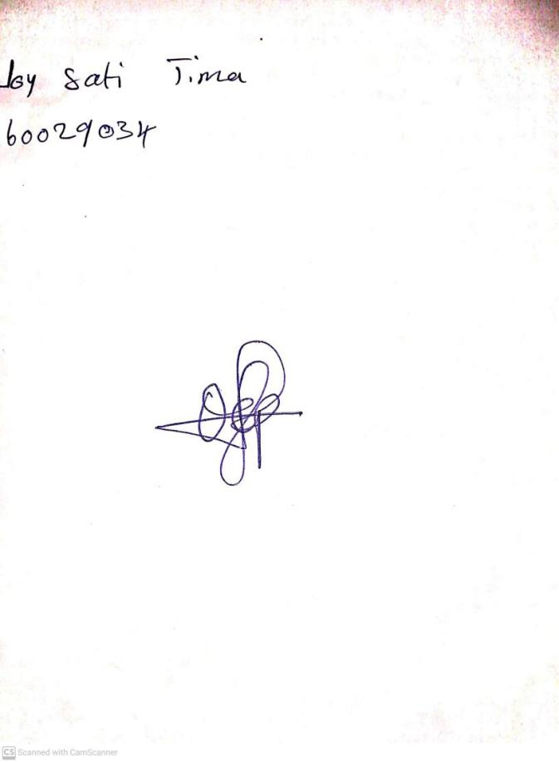

21st June, 2024

Perpetual Ojoma Ocheja

Stream Head Nursery