**LESSON PLAN AND NOTE 1 FOR WEEK 1 ENDING 15/09/2023**

**Term 1st term**

**Week 1st Week.**

**Date 11th September,2023.**

**Class Nursery One**

**Subject Letter Work**

**Topic Matching some letter Aa-Zz.**

**Sub-topic Reciting letters Aa-Ii.**

**Period 2nd period**

**Time 8:50 am**

**Duration 35 minutes**

**No in class 15**

**Average Age 3 years**

**Sex Mixed**

**Specific Objectives: By the end of the lesson, the pupils should be able to:**

1. **Recite letters Aa - Ii.**
2. **Identify letters Aa – Ii**
3. **Write letters Aa - Ii.**

**Rationale: To ensure the pupils have knowledge of letter Aa - Ii.**

**Previous Knowledge: The pupils can copy letters and words in uppercase A-Z.**

**Instructional Resources: Alphabet chart, Online research.**

**Reference Material: Online research, chart.**

**LESSON PRESENTATION**

|  |  |  |  |
| --- | --- | --- | --- |
| **Steps** | **Teacher’s Activities** | **Pupils’ Activities** | **Learning Points** |
| **Introduction** | **The teacher introduces the lesson by reciting the letters Aa – Ii by rhyming it for the pupils.** | **The pupils listen to the teacher.** | **To arouse the interest of the pupils.** |
| **Step 1** | **The teacher guides the pupils to first recite letters Aa – Ii.** | **The pupils repeat after the teacher the letters Aa – Ii.** | **For proper understanding of the pupils.** |
| **Step 2** | **The teacher leads the pupils to identify letters Aa – Ii.** | **The pupils identify the letters Aa – Ii.** | **For better understanding.** |
| **Step 3** | **The teacher guides the pupils to write letters Aa – Ii.**   |  |  | | --- | --- | | **Aa** | **Bb** | |  |  | | **Cc** | **Dd** | |  |  | | **Ee** | **Ff** | |  |  | | **Gg** | **Hh** | |  |  | | **Ii** | **Ii** | |  |  | | **The pupils write letters Aa – Ii.** | **For further understanding.** |
| **Summary** | **The teacher summarizes the lesson by writing letter Aa – Ii for the pupils on the board.**  **Aa Bb Cc**  **Dd Ee Ff**  **Gg Hh Ii** | **The pupils pays attention to the teacher.** | **For onward study.** |
| **Evaluation** | 1. **Recite letters Aa – Ii ?** 2. **What letter is this “ Gg” ?** 3. **Write the following capital and small letters below**  |  |  |  | | --- | --- | --- | | **Aa** | **Bb** | **Cc** | |  |  |  | | **The pupils answers the questions correctly.** | **To ascertain the pupils’ understanding.** |
| **Conclusion** | **The teacher summarizes and reacts the lesson to the pupils.** | **The pupils gives answer to the teacher’s question.** | **To consolidate the lesson.** |
| **Assignment** | 1. **Recite letters Aa – Ii ?** 2. **What letter is this “ Ff” ?** 3. **Write the letters below**  |  |  | | --- | --- | | **Aa** | **Bb** | |  |  | | **Cc** | **Dd** | |  |  | | **Ee** | **Ff** | |  |  | | **The pupils copy and do their homework at home.** | **To encourage learning while at home.** |

**LESSON PLAN AND NOTE 2 FOR WEEK 1 ENDING 15/09/2023**

**Term 1st term**

**Week 1st Week.**

**Date 13th September,2023.**

**Class Nursery One**

**Subject Letter Work**

**Topic Matching some letter Aa-Zz.**

**Sub-topic Reciting letters Jj - Rr.**

**Period 4th period**

**Time 10:40 am**

**Duration 35 minutes**

**No in class 15**

**Average Age 3 years**

**Sex Mixed**

**Specific Objectives: By the end of the lesson, the pupils should be able to:**

1. **Recite letters Jj - Rr.**
2. **Identify letters Jj - Rr.**
3. **Write letters Jj - Rr.**

**Rationale: To ensure the pupils have knowledge of letter Jj - Rr.**

**Previous Knowledge: The pupils can recite letters Aa - Ii.**

**Instructional Resources: Alphabet chart, Online research.**

**Reference Material: Online research, chart.**

**LESSON PRESENTATION**

|  |  |  |  |
| --- | --- | --- | --- |
| **Steps** | **Teacher’s Activities** | **Pupils’ Activities** | **Learning Points** |
| **Introduction** | **The teacher introduces the lesson by reciting the letters Jj – Rr by rhyming it for the pupils.** | **The pupils listen to the teacher.** | **To arouse the interest of the pupils.** |
| **Step 1** | **The teacher guides the pupils to first recite letters Jj - Rr.** | **The pupils repeat after the teacher the letters Jj - Rr.** | **For proper understanding of the pupils.** |
| **Step 2** | **The teacher leads the pupils to identify letters Jj - Rr.** | **The pupils identify the letters Jj - Rr.** | **For better understanding.** |
| **Step 3** | **The teacher guides the pupils to write letters Jj - Rr.**   |  |  | | --- | --- | | **Jj** | **Kk** | |  |  | | **Ll** | **Mm** | |  |  | | **Nn** | **Oo** | |  |  | | **Pp** | **Qq** | |  |  | | **Rr** | **Rr** | |  |  | | **The pupils write letters Jj - Rr.** | **For further understanding.** |
| **Summary** | **The teacher summarizes the lesson by writing letter Jj – Rr for the pupils on the board.**  **Jj Kk Ll**  **Mm Nn Oo**  **Pp Qq Rr** | **The pupils pays attention to the teacher.** | **For onward study.** |
| **Evaluation** | 1. **Recite letters Jj - Rr. ?** 2. **What letter is this “ Kk” ?** 3. **Write the following capital and small letters below?**  |  |  | | --- | --- | | **Jj** | **Kk** | |  |  | | **Ll** | **Mm** | |  |  | | **Nn** | **Oo** | |  |  | | **Pp** | **Qq** | |  |  | | **Rr** | **Rr** | |  |  | | **The pupils answers the questions correctly.** | **To ascertain the pupils’ understanding.** |
| **Conclusion** | **The teacher summarizes and reacts the lesson to the pupils.** | **The pupils gives answer to the teacher’s question.** | **To consolidate the lesson.** |
| **Assignment** | 1. **Recite letters Jj - Rr. ?** 2. **What letter is this “ Mm” ?** 3. **Write the letters below**  |  |  | | --- | --- | | **Jj** | **Kk** | |  |  | | **Ll** | **Mm** | |  |  | | **Nn** | **Oo** | |  |  | | **The pupils copy and do their homework at home.** | **To encourage learning while at home.** |

**LESSON PLAN AND NOTE 3 FOR WEEK 1 ENDING 15/09/2023**

**Term 1st term**

**Week 1st Week.**

**Date 15th September,2023.**

**Class Nursery One**

**Subject Letter Work**

**Topic Matching some letter Aa-Zz.**

**Sub-topic Reciting letters Ss - Zz.**

**Period 2nd period**

**Time 8:50 am**

**Duration 35 minutes**

**No in class 15**

**Average Age 3 years**

**Sex Mixed**

**Specific Objectives: By the end of the lesson, the pupils should be able to:**

1. **Recite letters Ss - Zz.**
2. **Identify letters Ss - Zz.**
3. **Write letters Ss - Zz.**

**Rationale: To ensure the pupils have knowledge of letter Ss - Zz.**

**Previous Knowledge: The pupils can recite letters Jj – Rr.**

**Instructional Resources: Alphabet chart, Online research.**

**Reference Material: Online research, chart.**

**LESSON PRESENTATION**

|  |  |  |  |
| --- | --- | --- | --- |
| **Steps** | **Teacher’s Activities** | **Pupils’ Activities** | **Learning Points** |
| **Introduction** | **The teacher introduces the lesson by reciting the letters Ss – Zz by rhyming it for the pupils.** | **The pupils listen to the teacher.** | **To arouse the interest of the pupils.** |
| **Step 1** | **The teacher guides the pupils to first recite letters Ss - Zz.** | **The pupils repeat after the teacher the letters Ss - Zz.** | **For proper understanding of the pupils.** |
| **Step 2** | **The teacher leads the pupils to identify letters Ss - Zz.** | **The pupils identify the letters Ss - Zz.** | **For better understanding.** |
| **Step 3** | **The teacher guides the pupils to write letters Ss - Zz.**   |  |  | | --- | --- | | **Ss** | **Tt** | |  |  | | **Uu** | **Vv** | |  |  | | **Ww** | **Xx** | |  |  | | **Yy** | **Zz** | |  |  | | **The pupils write letters Ss - Zz.** | **For further understanding.** |
| **Summary** | **The teacher summarizes the lesson by writing letter Ss – Zz for the pupils on the board.**  **Ss Tt Uu**  **Vv Ww Xx**  **Yy Zz** | **The pupils pays attention to the teacher.** | **For onward study.** |
| **Evaluation** | 1. **Recite letters Ss - Zz. ?** 2. **What letter is this “ Yy” ?** 3. **Write the following capital and small letters below?**  |  |  | | --- | --- | | **Ss** | **Tt** | |  |  | | **Uu** | **Vv** | |  |  | | **Ww** | **Xx** | |  |  | | **Yy** | **Zz** | |  |  | | **The pupils answers the questions correctly.** | **To ascertain the pupils’ understanding.** |
| **Conclusion** | **The teacher summarizes and reacts the lesson to the pupils.** | **The pupils gives answer to the teacher’s question.** | **To consolidate the lesson.** |
| **Assignment** | 1. **Recite letters Ss - Zz. ?** 2. **What letter is this “ Yy” ?** 3. **Write the letters below**  |  |  | | --- | --- | | **Ss** | **Tt** | |  |  | | **Uu** | **Vv** | |  |  | | **Ww** | **Xx** | |  |  | | **Yy** | **Zz** | |  |  | | **The pupils copy and do their homework at home.** | **To encourage learning while at home.** |

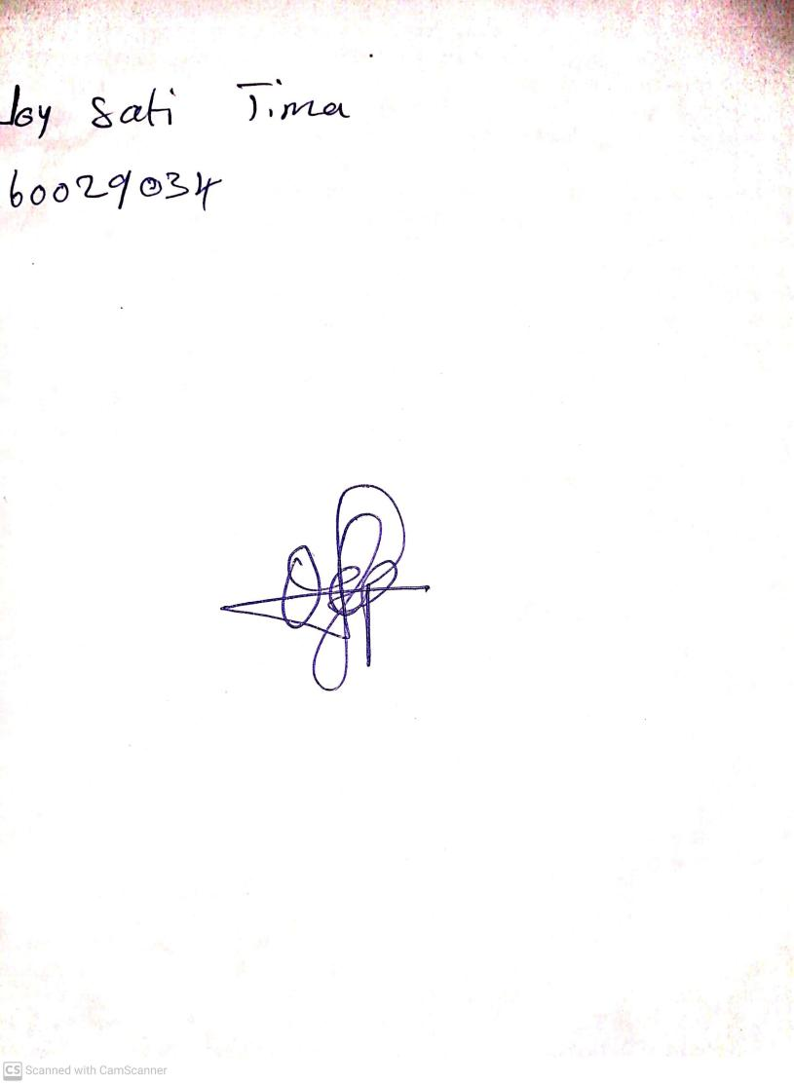

15th August, 2023

Perpetual Ojoma Ocheja

Stream Head Nursery