**LESSON PLAN AND NOTE FOR WEEK 3 ENDING 27/09/2024**

**Term 1st term**

**Week 3rd week.**

**Date 25th September,2024**

**Class Nursery one**

**Subject Social Norms**

**Topic My School.**

**Sub-topic Name of your school**

**Period 4th period**

**Time 10:40 am**

**Duration 35 minutes**

**No in class 15**

**Average Age 3 years**

**Sex Mixed**

**Specific Objectives: By the end of the lesson the pupils should be able to:**

1. **Identify the name of their school.**
2. **Mention the activities and equipments found in school.**

**Rationale: To ensure the pupils identify the name of their school.**

**Previous Knowledge: The pupils can mention their state origin and spell their name.**

**Instructional Resources: Board,marker ,online research.**

**Reference Materials: Smart smart Civic Education by A.M Solu, T.Y Alabi, Nursery 2**

**LESSON PRESENTATION**

|  |  |  |  |
| --- | --- | --- | --- |
| **Steps** | **Teacher’s Activities** | **Pupils’ Activities** | **Learning Points** |
| **Introduction** | **The teacher introduces the lesson by singing the school anthem and taking the pupils round the school compound.** | **The pupils participates actively with the teacher in learning.** | **To arouse the pupils’ interest towards the lesson.** |
| **Step 1** | **The teacher mentions the name of their school to the pupils and asks them to repeat after her**  **EMERALD ROYAL INTERNATIONAL SCHOOL.** | **The pupils actively repeats after their teacher the name of their school.** | **For proper understanding.** |
| **Step 2** | **The teacher mentions to the pupils the activities done in the school and places we can find inside the school which includes:**  **ACTIVITES DONE IN SCHOOL**  **School morning assembly**  **Learning inside the classroom etc.**  **PLACES INSIDE SCHOOL**  **Computer Room**  **Library**  **Office**  **Playground**  **Cafeteria**  **Reception etc.** | **The pupils pays attention to the teacher and repeats after the teacher.** | **For better understanding.** |
| **Summary** | **The teacher summarizes the lesson by taking the pupils round the school compound.** | **The pupils actively participates with their teacher.** | **For onward study.** |
| **Evaluation** | **What is the name of your school?**  **Mention two each activities and places inside your school?** | **The pupils answer the questions accordingly.** | **To ascertain the pupils’ understanding.** |
| **Conclusion** | **The teacher summarizes,reacts,and corrects the pupils.** | **The teacher gives answers to the teacher’s question.** | **To consolidate the lesson.** |
| **Assignment** | **Mention the activities done in your school?**  **What is the name of your school?** | **The pupils copy and do their home-work at home.** | **To encourage learning while at home.** |

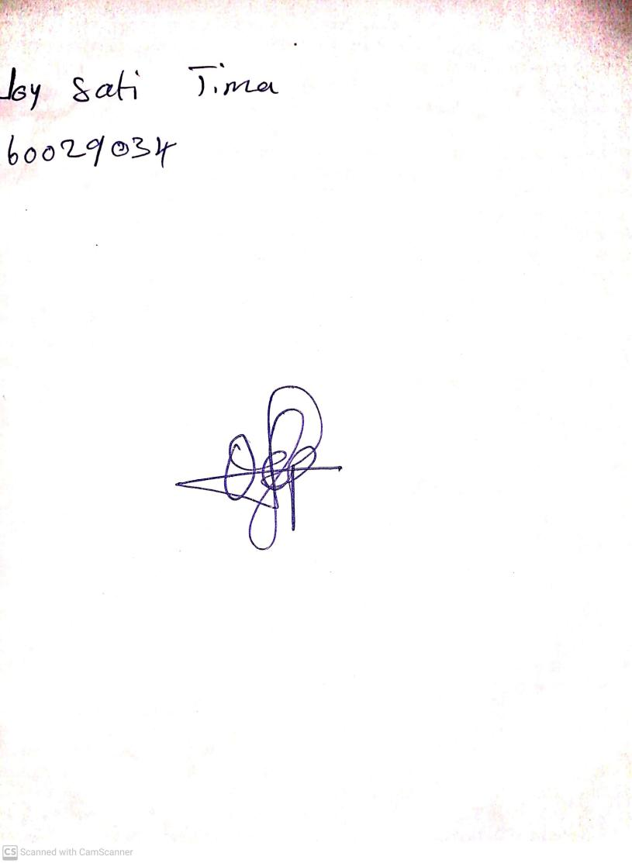

27th September, 2024

Perpetual Ojoma Ocheja

Stream Head Nursery